

SoftwareRequirement Specification

Happy Programming Mentorship System

– Hanoi, Aug 2026 –

Table of Contents
Change Log 5
OverView 6
I Overall Requirements 7
1. Context Diagram 7
1.1 Internal entities 7
1.2 External entities 8
2. Main Business Flow 9
2.1 Monthly Mentorship Booking Process 9
2.2 Mentor Registration and Approval Process 10
2.3 Rating and Comment Process 11
2.4 Mentor Withdrawal Process 12
2.5 Dispute Resolution and Refund Process 12
3. Conceptual Data Model 14
3.1 Entity Relationship Diagram 14
3.2 Entity Descriptions 14
3.3 Data Business Rules 16
4. User Requirements 16
4.1 Use Cases (UC) 16
4.2 Use Case Diagrams 25
4.3 System Functionalities 29
II. Requirement Specifications 32
1. User Account & Authentication Management 32
1.1 UC - Register Account 32
1.2 UC - UC - Login / Register with Google 34
2. Mentor Discovery & Skill Management 36
2.1 UC - View Mentor List 36
2.2 UC -Search / Filter Mentor by Skill 38
2.3 UC - View Mentor Profile 39
2.4 UC - View Skill List 40
2.5 UC -View Mentor Ratings and Comments 41
2.6 UC - View Mentor Profile & Skills 43
2.7 UC - Save Mentor to Wishlist 44
2.8 UC - Manage Wishlist 45
3. Mentorship Booking & Contract Management 47
3.1. UC - Book Mentorship Service 47
3.2. UC - Apply for Monthly Mentorship 49
3.3. UC -Book One-Off Session 51
3.4. UC -Submit Learning Goals 53
3.5. UC - Select Time Slot 54
3.6. Manage / Cancel Subscription 56
4. Payment & Escrow Management 58
4.1. UC - Process Payment via Gateway 58
4.2. UC - View Transaction History 60
4.3. UC Upload Dispute Evidence and Refund Details 62
5. Request & Invitation Management 64
6. Mentorship Workspace & Communication 64
6.1. UC - Chat in Direct Messaging 64
6.2. UC - Join 1-on-1 Video Call 66
6.3. UC - View Notification 67
7. Feedback & Rating Management 69
7.1. UC - Submit Rating & Review 69
8. System Administration & Operation Management 71
8.1. UC - Manage Accounts 71
8.2. UC - View Account List 72
8.3. UC - View Account Detail 74
8.4. UC - Manage Staff Authorization 75
8.5. UC - View Staff List 76
8.6. UC - Update Staff Permissions 78
8.7. UC - Manage System Configuration 79
8.8. UC - View Audit Logs 81
8.9. UC - View Revenue Reports 82
8.10. UC - View Admin OverView 84
8.11. UC - View Payment Transactions 85
8.12. UC - Process Mentor Payout 86
8.13. UC - Process Mentee Refund 88
8.14. UC - Update Account Status 90
8.15. UC - View Payout Requests and History 91
8.16. UC - View Refund Requests and History 93
9. Request & Inquiry Management 94
9.1. UC - Send Direct Inquiry 94
10. Mentor Management 95
10.1. UC - Submit CV and Qualification Certificates 95
10.2. UC - Manage Profile & Biography 97
10.3. UC - Select & Update Teaching Skills 99
10.4. UC - Handle Mentorship Requests (Accept / Reject) 100
10.5. UC - View Net Earnings & Mentee Feedback 101
10.6. UC - View Mentor Wallet and Payout History 103
10.7. UC - Request Mentor Withdrawal 104
10.8. UC - Provide Dispute Response 105
11. Manage User 106
11.1. UC - Manage Mentor 106
11.2. UC - Manage Mentees 108
12. Manage Requests 109
12.1. UC - Manage Mentorship Requests 109
13. Dispute and Payout Operations 111
13.1.UC - Review Mentor Payout Request 111
13.2.UC - Submit Dispute 113
13.3.UC - View Dispute and Refund Outcome 114
13.4.UC - Review and Resolve Dispute 116
III. Functional Requirements 118
1. Guest 118
1.1 Sign up as a mentee 118
1.2 Apply as a mentor 120
1.3 Login 126
1.4 View Mentor Ratings and Comments 128
2. Mentee 130
2.1 Mentor discovery 130
2.2 View mentor profile 132
2.3 Application & Learning Goals 134
2.4 Payment Process 135
2.5 Mentee Workspace & Chat 137
2.6 Mentee My Bookings & Sessions 138
2.7 Book 1-on-1 Session 140
2.8 Rating and Submit Review 142
3.Mentor 143
3.1 Mentor Workspace Overview & Requests 143
3.2. Mentor Profile & CV Management 145
3.3 Teaching Skills Management 147
3.4 Statistics, Net Earnings & Mentee Feedback 147
4. Admin 149
4.1 Admin Dashboard 149
4.2 Account Management 151
4.3 Account Detail 152
4.4 Staff Authorization 154
4.5 System Configuration 156
4.6 Audit Log 158
4.7 Revenue Report 159
4.8 Mentor Payout 161
5. Staff 163
5.1 Staff Dashboard 164
5.2 Manager Mentor 165
5.3 Manager Mentees 167
5.4 Manager Requests 168
6. Background Job Inventory 169
6.1 Clean Up Old Audit Log Entries (JOB-01) 169
6.2 Expire Pending Payments and Bookings (JOB-02) 169
7. External API Inventory 170
7.1 SePay Bank Transaction Webhook (API-01) 170
7.2 Google OAuth2 Callback (API-02) 170
7.3 Email Notification Service (API-03) 170
IV. Non functional requirement 170
1. External Interfaces 170
2. Quality Attributes 171
V. Requirement Appendix 173
1. Business Rules 173
2. System Messages 177
3. Other Requirements 180

Change Log
Date | A*  M, D | In charge | Change Description
13/09/2026 | A | Group 3 | Draw Context Diagram, Draw Use Case, Draw Business Process.
18/09/2026 | A | Group 3 | Draw Screen Flow All Role, Use Case Specification, Requirement Appendix
12/10/2026 | M | Group 3 | Revised payment requirements from SePay redirect checkout to SePay bank-transfer QR and authenticated webhook settlement; aligned mentorship activation, escrow, wallet, API, security, reporting, and UI requirements.
*A - Added M - Modified D - Deleted

OverView
The HappyProgramming Mentorship Management System is a web-based platform designed to connect people who want to learn programming with suitable mentors. The system supports mentor discovery, learning requests, mentor invitations, profile and CV management, booking and payment, ratings and comments, and system administration. It integrates with Gmail for email services, Google OAuth2 for authentication, and SePay for bank-transfer QR generation and incoming-transaction webhook notifications. The system interacts with five primary user roles:
● Guest: An unregistered user who can view mentor and skill information and register an account.
● Mentee: A registered user who searches for mentors, creates learning requests, manages their profile, makes bookings and payments, tracks request status, and rates mentors.
● Mentor: A registered mentor who maintains CV information, receives invitations, responds to requests, and views request statistics.
● Staff: Operational staff who manage mentor approval, mentees, requests and skills, and review mentor and CV information.
● Admin: The highest-level system user who manages accounts and system configuration and monitors audit logs and reports.

I Overall Requirements

1. Context Diagram
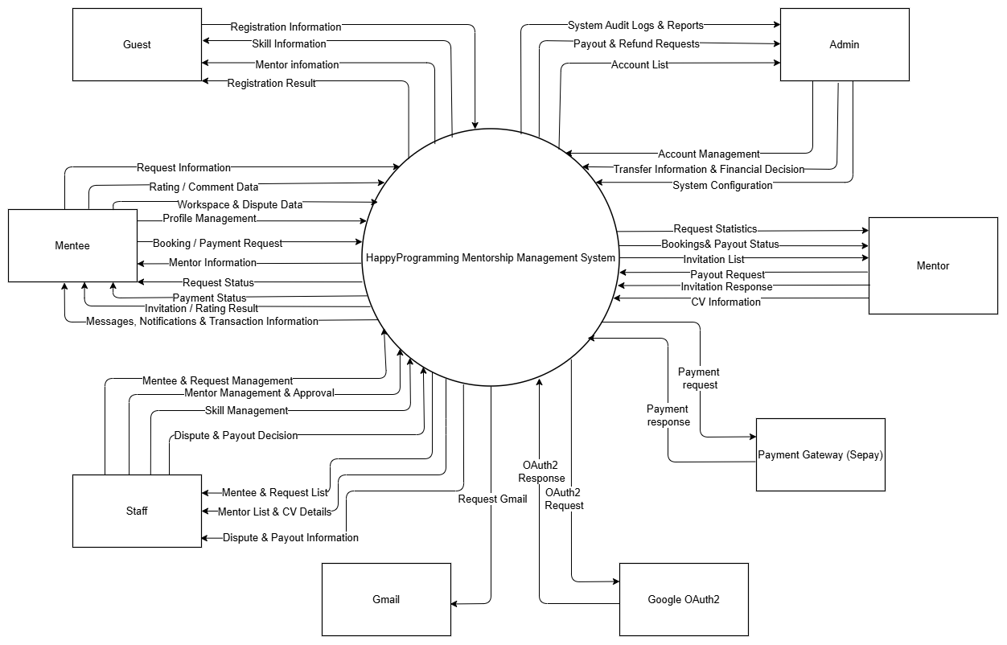

1.1 Internal entities

# | Entity | Description
1 | Admin | The highest-level user in the system. The Admin manages user accounts, system-wide configuration, audit logs, and reports to maintain the overall platform.
2 | Guest | An unregistered user who can access public features such as viewing mentor information and skill information, and can register a new account.
3 | Mentee | A registered user who wants to learn programming. Mentees can search and view mentors, create and manage learning requests, manage their profile, make bookings and payments, track request status, and submit ratings and comments.
4 | Staff | An operational user responsible for mentor management and approval, mentee and request management, and skill management. Staff can also review mentor lists and CV details.
5 | Mentor | A registered user who provides programming mentorship. Mentors can create and update CV information, receive invited requests, respond to invitations, and view request statistics.

1.2 External entities

6 | SePay | SePay provides bank-transfer QR payment instructions and sends incoming-transaction webhook notifications. The configured HappyProgramming bank account receives the actual funds; SePay does not hold platform escrow funds.
7 | Google OAuth2 | An external authentication service that allows users to sign in or register with a Google account. It verifies user identity and returns OAuth2 authentication information to HappyProgramming.
8 | Email | An external email service used for account verification, password reset, and system notifications such as request, invitation, and payment-related messages.

2. Main Business Flow

2.1 Monthly Mentorship Booking Process
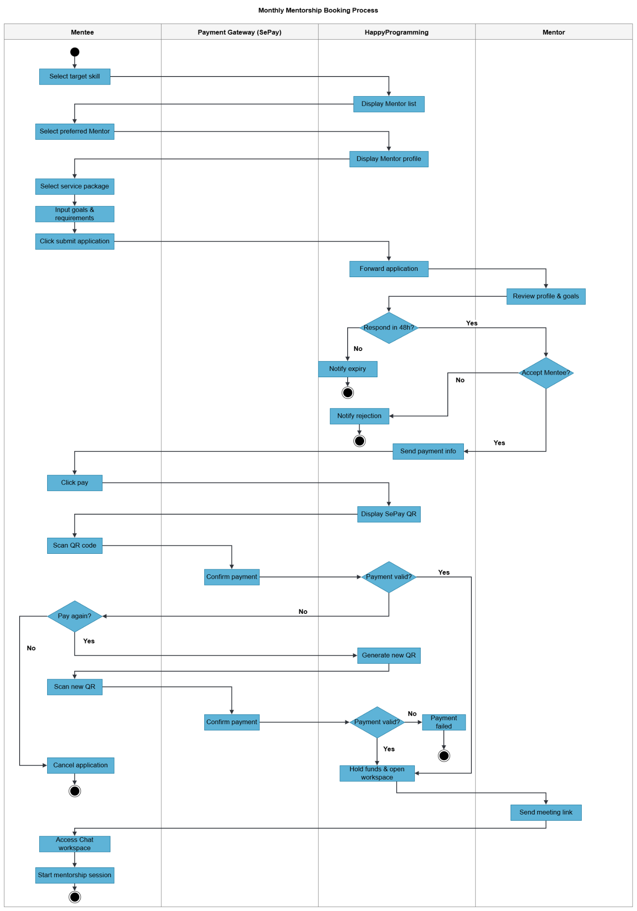

2.2 Mentor Registration and Approval Process
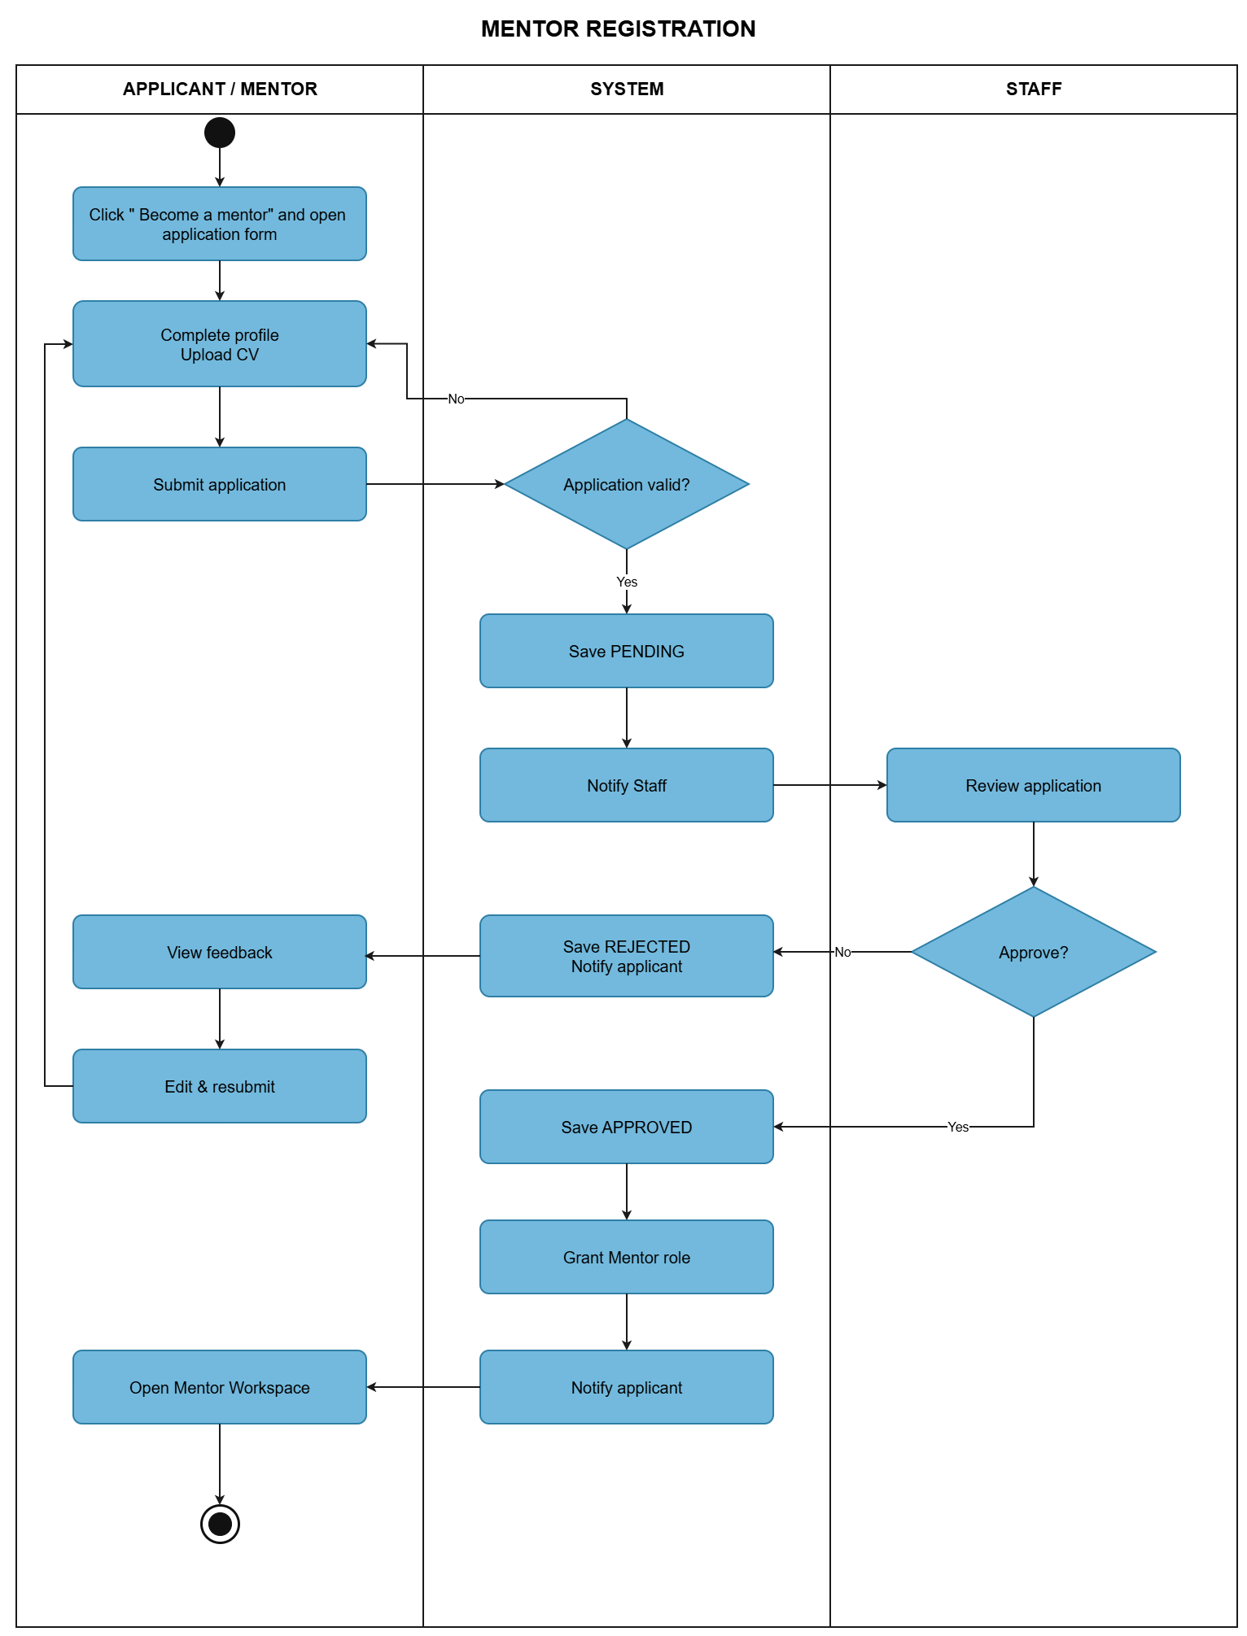

2.3 Rating and Comment Process
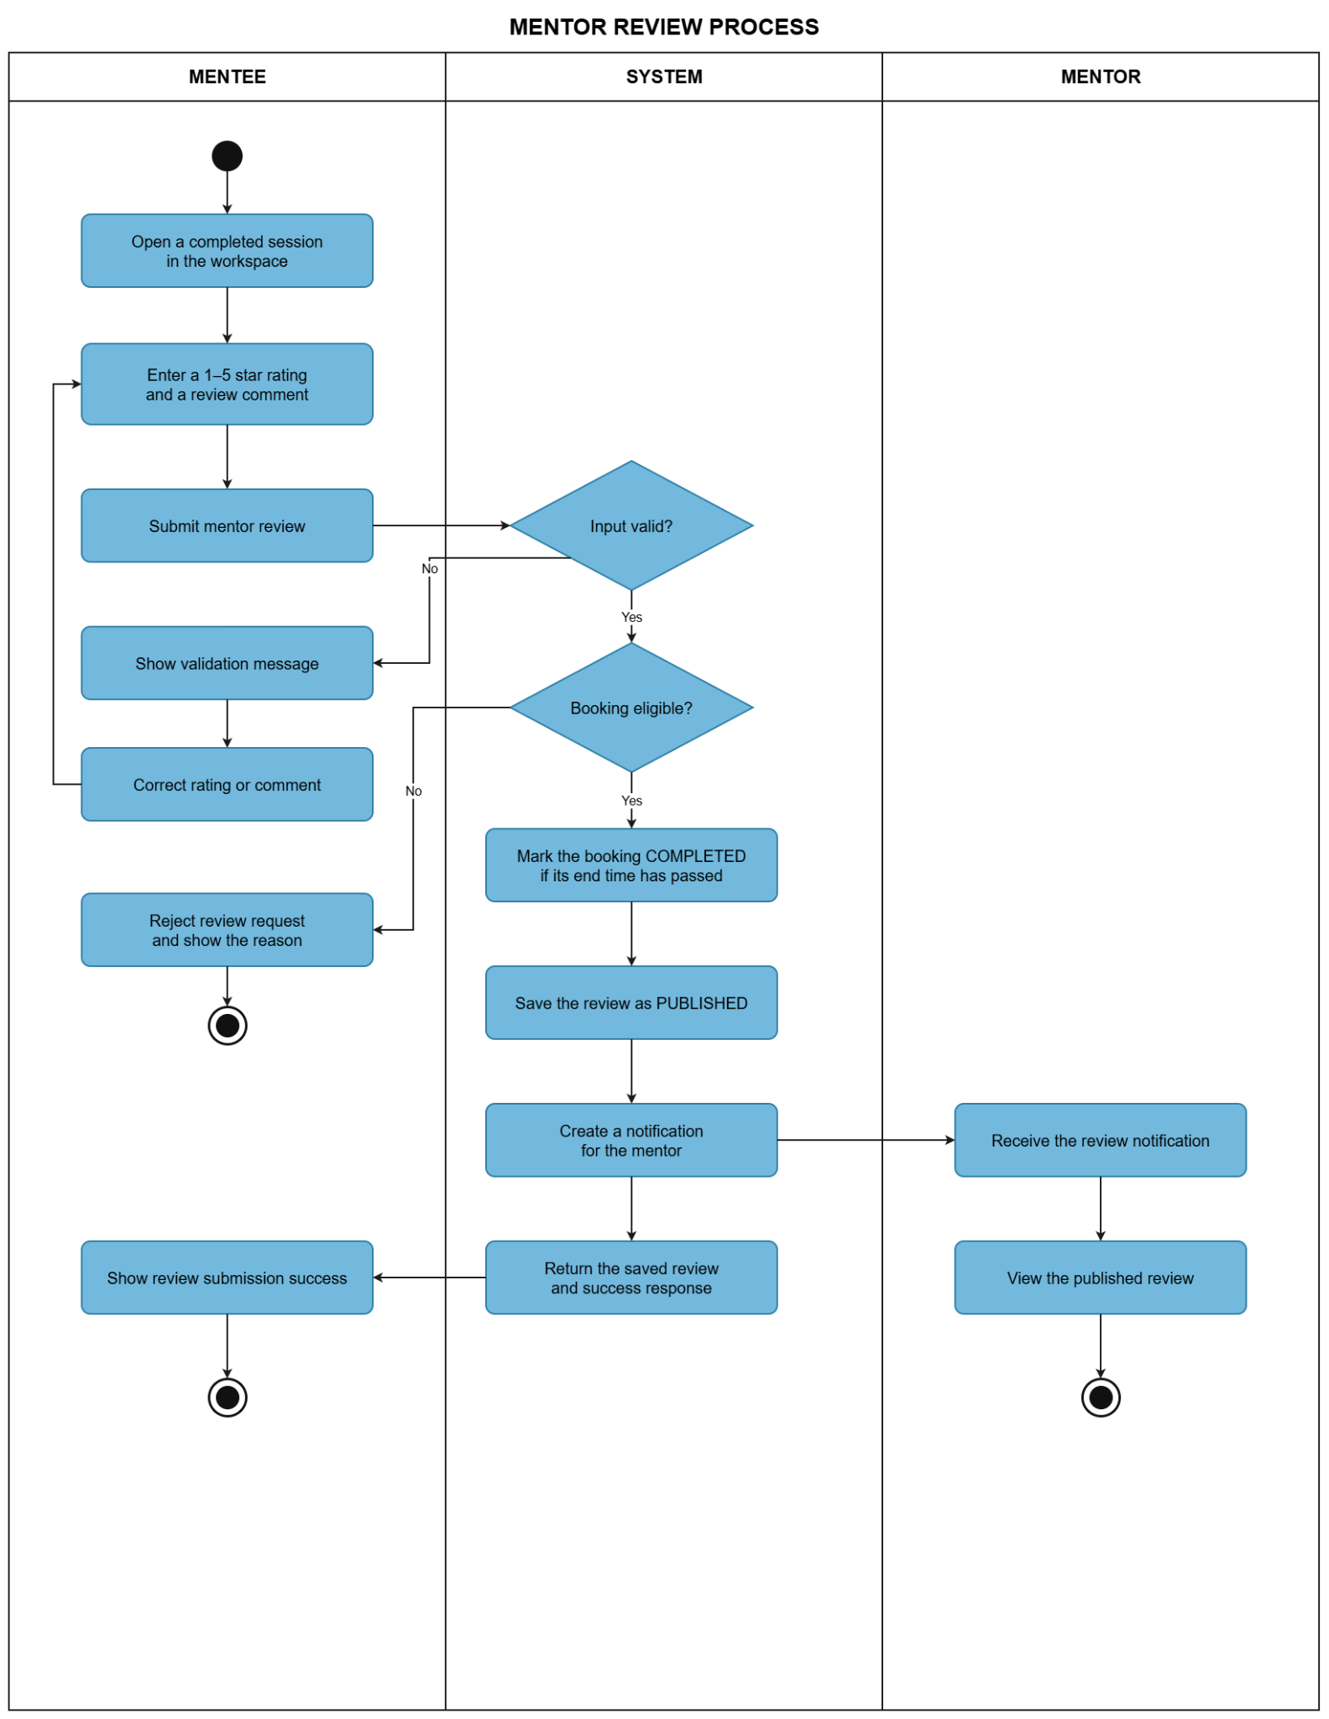

2.4 Mentor Withdrawal Process
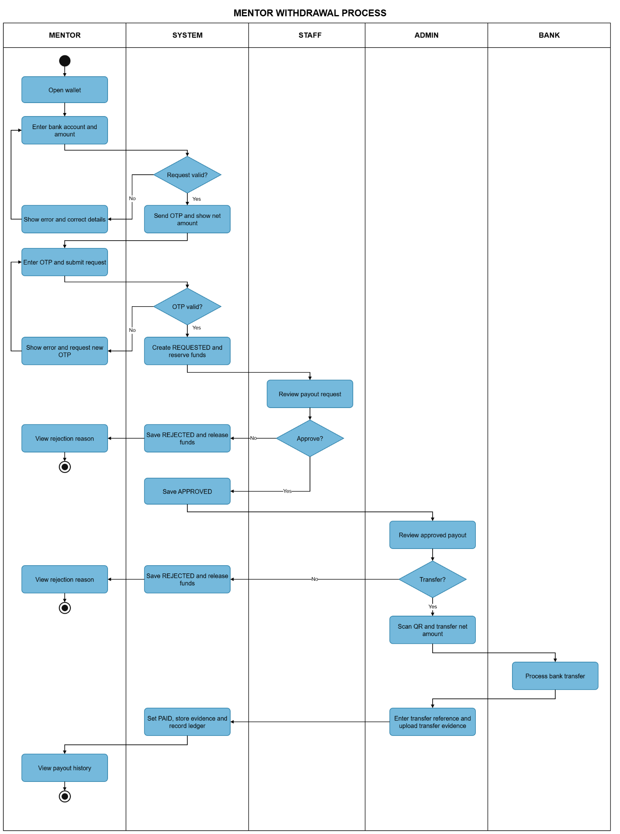

2.5 Dispute Resolution and Refund Process

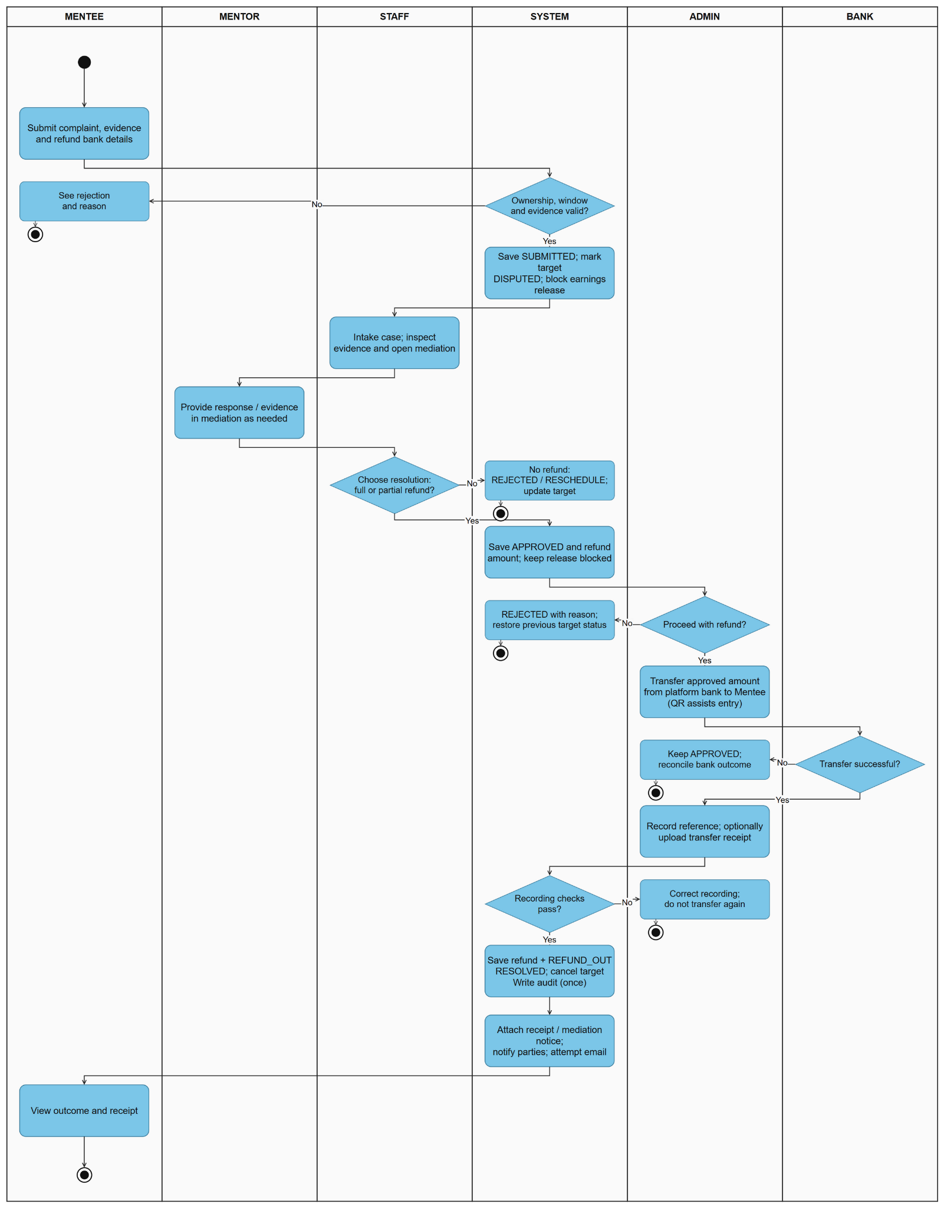

3. Conceptual Data Model

3.1 Entity Relationship Diagram
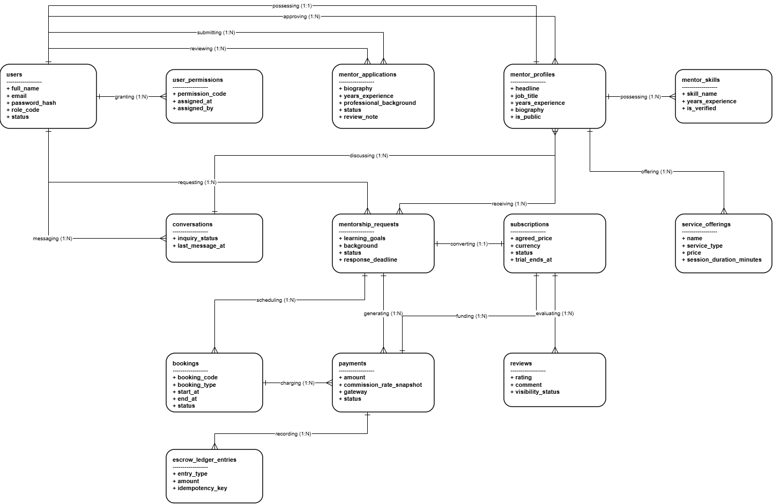

3.2 Entity Descriptions
[Provide one block per entity with descriptions and key business attributes only.]
Entity: User
Field | Value
Purpose | Manages user account information for all actors in the system (Admin, Staff, Mentor, Mentee).
Key business attributes | full_name, email, role_code (MENTOR/MENTEE/STAFF/ADMIN), password_hash, status
Business identity | email is globally unique across the entire system (UX_users_email).
Status / lifecycle | ACTIVE $→$ INACTIVE $→$ LOCKED (temporarily locked upon repeated failed sign-in attempts).
Entity: Mentor Profile
Field | Value
Purpose | Stores professional profile information and public display details of a Mentor.
Key business attributes | headline, job_title, company_name, years_experience, biography, is_public.
Business identity | Each User with a Mentor role owns exactly 1 Mentor Profile (1:1 relationship via user_id).
Status / lifecycle | Pending Review $→$ APPROVED $→$ Eligible to enable is_public = 1.
Entity: Mentorship Request
Field | Value
Purpose | Records mentorship applications submitted by Mentees to Mentors.
Key business attributes | mentee_id, mentor_id, service_id, learning_goals, status, response_deadline.
Business identity | Auto-increment ID. At most 1 PENDING request is allowed per Mentee-Mentor pair.
Status / lifecycle | DRAFT $→$ PENDING $→$ ACCEPTED / REJECTED / EXPIRED / CANCELLED.
Entities: Subscription
Field | Value
Purpose | Manages long-term monthly mentorship engagements after request approval and payment.
Key business attributes | agreed_price, currency, plan_snapshot, status, activated_at, trial_ends_at.
Business identity | Exactly 1:1 mapping with an accepted Mentorship Request (request_id).
Status / lifecycle | TRIALING (7-day trial) $→$ ACTIVE $→$ PAST_DUE / CANCELLED / ENDED.

Entities: Booking
Field | Value
Purpose | Manages individual one-off session bookings or recurring monthly calls.
Key business attributes | booking_code, booking_type, start_at, end_at, status, meeting_url.
Business identity | Unique booking_code generated per scheduled meeting.
Status / lifecycle | PENDING_PAYMENT $→$ CONFIRMED $→$ COMPLETED / CANCELLED.

Entities: Payment
Field | Value
Purpose | Records transaction details processed through the VNPay payment gateway.
Key business attributes | merchant_reference, gateway_transaction_id, amount, commission_rate_snapshot, status.
Business identity | Unique merchant_reference generated per checkout attempt.
Status / lifecycle | PENDING $→$ SUCCEEDED / FAILED / EXPIRED / CANCELLED.

Entities: Review
Field | Value
Purpose | Stores star ratings, feedback, and comments submitted by Mentees for Mentors.
Key business attributes | rating (1-5 stars), comment, visibility_status, moderation_status
Business identity | Each Booking or Subscription can be reviewed at most once.
Status / lifecycle | PUBLISHED / HIDDEN / FLAGGED.

3.3 Data Business Rules
[Rules about data that are not obvious from the ERD. ]
Rule | Description | Enforced On
Unique User Email | Email must be globally unique across all accounts (UNIQUE CONSTRAINT on users.email). | users table constraint (UX_users_email)
Unique Account Profile | Each user can possess at most one active Mentor Profile (UNIQUE FK / 1:1 mapping on mentor_profiles.user_id). | mentor_profiles table (user_id unique index)
Single Active Application | A candidate cannot submit a new mentor_applications if an application is already in PENDING status. | Application submission check / mentor_applications
Pending Request Limit | At most one active request in PENDING status is allowed between the same Mentee and Mentor. | mentorship_requests unique constraint / logic
Response Deadline Constraint | Mentors must accept or reject a request before response_deadline; overdue requests transition to EXPIRED | mentorship_requests.response_deadline & background worker
Slot Overlap Prevention | Availability slots created in mentor_availability_slots must not overlap in time (start_at to end_at). | mentor_availability_slots validation
Slot Hold Expiration | Temporary slot holds (slot_holds) automatically expire after the reservation window if payment is not initiated. | slot_holds.expires_at & cleanup worker
1:1 Subscription Conversion | An accepted mentorship_requests record converts to exactly one subscriptions entry (request_id FK). | subscriptions.request_id unique relationship
Payment Verification Trigger | A subscription or booking status only updates to CONFIRMED/ACTIVE upon verified gateway transaction in payments. | payments.status webhook & payment service
Immutable Escrow Ledger | Entries in escrow_ledger_entries are strictly append-only; updates and deletions are restricted to preserve financial auditability. | escrow_ledger_entries table integrity policy
Single Review per Booking/Sub | A Mentee can create at most one review record in reviews per completed booking_id or subscription_id. | reviews unique constraints (booking_id, subscription_id)
Account Soft Delete | User records are deactivated by setting status = 'INACTIVE', preserving audit history instead of physical deletion. | users.status updating logic

4. User Requirements

4.1 Use Cases (UC)
The following user requirements are defined based on the HappyProgramming system context and the current business processes, including mentor registration and approval, mentorship requests and booking, payment through SePay bank-transfer QR, escrow accounting, mentor wallet settlement, and rating/comment activities.

ID | Use Case | Feature | Main Actor | Use Case Description
1 | Register Account | User Account & Authentication Management | Guest | Allows a guest to create a HappyProgramming account and access registered-user features after completing account verification.
2 | Login with Email and Password | User Account & Authentication Management | Mentee / Mentor / Staff / Admin | Allows registered users to sign in using their email and password and access functions authorized for their role.
3 | Login / Register with Google | User Account & Authentication Management | Guest / Registered User | Allows users to authenticate through Google OAuth2. A new account may be created automatically for a first-time Google user.
4 | Forgot Password | User Account & Authentication Management | Registered User | Allows a user who forgot the password to request a password-reset link through the registered email address.
5 | Reset Password | User Account & Authentication Management | Registered User | Allows a user to create a new password using a valid password-reset link received by email.
6 | Change Password | User Account & Authentication Management | Authenticated User | Allows a logged-in user to securely change the current account password.
7 | Logout | User Account & Authentication Management | Authenticated User | Allows a logged-in user to securely end the current session.
8 | View Mentor List | Mentor Discovery & Skill Management | Guest / Mentee | Allows users to view available mentors on the platform.
9 | Search / Filter Mentor by Skill | Mentor Discovery & Skill Management | Guest / Mentee | Allows users to find suitable mentors by selecting a target programming skill or other available search criteria.
10 | View Mentor Profile | Mentor Discovery & Skill Management | Guest / Mentee | Allows users to view a mentor profile including CV, skills, experience, service information, ratings and comments.
11 | View Skill List | Mentor Discovery & Skill Management | Guest / Mentee | Allows users to view the programming skills available in the system for mentor discovery and request creation.
12 | View Mentor Ratings and Comments | Mentor Discovery & Skill Management | Guest / Mentee | Allows users to view ratings and comments submitted by previous mentees for a mentor.
13 | Manage Profile | User Account & Authentication Management | Mentee / Mentor | Allows a mentee or mentor to view and update personal profile information.
14 | Register as Mentor | Mentor Management | Registered User | Allows a registered user to start the mentor registration process.
15 | Submit CV and Skills | Mentor Management | Mentor Applicant | Allows a mentor applicant to provide CV information, programming skills and other required information for staff review.
16 | View Mentor Registration Status | Mentor Management | Mentor Applicant | Allows an applicant to view whether the mentor registration is pending, approved or rejected.
17 | Review Mentor Application | Mentor Management | Staff | Allows staff to view a pending mentor application and review the applicant profile, CV and skills.
18 | Approve / Reject Mentor Application | Mentor Management | Staff | Allows staff to approve a valid mentor application or reject an application that does not meet the platform requirements.
19 | View Mentor List and CV Details | Mentor Management | Staff | Allows staff to view mentor accounts and inspect mentor profile and CV information for operational management.
20 | Select Service Package | Mentorship Booking & Contract Management | Mentee | Allows a mentee to select an available mentorship service package offered by the selected mentor before submitting a request.
21 | Create Mentorship Request | Mentorship Booking & Contract Management | Mentee | Allows a mentee to enter learning goals and requirements and submit a mentorship request to the selected mentor.
22 | View My Requests | Mentorship Booking & Contract Management | Mentee | Allows a mentee to view all submitted mentorship requests and their current statuses.
23 | Update / Cancel Request | Mentorship Booking & Contract Management | Mentee | Allows a mentee to update or cancel a request when the request status still permits modification.
24 | View Invited Requests | Mentor Management | Mentor | Allows a mentor to view mentorship requests sent to them by mentees.
25 | View Request Detail | Mentor Management | Mentor | Allows a mentor to review the mentee profile, selected service package, learning goals and request details before responding.
26 | Accept / Reject Mentorship Request | Mentor Management | Mentor | Allows a mentor to accept or reject a mentorship request. The system updates the request status and notifies the mentee.
27 | Track Request Status | Mentorship Booking & Contract Management | Mentee | Allows a mentee to track the current state of a mentorship request, including pending, accepted, rejected, paid or completed states as applicable.
28 | View Request Statistics | Mentor Management | Mentor | Allows a mentor to view statistics related to received, accepted, rejected and completed mentorship requests.
29 | Create Booking | Mentorship Booking & Contract Management | Mentee | Allows a mentee to confirm booking information after a mentor accepts the mentorship request.
30 | Pay via SePay Bank Transfer QR | Payment & Escrow Management | Mentee | Allows a mentee to pay an accepted mentorship request by scanning a SePay-generated bank-transfer QR or copying the exact bank-transfer details.
31 | View Payment Status | Payment & Escrow Management | Mentee | Allows a mentee to view whether the bank transfer is awaiting confirmation, verified, expired, cancelled, or requires reconciliation.
32 | Access Chat Workspace | Mentorship Workspace & Communication | Mentee / Mentor | Allows both parties to access the mentorship workspace after the booking and payment are successfully confirmed.
33 | Start Mentorship Session | Mentorship Workspace & Communication | Mentee / Mentor | Allows the mentee and mentor to begin the mentorship session through the confirmed mentorship workspace.
34 | Submit Rating and Comment | Feedback & Rating Management | Mentee | Allows an eligible mentee to rate and comment on a mentor after completing a mentorship booking.
35 | View Received Ratings and Comments | Feedback & Rating Management | Mentor | Allows a mentor to view ratings and comments received from mentees.
36 | Manage Mentees | Manage User | Staff | Allows staff to view and manage mentee information needed for platform operations.
37 | Manage Requests | Manage Requests | Staff | Allows staff to view and manage mentorship requests for operational support and issue handling.
38 | Manage Skills | Mentor Discovery & Skill Management | Staff | Allows staff to create, update, activate or deactivate programming skills used for mentor profiles and mentor discovery.
39 | Manage Accounts | System Administration & Operation Management | Admin | Allows the admin to view and manage user accounts and account statuses across the platform.
40 | Manage System Configuration | System Administration & Operation Management | Admin | Configure commission, support email, OTP resend/expiry, withdrawal threshold/fee, earnings hold, maintenance and announcements.
41 | View Audit Logs | System Administration & Operation Management | Admin | Allows the admin to review system audit logs for monitoring and administrative control.
42 | View Admin Dashboard | System Administration & Operation Management | Admin | View administrative overview and navigate to platform operations.
43 | Update Account Status | System Administration & Operation Management | Admin | Allows the admin to change the status of a selected account and control its platform access.
44 | Manage Staff Authorization | System Administration & Operation Management | Admin | Allows the admin to manage Staff access permissions for HappyProgramming operational functions.
45 | View Staff List | System Administration & Operation Management | Admin | Allows the admin to view accounts assigned to the Staff role and their authorization information.
46 | Update Staff Permission | System Administration & Operation Management | Admin | Allows the admin to update permissions assigned to a selected Staff account.
47 | View Payout Requests and History | Payment & Escrow Management | Admin | Inspect payout requests approved by Staff and their processing history.
48 | View Audit Logs | System Administration & Operation Management | Admin | Allows the admin to review system audit logs for monitoring and administrative control.
49 | View Revenue Report | System Administration & Operation Management | Admin | Allows the admin to view revenue information generated from successful mentorship payment transactions.
50 | View Refund Requests and History | Payment & Escrow Management | Admin | Inspect approved refund requests and recorded refund outcomes.
51 | View Payment Transactions | Payment & Escrow Management | Admin | Payment records are displayed without changing settlement status.
52 | Process Mentor Payout | Payment & Escrow Management | Admin | Successful recording sets PAID once; rejection sets REJECTED and releases the reserved balance.
53 | Process Mentee Refund | Payment & Escrow Management | Admin | Paid refund is recorded once and the dispute is RESOLVED. Rejection does not create a refund debit.
54 | View Mentor Wallet and Payout History | Payment & Escrow Management | Mentor | Wallet information is displayed without creating a payout.
55 | Request Mentor Withdrawal | Payment & Escrow Management | Mentor | A valid request reserves funds; it does not transfer money or mark the request paid.
56 | Review Mentor Payout Request | Payment & Escrow Management | Staff | The request is APPROVED for Admin processing or REJECTED; Staff does not perform the PAID transition
57 | Submit Dispute | Payment & Escrow Management | Mentee | A dispute is recorded with no refund automatically issued.
58 | View Dispute and Refund Outcome | Payment & Escrow Management | Mentee | The party can review the recorded outcome and available receipt.
59 | Provide Dispute Response | Payment & Escrow Management | Mentor | Supporting information is available for Staff review; the Mentor cannot approve their own refund.
60 | Review and Resolve Dispute | Payment & Escrow Management | Staff | An approved refund goes to Admin; a non-refund resolution is recorded without a bank transfer.
61 | View Account List | System Administration & Operation Management | Admin | The list is shown without account modifications.
62 | View Account Detail | System Administration & Operation Management | Admin | Account details are displayed without changing them.
63 | Manage Wishlist | Mentor Discovery & Skill Management | Mentee | Allows a mentee to view saved mentors, search, filter, sort, and remove mentors from their personal wishlist.
64 | Select Time Slot | Mentorship Booking & Contract Management | Mentee | Allows a mentee to view a mentor's available one-off session slots and select an eligible time slot before creating the booking.
65 | View Transaction History | Payment & Escrow Management | Mentee | Allows a mentee to view their payment transaction history, including transaction reference, amount, payment status, service, and date.
66 | View Notifications | Mentorship Workspace & Communication | Mentee | Allows a mentee to view notification history, open the related booking or workspace, and mark notifications as read.
67 | Upload Dispute Evidence and Refund Details | Payment & Escrow Management | Mentee | Allows a mentee to upload image evidence and provide refund bank details when submitting a dispute. This use case is included in Submit Dispute.
68 | View Mentor Wallet and Payout History | Mentor Wallet | Mentor | View held, available, and reserved balances, along with payout request history.
69 | Request Mentor Withdrawal | Mentor Wallet | Mentor | Request a withdrawal using an email OTP verification.
70 | View Dispute and Refund Outcome | Dispute Management | Mentee / Mentor | View dispute resolution details, evidence, and payment receipt.
71 | Provide Dispute Response | Dispute Management | Mentor | Provide supporting evidence and responses for staff dispute mediation.

4.2 Use Case Diagrams

4.2.1 UCs for Guest

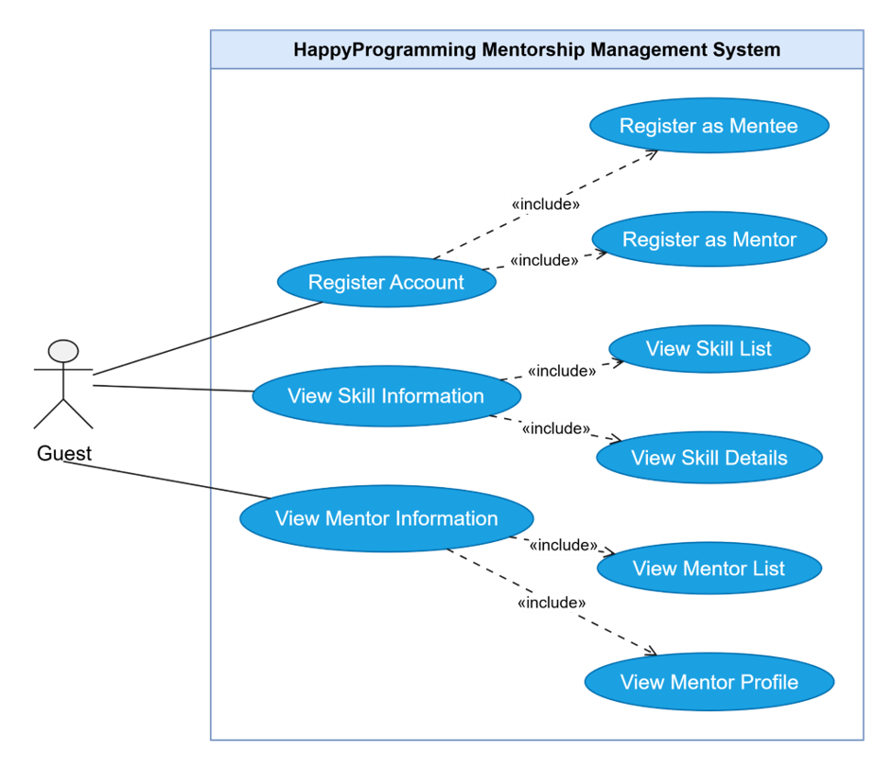

4.2.2 UCs for Mentee
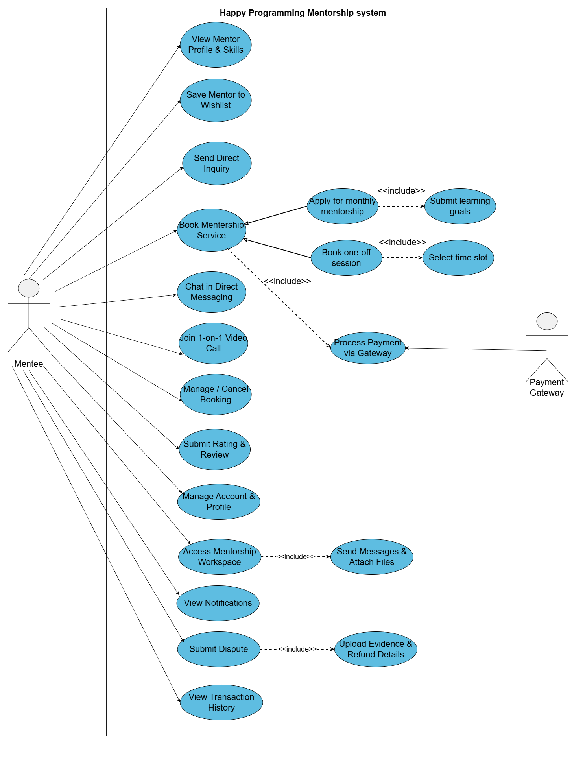

4.2.3 UCs for Mentor
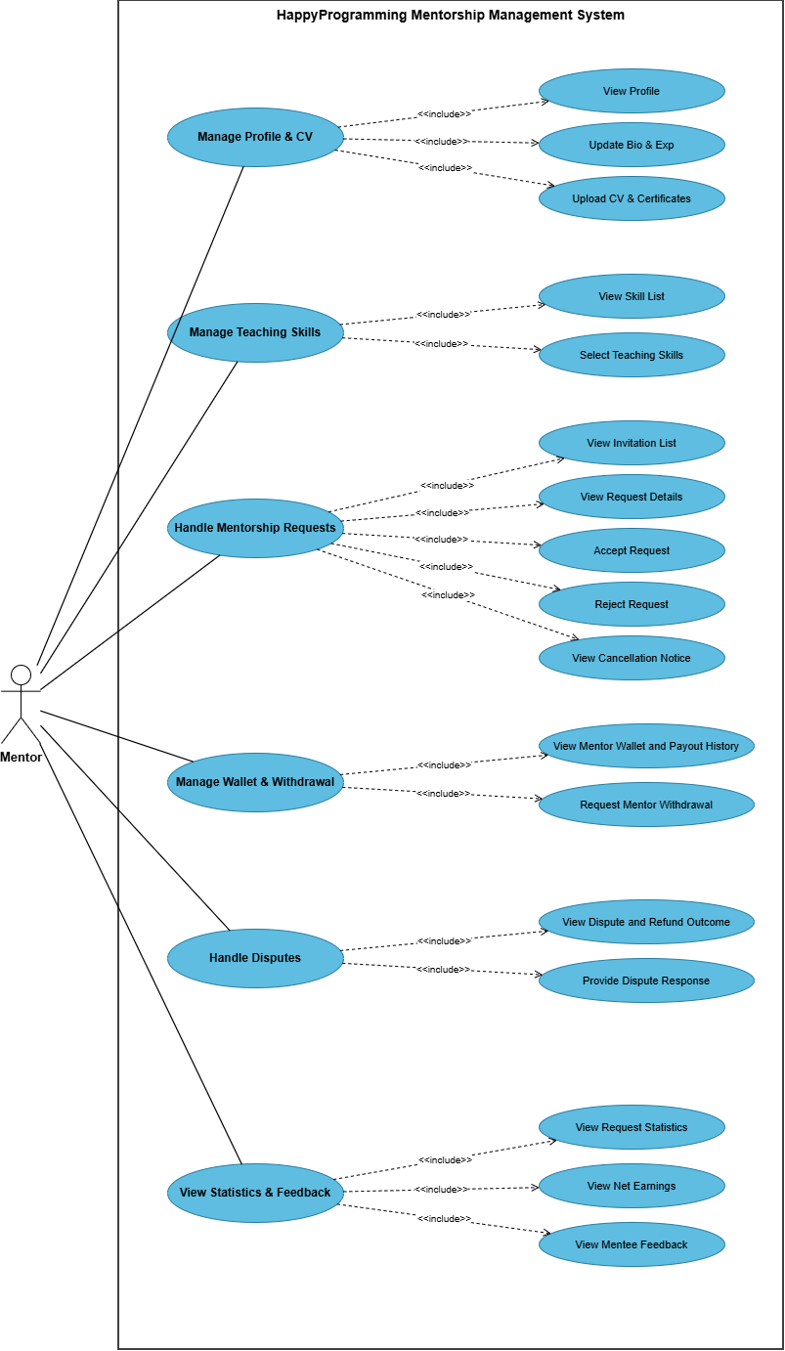

4.2.4 UCs for Staff
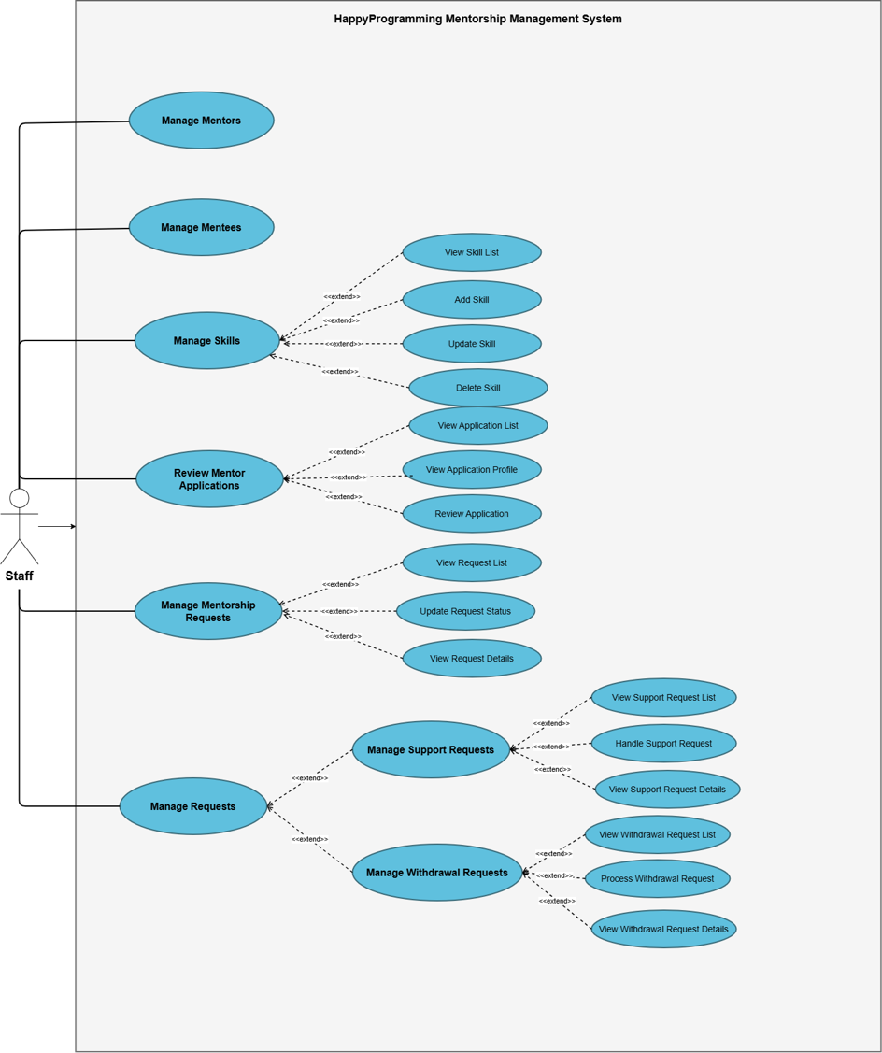

4.2.5 UCs for Admin

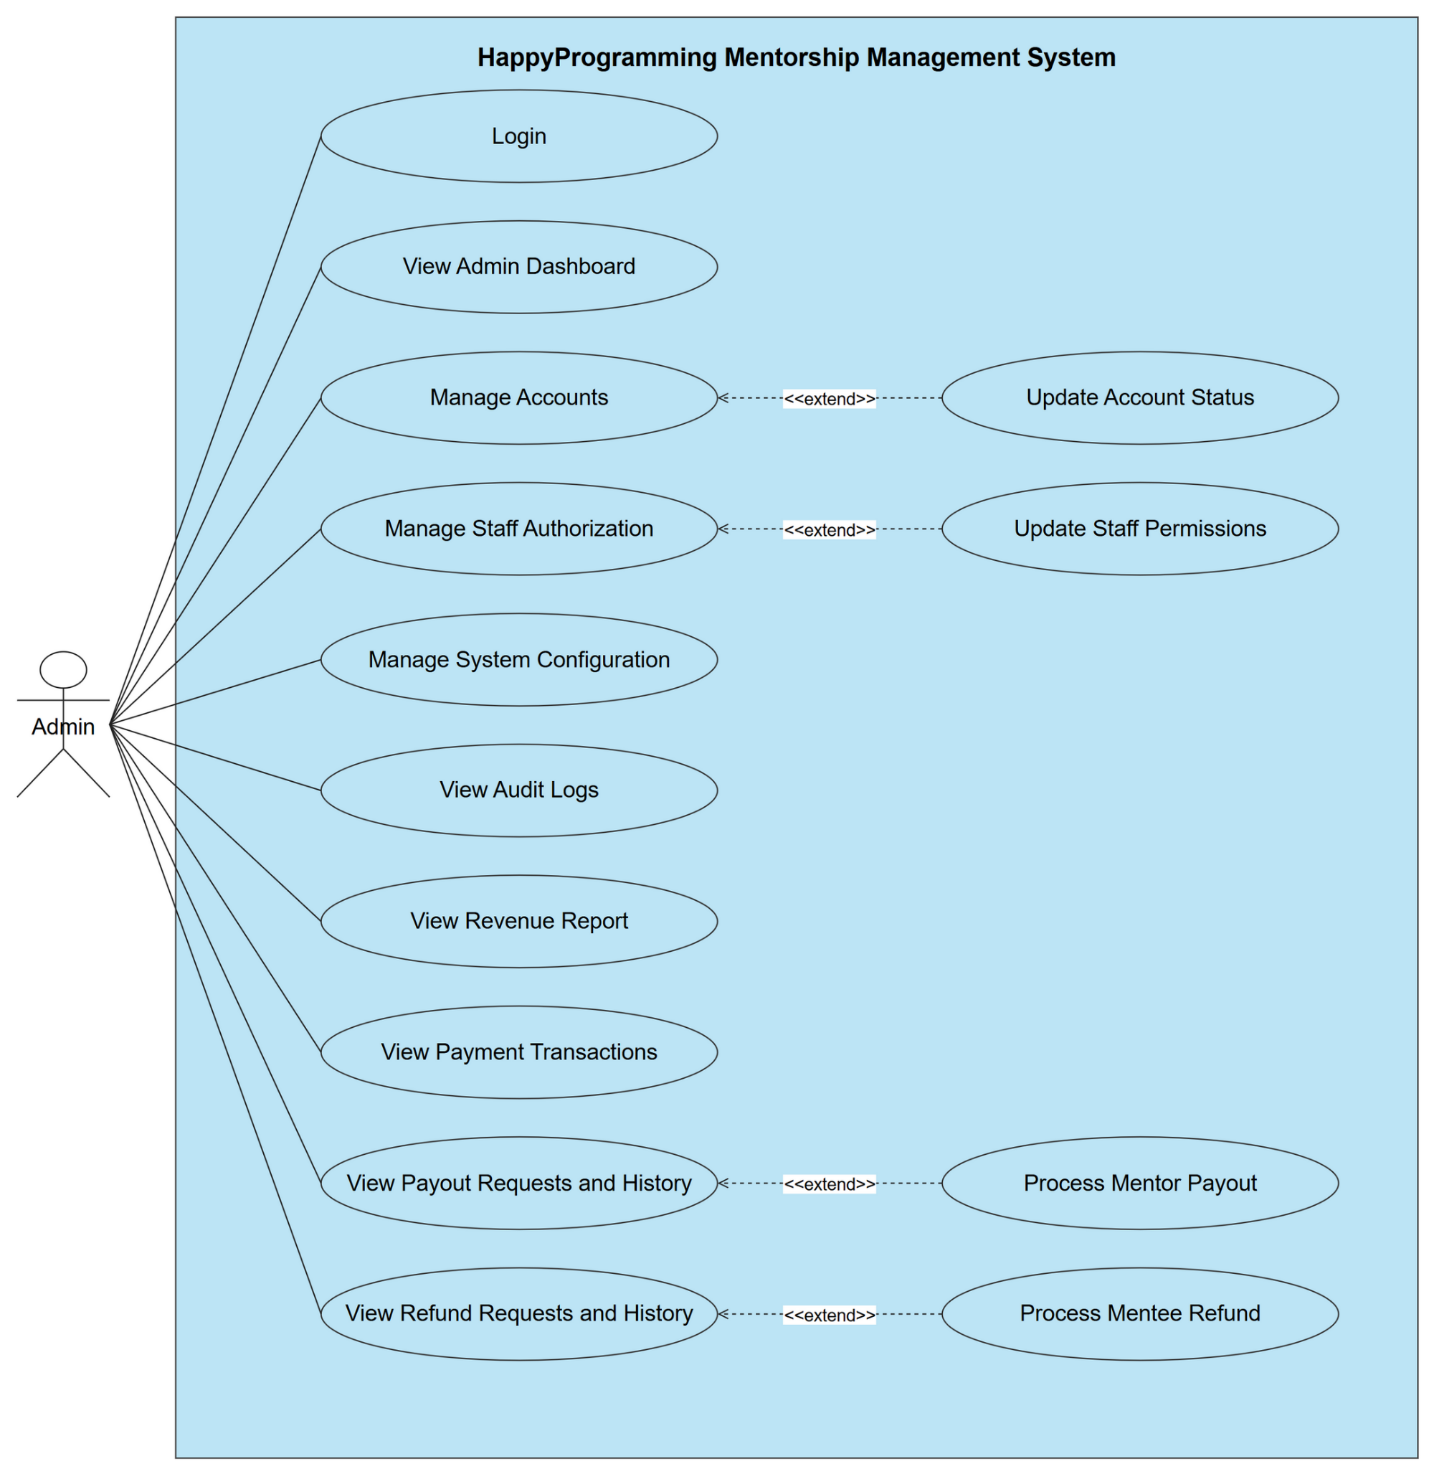

4.3 System Functionalities

4.3.1 Screen flow

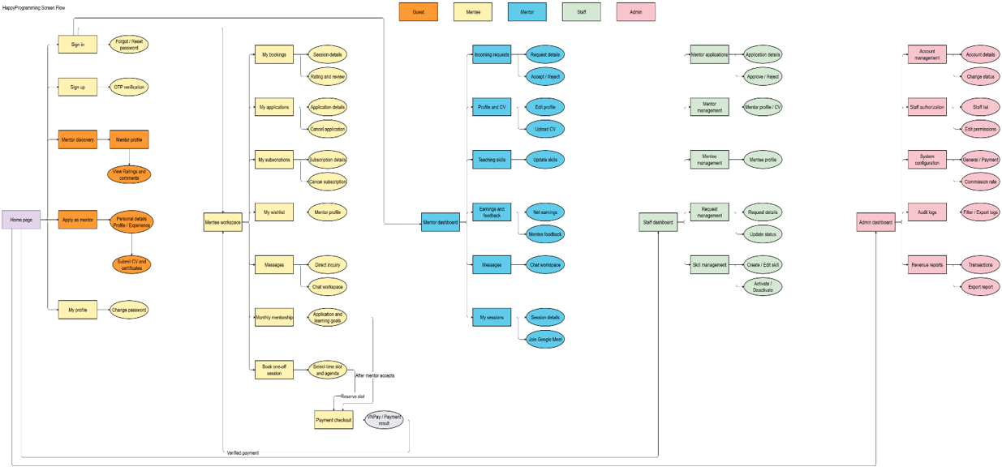

4.3.2 Non-UI Functions

# | Feature | System Function | Description
1 | Payment | SePay Payment Integration | Generate signed SePay checkout requests and process payment notifications. Verify the signature, payment reference, amount, and transaction result before updating payment and booking or subscription statuses. Repeated notifications must not cause duplicate processing.
2 | Payment | Escrow Fund Management | Record verified payments as funds held in escrow. Release eligible funds to Mentors only when the applicable service completion and settlement conditions are satisfied. Preserve transaction history through compensating or reversal entries for corrections.
3 | Payment | Commission Calculation | Calculate platform commission and Mentor net earnings using the commission rate captured for each payment. Configuration changes apply to future payments without modifying existing commission snapshots.
4 | Payment | Refund Processing | Process eligible refunds under cancellation and trial policies, including a full refund for Monthly Mentorship cancelled within the 7-day trial. Record refund results and corresponding escrow adjustments without duplicate processing. Applications closed before payment require no refund.
5 | Security | Authentication and Authorization | Validate user sessions and enforce role, permission, and resource ownership checks on protected operations. Apply individual Staff permissions granted or revoked by Admin.
6 | Security | Google OAuth2 Integration | Process Google authentication callbacks and validate authorization codes and tokens before signing in users or creating accounts.
7 | Security | Password Hashing | Hash passwords using a salted adaptive algorithm, such as BCrypt, before storage. Verify submitted passwords against stored hashes without storing plaintext or reversibly encrypted passwords.
8 | Security | Account Verification and Password Reset | Generate and validate verification links or OTPs and password-reset tokens. Enforce token expiration, single use, and request limits before activating accounts or allowing password changes.
9 | Security | Secure Data Communication | Protect client–server communication using HTTPS and secure WebSockets. Prevent credentials, authentication tokens, and integration secrets from being exposed in client content or logs.
10 | Monthly Mentorship | Application Lifecycle Processing | Record submitted applications as PENDING and start the 48-hour response deadline. Enable payment only after Mentor acceptance. Close rejected, expired, or cancelled unpaid applications without initiating refunds.
11 | Monthly Mentorship | Subscription Activation and Trial Tracking | Activate mentorship only after payment is verified for an accepted application. Record the subscription period, start the 7-day trial, and enable the mentorship workspace. Failed or cancelled payments must not activate mentorship.
12 | Booking | Slot Availability and Reservation Control | Validate Mentor availability and prevent overlapping bookings. Temporarily reserve selected slots for 10 minutes, release replaced or expired holds, and recheck reservation validity before confirming a booking.
13 | Booking | Payment and Booking Expiration | Run JOB-02 every 15 minutes to identify unpaid payments or bookings past their deadlines, update their statuses to Expired or Cancelled, release related temporary reservations, and record processing results.
16 | Messaging | Real-Time Message Processing | Validate conversation access, store messages and delivery timestamps, and deliver messages through WebSockets. Track unread messages and retain saved conversation history after reconnection.
17 | File Management | Attachment Validation and Access Control | Validate uploaded file types and sizes, reject executable files, and restrict private downloads to authorized users. Enforce the 20 MB limit for chat attachments and 10 MB limit for application documents and review evidence.
18 | Notification | Email Notification Dispatch | Send verification, password-reset, application-decision, invitation, payment, and session notifications through Gmail or the configured email service. Queue an email digest when a chat message remains unread for 15 minutes.
19 | System Monitoring | Audit Logging Service | Record sensitive operations, including account administration, Staff permission changes, system configuration updates, and financial actions, with the responsible actor, timestamp, and action details.
20 | System Monitoring | Audit Log Retention Processing | Run JOB-01 daily at 2:00 AM to delete or archive audit records older than the configured retention period. Record the number of processed entries and log failures for subsequent retry.
21 | Data Management | Database Backup Service | Perform daily database backups and restrict backup access to authorized operators. Support database restoration and complete a restoration test before deployment.

II. Requirement Specifications

1. User Account & Authentication Management

1.1 UC - Register Account

UC ID and Name: | UC01 - Register Account
Created By: | Tuantd | Date Created: | 17/09/2026
Primary Actor: | Guest | Secondary Actors: | Email Service System
Trigger: | Guest clicks on the "Register" or "Sign Up" button on the HappyProgramming platform.
Description: | As a Guest, I want to create a HappyProgramming account and complete account verification so that I can access registered-user features.
Preconditions: | PRE-1: Guest is not logged into the system.  PRE-2: Guest has a valid email address.
Postconditions: | POST-1: A new user account is created, verified, and saved in the database.  POST-2:Guest is redirected to the login page or automatically logged in.  POST-3: If registration fails, no account is created and an appropriate error message is displayed.
Normal Flow: | 1.Guest navigates to the registration page on HappyProgramming.  2.System displays the account registration form.  3.Guest inputs required information (e.g., Full Name, Email, Password, Confirm Password) and submits the form.  4.System validates the submitted information.  5.System sends a verification email with an activation link or OTP to the provided email address.  6.Guest opens the email and clicks the verification link or enters the OTP.  7.System verifies the account, activates it, and notifies the user of successful registration.
Alternative Flows: | Registration via Social Media (Google/Facebook):  1.Guest selects "Sign up with Google/Facebook".  2.System redirects to the third-party authentication service.  3.Guest authenticates and grants permissions.  4.System receives user details, creates the account, and automatically activates it.
Exceptions: | E1 – Invalid Input Data: System displays validation error messages (e.g., weak password, invalid email format) and prompts the Guest to re-enter.  E2 – Email Already Exists: System alerts the Guest that the email is already registered and suggests logging in or resetting password.  E3 – Verification Timeout/Invalid OTP: System notifies that the link/OTP has expired and offers a "Resend Code" option.
Priority: | High
Frequency of Use: | High
Business Rules: | BR-01: Passwords must be at least 8 characters long and include uppercase letters, numbers, and special characters.  BR-02: Each email address can only be associated with one account.  BR-03: Verification link/OTP is valid for 15 minutes.
Other Information: | Standard user authentication use case in UML design.
Assumptions: | Email service gateway is operational and able to send verification emails promptly.

1.2 UC - UC - Login / Register with Google

UC ID and Name: | UC03 - Login / Register with Google
Created By: | Tuantd | Date Created: | 17/09/2026
Primary Actor: | Guest | Secondary Actors: | Google Authentication Server
Trigger: | Users select the "Continue with Google" or "Login/Register with Google" option on the platform.
Description: | Allows users to authenticate through Google OAuth2. A new account may be created automatically for a first-time Google user.
Preconditions: | PRE-1: User has an active Google account.  PRE-2: User is on the Login or Registration page of HappyProgramming.
Postconditions: | POST-1: User is successfully authenticated and logged into HappyProgramming.  POST-2: If it is the user's first time logging in, a new account profile is automatically generated in the database.  POST-3: If authentication fails or is canceled, user remains unauthenticated and receives an appropriate notification.
Normal Flow: | 1.User clicks the "Continue with Google" button.  2.System redirects the user to Google’s OAuth2 consent page.  3.User enters Google credentials (if not already logged in) and grants permission to HappyProgramming.  4.Google OAuth2 validates the user credentials and sends an authorization token back to the system.  5.System verifies the token with Google Authentication Server.  6.System checks whether the Google account exists in the database:  - a. If existing: System logs the user in.  - b. If new user: System automatically creates a new account using the Google profile data and logs the user in.  7.System redirects the user to the platform home page / dashboard.
Alternative Flows: | User is already logged into Google in the browser:  1..User clicks "Continue with Google".  2.Google prompts user to select an existing account.  3.User selects the account, and the system proceeds directly from Step 4 of the Normal Flow.
Exceptions: | E1 – User cancels Google Login: User closes the Google authentication popup/page; system returns to the login page without creating an account or session.  E2 – Google OAuth Service Error: System cannot communicate with Google OAuth2 server; system alerts the user that third-party authentication is currently unavailable.  E3 – Account Linked Error / Suspended Account: If the user account is suspended, system displays an error message and denies access.
Priority: | High
Frequency of Use: | Frequent
Business Rules: | BR-01: System must only request basic profile permissions (Email, Profile Name, Avatar) from Google OAuth2.  BR-02: Accounts created via Google OAuth2 do not require separate password verification.
Other Information: | Standard OAuth2 authentication flow in UML design.
Assumptions: | Google OAuth2 API service is operational and reachable by the application server.

2. Mentor Discovery & Skill Management

2.1 UC - View Mentor List

UC ID and Name: | UC08 - View Mentor List
Created By: | Tuantd | Date Created: | 17/09/2026
Primary Actor: | Guest | Secondary Actors: | None
Trigger: | User navigates to the Mentor Discovery section or clicks "Find Mentors" on the platform.
Description: | Allows users to view available mentors on the platform.
Preconditions: | PRE-1: User is on the HappyProgramming platform.
Postconditions: | POST-1: A list of active mentors is displayed with summary profile details.
Normal Flow: | 1.User clicks on "Find Mentors" or navigates to the mentor discovery page.  2.System retrieves the list of active mentors from the database.  3.System displays the mentor list with basic details (e.g., Name, Avatar, Primary Skills, Rating)
Alternative Flows: | Pagination / Infinite Scroll:  1.User scrolls down or clicks on next page numbers.  2.System loads and displays the next set of mentors.
Exceptions: | E1 – No mentors available: System displays a message informing that no mentors are currently available.
Priority: | High
Frequency of Use: | High
Business Rules: | BR-01: Only active and verified mentor accounts are displayed in the list.
Other Information: | Core feature for mentor discovery.
Assumptions: | Platform has registered and active mentors in the system.

2.2 UC -Search / Filter Mentor by Skill

UC ID and Name: | UC09 - Search / Filter Mentor by Skill
Created By: | Tuantd | Date Created: | 17/09/2026
Primary Actor: | Guest | Secondary Actors: | None
Trigger: | User inputs a keyword into the search bar or selects skill filters on the mentor discovery page.
Description: | Allows users to find suitable mentors by selecting a target programming skill or other available search criteria.
Preconditions: | PRE-1: User is on the Mentor List page.
Postconditions: | POST-1: System displays a filtered list of mentors matching the selected skill or search criteria.
Normal Flow: | 1.User enters a skill keyword in the search bar or selects skills from the filter menu.  2.User submits the search/filter request.  3.System queries the database for mentors matching the selected criteria.  4.System updates and displays the list of matching mentors.
Alternative Flows: | Clear Filter:  1.User clicks "Reset Filters" or clears search text.  2.System resets the page to display the full mentor list.
Exceptions: | E1 – No matching results: System displays "No mentors found matching your criteria" along with suggestions to broaden search.
Priority: | High
Frequency of Use: | Very Frequent
Business Rules: | BR-01: Search supports partial text matching for skill names and mentor names.
Other Information: | Enhances user experience in finding specific domain experts.
Assumptions: | Skills tags are correctly mapped to mentor profiles in the database.

2.3 UC - View Mentor Profile

UC ID and Name: | UC10 - View Mentor Profile
Created By: | Tuantd | Date Created: | 17/09/2026
Primary Actor: | Guest | Secondary Actors: | None
Trigger: | User selects a specific mentor card/name from the mentor list.
Description: | Allows users to view a mentor profile including CV, skills, experience, service information, ratings and comments.
Preconditions: | PRE-1: User is viewing the mentor list or search results.
Postconditions: | POST-1: Detailed mentor profile page is displayed.
Normal Flow: | 1.User clicks on a mentor's profile card or name.  2.System retrieves the detailed profile information for the chosen mentor.  3.System displays the complete mentor profile page including bio, CV/experience, skill sets, available mentorship services, and overall rating/reviews.
Alternative Flows: | User clicks on booking button from profile:  1.User clicks "Book Mentorship" on the mentor's profile.  2.System initiates booking flow (executes child/related booking use cases).
Exceptions: | E1 – Profile Not Found: If the mentor account was deactivated recently, system displays an error message and redirects to the mentor list.
Priority: | High
Frequency of Use: | Very Frequent
Business Rules: | BR-01: Contact details (e.g., direct phone/email) may be hidden or masked prior to booking completion.
Other Information: | Main decision point for mentees before booking a service.
Assumptions: | Mentor profile details are regularly updated by mentors.

2.4 UC - View Skill List

UC ID and Name: | UC11 - View Skill List
Created By: | Tuantd | Date Created: | 17/09/2026
Primary Actor: | Guest | Secondary Actors: | None
Trigger: | User accesses the skill category/filter section or opens the skill selector
Description: | Allows users to view the programming skills available in the system for mentor discovery and request creation.
Preconditions: | PRE-1: User is on the mentor discovery section or request creation page.
Postconditions: | POST-1: Full or categorized list of available programming skills is displayed.
Normal Flow: | 1.User opens the skill filter or skill directory page.  2.System fetches all active programming skills from the system dictionary.  3.System displays skills categorized by topic/domain (e.g., Frontend, Backend, AI/ML).
Alternative Flows: | User selects a skill directly from the list to filter mentors.
Exceptions: | E1 – System error loading skills: System displays a notification and allows retry.
Priority: | Medium
Frequency of Use: | Frequent
Business Rules: | BR-01: Only system-approved skills are publicly visible in the skill list.
Other Information: | Acts as a master list for filtering and tagging.
Assumptions: | Skills dictionary is maintained by platform administrators.

2.5 UC -View Mentor Ratings and Comments

UC ID and Name: | UC12 - View Mentor Ratings and Comments
Created By: | Tuantd | Date Created: | 17/09/2026
Primary Actor: | Guest | Secondary Actors: | None
Trigger: | User clicks on the "Reviews", "Ratings", or comment section on a mentor's profile.
Description: | Allows users to view ratings and comments submitted by previous mentees for a mentor.
Preconditions: | PRE-1: User is on a mentor's profile page.
Postconditions: | POST-1: Ratings summary and list of mentee comments are displayed.
Normal Flow: | 1.User navigates to the reviews/ratings tab on a mentor's profile.  2.System retrieves feedback records submitted by mentees for this specific mentor.  3.System displays the overall rating score (e.g., 4.8/5.0), rating distribution, and individual mentee comments/reviews.
Alternative Flows: | Filter/Sort Reviews:  1.User chooses to sort reviews by highest/lowest rating or newest date.  2.System reorders and displays the feedback accordingly.
Exceptions: | E1 – No reviews available: System displays "No ratings or comments yet for this mentor".
Priority: | Medium
Frequency of Use: | Frequent
Business Rules: | BR-01: Only verified reviews from completed mentorship sessions are displayed.
Other Information: | Provides social proof and builds trust for potential mentees.
Assumptions: | Ratings and comments cannot be edited or deleted by the mentor directly.

2.6 UC - View Mentor Profile & Skills

UC ID and Name: | UC10 - View Mentor Profile & Skills
Created By: | Linhntn | Date Created: | 17/09/2026
Primary Actor: | Mentee | Secondary Actors: | None
Trigger: | Mentee clicks on a specific Mentor card from the mentor discovery or recommendation list
Description: | As a Mentee, I want to view a mentor's profile, bio, skills, work experience, service packages, and public ratings so that I can evaluate their suitability for my learning goals.
Preconditions: | PRE-1: Mentee is logged into HappyProgramming.  PRE-2: Mentee has navigated to the mentor directory or skill search page
Postconditions: | POST-1: Detailed Mentor profile page is displayed with active packages and public ratings.
Normal Flow: | 1. Mentee clicks on a Mentor card from the listing.  2. System retrieves and displays the Mentor Profile screen including CV, bio, verified skills, rating summary, and available packages.  3. Mentee reviews qualifications, package rates, and feedback from previous mentees.
Alternative Flows: | None
Exceptions: | E1 – Mentor profile unavailable (MSG01): System displays warning toast and redirects Mentee back to the mentor directory.
Priority: | High
Frequency of Use: | Very frequent (daily browsing activity).
Business Rules: | BR-01: Only mentors with active and approved profiles are publicly visible on the platform
Other Information: | None
Assumptions: | Mentor information, package rates, and skills are updated in real time.

2.7 UC - Save Mentor to Wishlist

UC ID and Name: | UC08 - Save Mentor to Wishlist
Created By: | Linhntn | Date Created: | 17/09/2026
Primary Actor: | Mentee | Secondary Actors: | None
Trigger: | Mentee clicks the bookmark/heart icon on a mentor card or profile
Description: | As a Mentee, I want to save a mentor to my wishlist so that I can quickly revisit, compare, and book their services later
Preconditions: | PRE-1: Mentee is logged into HappyProgramming.  PRE-2: Mentee is viewing a mentor card or profile page
Postconditions: | POST-1 : Mentor is added to wishlist; icon switches to active state.  POST-2 : Mentor is removed from wishlist; icon reverts to inactive state.
Normal Flow: | 1. Mentee clicks the "Save to Wishlist" icon on the mentor card.  2. System checks whether the mentor is already saved in Mentee's wishlist.  3. System identifies that the mentor is not yet in the wishlist.  4. System records the mentor in the Mentee's wishlist.  5. System toggles the icon to active state and displays success toast: "Mentor added to your wishlist."
Alternative Flows: | Remove from Wishlist:  1. If mentor is already saved, system removes the entry.  2. System reverts the icon to inactive and displays toast: "Mentor removed from your wishlist."
Exceptions: | E1 – Update error: System displays warning toast and leaves icon unchanged.
Priority: | Medium
Frequency of Use: | Frequent
Business Rules: | BR-02: Duplicate wishlist entries for the same mentor are disallowed.
Other Information: | None
Assumptions: | Wishlist state synchronizes immediately across the client interface.

2.8 UC - Manage Wishlist

UC ID and Name: | UC63 - Manage Wishlist
Created By: | Linhntn | Date Created: | 17/09/2026
Primary Actor: | Mentee | Secondary Actors: | None
Trigger: | Mentee selects the save button on a public mentor card/profile or opens the Saved Mentors page.
Description: | As a Mentee, I want to save, view, search, filter, sort, and remove mentors from my wishlist so that I can compare suitable mentors before booking a service.
Preconditions: | PRE-1: Mentee is logged in with an active account.  PRE-2: The selected mentor has a public and available mentor profile.  PRE-3: The selected mentor is not the Mentee's own account.
Postconditions: | POST-1: The selected mentor is saved to or removed from the current Mentee's wishlist.  POST-2: The updated wishlist state is displayed to the Mentee.  POST-3: No duplicate wishlist entry is created.
Normal Flow: | 1. Mentee opens the mentor directory or a mentor profile.  2. Mentee selects Save to Wishlist.  3. System verifies the current account is an active Mentee.  4. System verifies the mentor profile is publicly available.  5. System saves the mentor to the current Mentee's wishlist.  6. System changes the save control to its active state.  7. Mentee opens the Saved Mentors page.  8. System displays the Mentee's saved mentors.  9. Mentee may search by name, role, company or skill; filter by skill; or sort the results.
Alternative Flows: | A1 - Mentor already saved: System returns the existing saved state without creating another record.  A2 - Remove mentor: Mentee selects the active save button, and the system removes the mentor from the wishlist.  A3 - Empty wishlist: System displays an empty state and a link to browse mentors.  A4 - No matching result: System displays a no-results message and allows the Mentee to clear the filters.
Exceptions: | E1 - Unauthenticated user: System requests the user to log in.  E2 - Invalid account role or inactive account: System denies the operation.  E3 - Mentor unavailable: System reports that the mentor profile is not available.  E4 - Invalid mentor identifier: System rejects the request.  E5 - Update failure: System keeps the previous interface state and displays an error message.
Priority: | Medium
Frequency of Use: | Frequent
Business Rules: | BR-1: Only active Mentees may manage a wishlist.  BR-2: A Mentee cannot save their own mentor profile.  BR-3: Only public mentor profiles may be added.  BR-4: A mentor may appear only once in each Mentee's wishlist.  BR-5: A Mentee may access only their own wishlist.
Other Information: | Replaces and expands the existing “Save Mentor to Wishlist” specification.
Assumptions: | Public mentor information is available when the wishlist page is loaded.

3. Mentorship Booking & Contract Management

3.1. UC - Book Mentorship Service

UC ID and Name: | UC20 - Book Mentorship Service
Created By: | Linhntn | Date Created: | 17/09/2026
Primary Actor: | Mentee | Secondary Actors: | SePay, Receiving Bank
Trigger: | Mentee initiates a booking for any mentorship package on a mentor's profile.
Description: | As a Mentee, I want to book a mentorship service and complete payment so that my payment is held in escrow until the session is completed.
Preconditions: | PRE-1: Mentee is logged into HappyProgramming.  PRE-2: Mentor offers active packages (Monthly Mentorship or One-off Session).
Postconditions: | POST-1: A successful server-verified bank transfer is recorded and the corresponding amount is posted to the internal escrow ledger.  POST-2: A pending, expired, cancelled, or unmatched transfer does not activate mentorship.
Normal Flow: | 1. Mentee selects a mentorship package on the mentor profile.  2. For monthly mentorship, the system saves an application and waits for the mentor decision. For a one-off session, the system reserves the selected slot according to the booking rules.  3. When payment is permitted, the system creates a pending payment attempt with the accepted package price and a unique transfer reference.  4. The system displays the SePay-generated bank-transfer QR and exact transfer details.  5. After an authenticated SePay webhook is reconciled successfully, the system records the payment, posts the escrow hold, and advances the booking lifecycle.
Alternative Flows: | A1: If the mentee leaves checkout, the payment attempt remains pending until it is verified or expires. A2: If the payment attempt expires, the mentee may create a new attempt with a new transfer reference.
Exceptions: | E1: An invalid or unmatched webhook is rejected without changing payment or mentorship state. E2: A late or overpaid transfer is placed in reconciliation status for authorized administrative review.
Priority: | High
Frequency of Use: | Very frequent (core commercial transaction).
Business Rules: | BR-04: Mentorship services may start only after a server-verified payment has been recorded in the internal escrow ledger.
Other Information: | Abstract base use case in UML design.
Assumptions: | The HappyProgramming receiving bank account is linked to SePay, and the public webhook endpoint is available over HTTPS.

3.2. UC - Apply for Monthly Mentorship

UC ID and Name: | UC29 - Apply for Monthly Mentorship
Created By: | Linhntn | Date Created: | 17/09/2026
Primary Actor: | Mentee | Secondary Actors: | Mentor, SePay, Receiving Bank, Gmail
Trigger: | Mentee selects the "Monthly Mentorship" package and clicks "Apply".
Description: | As a Mentee, I want to submit my learning goals for mentor review and complete payment after my application is accepted so that I can start monthly mentorship with the selected mentor.
Preconditions: | PRE-1: Mentee is logged in with an active account.  PRE-2: Mentor has an active monthly package and is accepting mentees.  PRE-3: Mentee has no pending application to the same mentor.
Postconditions: | POST-1: The application and learning goals are saved with the corresponding status.  POST-2: Mentor acceptance changes the application to ACCEPTED and enables payment; mentorship and chat remain inactive.  POST-3: A verified bank transfer records the payment, posts the escrow hold, activates mentorship, and enables chat.  POST-4: Rejection, expiry, or cancellation before payment closes the application without a refund because no payment has been collected. POST-5: A pending, failed, cancelled, expired, or unmatched payment leaves mentorship inactive.
Normal Flow: | 1. Mentee selects a monthly package and enters learning goals, background, target skills, and optional project links.  2. System validates the information and displays the accepted package terms and the 48-hour mentor response policy.  3. Mentee submits the application.  4. System saves it as PENDING, starts the 48-hour response countdown, and notifies Mentor.  5. Mentor reviews and accepts the application.  6. System changes it to ACCEPTED, enables payment, and notifies Mentee.  7. Mentee opens checkout; system creates a pending payment attempt with the accepted price and unique transfer reference and displays a SePay-generated bank-transfer QR.  8. SePay sends an authenticated incoming-transaction webhook after the bank transfer arrives.  9. System verifies and reconciles the webhook, records the escrow hold, activates mentorship, and unlocks chat.
Alternative Flows: | A1 - Mentor declines: System changes the application to REJECTED, records the optional reason, and notifies Mentee. No refund is created because payment was not enabled before the decision.  A2 - Mentee cancels before payment: System changes the application to CANCELLED and closes any pending payment attempt.  A3 - Payment attempt expires: Mentorship remains inactive and the mentee may start a new payment attempt while the accepted application remains eligible.
Exceptions: | E1 - Mentor response timeout: If the mentor does not respond within 48 hours, the system expires the unpaid application and notifies Mentee.  E2 - Invalid webhook: Authentication failure, wrong receiving account, outgoing transaction, missing reference, or insufficient amount is rejected without activation.  E3 - Late or overpaid transfer: System prevents automatic activation and flags the transaction for reconciliation according to policy.
Priority: | High
Frequency of Use: | Frequent
Business Rules: | BR-05: A mentee cannot submit multiple pending applications to the same mentor simultaneously. BR-06: Mentor acceptance only enables payment. BR-07: Monthly mentorship and chat are activated only after a server-verified payment is posted to escrow.
Other Information: | Follows MentorCruise application and trial screening flow.
Assumptions: | The mentor reviews pending applications regularly, and SePay can deliver authenticated webhook notifications to the public HTTPS endpoint.

3.3. UC -Book One-Off Session

UC ID and Name: | UC29 - Book One-Off Session
Created By: | Linhntn | Date Created: | 17/09/2026
Primary Actor: | Mentee | Secondary Actors: | SePay, Receiving Bank, Gmail
Trigger: | Mentee selects a one-off consultation session (e.g., 30 or 60 minutes) on a mentor's profile.
Description: | As a Mentee, I want to select an available time and pay upfront to confirm a one-off session without Mentor approval.
Preconditions: | PRE-1: Mentee is logged in.  PRE-2: Mentor has published the session and configured availability in HappyProgramming.
Postconditions: | POST-1: Payment and booking are confirmed.  POST-2: The selected time is unavailable to others.  POST-3: The Mentor–Mentee workspace is created or reused.
Normal Flow: | 1. Mentee selects a session offering.  2. System displays available times from the Mentor’s internal schedule.  3. Mentee selects the time, quantity, participants, and enters an agenda.  4. System temporarily holds the required time range.  5. Mentee pays using the SePay QR.  6. The authenticated SePay webhook verifies the payment.  7. System confirms the booking and opens the workspace.
Alternative Flows: | Mentee may select another available time before payment.
Exceptions: | E1: Selected time is no longer available.  E2: Slot hold or payment expires.  E3: Invalid payment does not confirm the booking.
Priority: | High
Frequency of Use: | Very frequent (daily core feature).
Business Rules: | BR-07: One-off sessions are confirmed automatically upon payment without manual mentor screening.  BR-08: Cancellation at least 24 hours in advance gives a 100% refund; cancellation under 24 hours retains a 50% reservation fee for the mentor.
Other Information: | Scheduling is managed inside HappyProgramming. Mentor may send an external meeting link through the workspace.
Assumptions: | Mentor maintains an accurate availability schedule on Google Calendar.

3.4. UC -Submit Learning Goals

UC ID and Name: | UC21 - Submit Learning Goals
Created By: | Linhntn | Date Created: | 17/09/2026
Primary Actor: | Mentee | Secondary Actors: | None
Trigger: | Automatically triggered as a mandatory step in Apply for Monthly Mentorship (UC05).
Description: | As a Mentee, I want to submit my learning goals, current background, and project links so that the mentor has full context to assess my application.
Preconditions: | PRE-1: Mentee is in the application step of Apply for Monthly Mentorship
Postconditions: | POST-1: Learning goals data is validated and attached to the application payloa
Normal Flow: | 1. System displays questionnaire modal (Experience level, Target topics, Goals description, Project links).  2. Mentee selects experience level and chooses target skills.  3. Mentee enters detailed goals description (minimum 50 characters).  4. Mentee provides optional repository or portfolio links.  5. Mentee clicks "Confirm Goals".  6. System validates input constraints and attaches data to the application session.  7. System returns control to the parent application flow.
Alternative Flows: | None
Exceptions: | E1 – Validation error: Required fields empty or description is under 50 characters; system highlights errors with prompt: "Please describe your learning goals (minimum 50 characters)."
Priority: | High
Frequency of Use: | Frequent.
Business Rules: | BR-09: Goals description must contain at least 50 characters to ensure meaningful evaluation.
Other Information: | None
Assumptions: | Mentee inputs accurate background information.

3.5. UC - Select Time Slot

UC ID and Name: | UC20 - Select Time Slot
Created By: | Linhntn | Date Created: | 17/09/2026
Primary Actor: | Mentee | Secondary Actors:
Trigger: | Automatically triggered as a mandatory step in Book One-Off Session (UC06).
Description: | As a Mentee, I want to view open calendar slots and pick a meeting time so that our session is reserved.
Preconditions: | PRE-1: Mentee has initiated Book One-Off Session.  PRE-2: The mentor has configured active availability in HappyProgramming.
Postconditions: | POST-1: A specific time slot is selected and placed under a 10-minute temporary reservation lock.
Normal Flow: | 1. System displays interactive calendar with bookable dates.  2. Mentee selects a specific date.  3. System renders available time blocks for that day.  4. Mentee selects a preferred time slot.  5. System verifies slot availability in real time and places a temporary 10-minute lock to prevent collisions.  6. System stores selected slot parameters (start_time, end_time) and returns control to parent flow.
Alternative Flows: | Step 4_1. Mentee changes slot selection:  1. Mentee selects another slot.  2. System releases the previous lock and locks the newly chosen slot.
Exceptions: | E1 – No slots available: System displays: "No open slots found for this date. Please pick another date."  E2 – Collision lock: Another user reserved the slot seconds prior; system notifies and refreshes available slots.
Priority: | High
Frequency of Use: | Very frequent.
Business Rules: | BR-10: Temporary reservation locks expire automatically after 10 minutes if payment is not completed.  BR-11: Sessions must be booked at least 2 hours in advance of start time.
Other Information: | None
Assumptions: | Time zone conversions are handled automatically based on user's browser setting.

3.6. Manage / Cancel Subscription

UC ID and Name: | UC23 - Manage / Cancel Subscription
Created By: | Linhntn | Date Created: | 17/09/2026
Primary Actor: | Mentee | Secondary Actors: | None
Trigger: | Mentee opens "My Subscriptions" dashboard and selects an active monthly mentorship.
Description: | As a Mentee, I want to review my monthly subscription and turn off auto-renewal so that I am not billed for subsequent cycles while retaining access until current period ends.
Preconditions: | PRE-1: Mentee is logged into HappyProgramming.  PRE-2: Mentee has an ongoing monthly mentorship subscription within its active period.
Postconditions: | POST-1: Auto-renewal is disabled and package is set to conclude at the end of the prepaid period.  POST-2: Mentee retains access to chat workspace and mentorship activities until the current period expires.  POST-3: Confirmation email is dispatched to Mentee and notification sent to Mentor via Gmail.
Normal Flow: | 1. Mentee navigates to "My Subscriptions" screen.  2. System displays active subscription details (Mentor name, start/end dates, monthly rate, renewal status).  3. Mentee clicks "Cancel Subscription".  4. System displays confirmation modal explaining that mentorship access continues until current period end with no subsequent charges.  5. Mentee selects cancellation reason and confirms.  6. System updates subscription to turn off recurring billing and registers termination at the end of current cycle.  7. System sends cancellation confirmation to Mentee and notifies Mentor via Gmail.  8. System displays confirmation toast: "Subscription cancelled. Mentorship access remains active until the end of the current billing cycle."
Alternative Flows: | Step 5_1. Cancellation within 7-Day Trial Window:  1. Mentee cancels within the initial 7 days of package start.  2. System terminates access immediately and triggers a full 100% refund of escrowed fees back to Mentee.
Exceptions: | E1 – Modal dismissed: Mentee closes modal without confirming; subscription remains active.
Priority: | Medium
Frequency of Use: | Low (periodic account management).
Business Rules: | BR-17: Cancellations take effect at the conclusion of the prepaid period, except within the 7-day trial period.  BR-18: Cancelled subscriptions cannot be reactivated automatically; a new application is required to resume.
Other Information: | None
Assumptions: | Billing schedules are calculated using standard system date and time.

4. Payment & Escrow Management

4.1. UC - Process Payment via Gateway

UC ID and Name: | UC30 - Process Bank Transfer Payment via SePay
Created By: | Linhntn | Date Created: | 17/09/2026
Primary Actor: | Mentee | Secondary Actors: | SePay, Receiving Bank
Trigger: | Automatically executed as a mandatory step in the Book Mentorship Service workflow.
Description: | As a Mentee, I want to pay by scanning a bank-transfer QR or copying exact transfer details so that the system can verify the incoming transfer and hold the paid amount in the internal escrow ledger.
Preconditions: | PRE-1: The booking or accepted mentorship application is eligible for payment.  PRE-2: The accepted package price is available and immutable for this payment attempt.  PRE-3: SePay and receiving-bank configuration is enabled.
Postconditions: | POST-1 (Verified): Payment is marked SUCCEEDED, the transaction is recorded idempotently, funds are posted to the internal escrow ledger, and the eligible mentorship or booking is activated.  POST-2 (Pending/Expired): Mentorship remains inactive.  POST-3 (Reconciliation): A late, unmatched, insufficient, or overpaid transfer is retained for authorized review without automatic activation.
Normal Flow: | 1. Backend creates a PENDING payment attempt containing the exact payable amount, expiry time, and unique transfer reference.  2. Backend returns the SePay-generated bank-transfer QR URL and receiving-bank details.  3. Checkout displays the QR, bank name, account number, account holder, exact amount, transfer reference, expiry countdown, and pending status.  4. Mentee completes the bank transfer.  5. Receiving bank records the incoming transaction and SePay sends the transaction webhook to HappyProgramming.  6. Backend authenticates the webhook and verifies the event identifier, incoming direction, receiving account, transfer reference, amount, and payment eligibility.  7. Backend processes the event idempotently, marks payment SUCCEEDED, records funded time, posts the escrow hold, and activates the booking or mentorship in one transaction.  8. Frontend polling observes the server-confirmed status and displays payment confirmation.
Alternative Flows: | A1 - Mentee leaves checkout: The attempt stays PENDING until verification or expiry.  A2 - Attempt expires without payment: System marks it EXPIRED and allows a new attempt with a new transfer reference.  A3 - Duplicate webhook: Backend returns a successful idempotent response without creating duplicate payment, escrow, wallet, or mentorship records.
Exceptions: | E1 - Authentication failure: Reject webhook and log the event without exposing credentials.  E2 - Wrong account, outgoing transaction, unknown reference, or insufficient amount: Do not settle payment.  E3 - Late or overpaid transfer: Mark for reconciliation and notify authorized staff.  E4 - Temporary processing failure: Return a retryable error so SePay may redeliver the webhook.
Priority: | High
Frequency of Use: | Very frequent (all paid bookings).
Business Rules: | BR-12: Payment attempts expire after 15 minutes.  BR-13: Client-side actions cannot mark a payment as successful.  BR-14: Each SePay event and transfer reference must be processed idempotently.  BR-15: Automatic settlement requires an authenticated incoming transfer to the configured account with the expected reference and exact amount.  BR-16: Verified funds are posted to the internal escrow ledger and remain held until the configured release conditions are met.
Other Information: | The QR is displayed within HappyProgramming checkout. Actual funds are received by the configured HappyProgramming bank account; SePay supplies QR and transaction-notification services.
Assumptions: | The public webhook endpoint is reachable over HTTPS, webhook credentials are configured securely, and the linked receiving account is active.

4.2. UC - View Transaction History

UC ID and Name: | UC54 - View Transaction History
Created By: | Linhntn | Date Created: | 17/09/2026
Primary Actor: | Mentee | Secondary Actors: | None
Trigger: | Mentee opens My Transactions from their account menu.
Description: | As a Mentee, I want to view my payment history and payment attempts so that I can check their amounts, statuses and SePay references.
Preconditions: | PRE-1: Mentee is logged in.  PRE-2: The current account has the Mentee role.
Postconditions: | POST-1: Transactions belonging to the current Mentee are displayed.  POST-2: No payment or booking state is changed.
Normal Flow: | 1. Mentee opens My Transactions.  2. System identifies the authenticated Mentee.  3. System retrieves payment records associated with the Mentee's mentorship requests.  4. System orders transactions by creation time, newest first.  5. System displays mentor, package/session, service type, amount, currency, payment status and transaction date.  6. Mentee filters transactions by payment status or service type.  7. Mentee selects Details for a transaction.  8. System displays the payment reference and SePay transaction identifier when available.
Alternative Flows: | A1 - No transactions: System displays an empty history state and a link to browse mentors.  A2 - No matching transactions: System displays that no records match the selected filters.  A3 - Pending attempt: System displays the creation date when no paid date is available.  A4 - Missing provider reference: System displays an empty placeholder without changing the transaction.
Exceptions: | E1 - Unauthenticated user: System redirects the user to login.  E2 - Non-Mentee account: System denies access.  E3 - Retrieval failure: System displays an error and leaves all payment records unchanged.
Priority: | Medium
Frequency of Use: | Occasional
Business Rules: | BR-1: Mentees may view only payments associated with their own mentorship requests.  BR-2: Transaction history is read-only.  BR-3: Supported displayed statuses include Paid, Pending, Expired, Cancelled and Failed.  BR-4: Both monthly and one-off payment attempts are included.  BR-5: Paid time is displayed when available; otherwise, creation time is displayed.
Other Information: | The history includes successful payments as well as incomplete payment attempts.
Assumptions: | Payment and mentorship request records remain associated through the request identifier.

4.3. UC Upload Dispute Evidence and Refund Details

UC ID and Name: | UC56 - Upload Dispute Evidence and Refund Details
Created By: | Linhntn | Date Created: | 17/09/2026
Primary Actor: | Mentee | Secondary Actors: | Staff, Admin
Trigger: | Mentee provides evidence while submitting a dispute.
Description: | Allows a Mentee to upload dispute evidence and optionally provide bank details for an approved refund.
Preconditions: | PRE-1: Mentee is logged in.  PRE-2: The paid service belongs to the Mentee and is within the dispute period.  PRE-3: No active dispute exists for the same servic
Postconditions: | POST-1: Evidence and optional bank details are attached to the dispute.  POST-2: The information is available to authorized Staff and Admin users.
Normal Flow: | 1. Mentee selects an eligible service.  2. Mentee uploads 1–5 evidence images.  3. Mentee optionally enters refund bank details.  4. Mentee confirms the information is authentic.  5. System validates and stores the evidence and bank details.  6. System continues the dispute submission.
Alternative Flows: | A1: Mentee submits without bank details.  A2: Mentee changes the selected evidence before submission.
Exceptions: | E1: No evidence or more than five images are selected.  E2: File type is unsupported or file size exceeds 5 MB.  E3: The service is not eligible or already has an active dispute.  E4: Mentee does not confirm evidence authenticity.
Priority: | High
Frequency of Use: | Occasional
Business Rules: | BR-1: Evidence must contain 1–5 PNG, JPG, JPEG or WEBP images.  BR-2: Each image must not exceed 5 MB.  BR-3: Bank details are optional.  BR-4: Only the service owner may submit evidence.  BR-5: Evidence is accessible only to authorized users.
Other Information: | None
Assumptions: | Staff and Admin can securely access the submitted information.

5. Request & Invitation Management

6. Mentorship Workspace & Communication

6.1. UC - Chat in Direct Messaging

UC ID and Name: | UC32 - Chat in Direct Messaging
Created By: | Linhntn | Date Created: | 17/09/2026
Primary Actor: | Mentee | Secondary Actors: | Mentor
Trigger: | Mentee opens the Messages menu or clicks "Open Chat" from an active booking or subscription.
Description: | As a Mentee, I want to exchange real-time text messages, code snippets, and files with my mentor to facilitate learning
Preconditions: | PRE-1: Mentee is logged into HappyProgramming.  PRE-2: Mentee has an active subscription, confirmed session, or open inquiry with the mentor.
Postconditions: | POST-1: Messages and attachments are stored and delivered in real time to the mentor's chat window.  POST-2: Unread counter increments if recipient is offline.
Normal Flow: | 1. Mentee opens the Chat Workspace and selects the conversation with Mentor.  2. The system loads message history and renders the chat interface.  3. Mentee types text or attaches an allowed file (.pdf, .zip, source code) and clicks "Send".  4. The system validates the message body and verifies file format and size.  5. The system stores the message with a delivery timestamp.  6. The system broadcasts the message in real time to Mentor's active session.  7. The system displays a message bubble with delivered indicator checkmarks.
Alternative Flows: | Mentor is offline:  1. System marks the message as unread.  2. System enqueues an email digest notification if message remains unread for 15 minute
Exceptions: | E1 – Disallowed file format or size: Upload exceeds 20MB or is an executable file (.exe); system rejects upload with warning toast (MSG06).  E2 – Real-time connection dropped: System displays a reconnecting notice.
Priority: | High
Frequency of Use: | Daily / Continuous (core mentorship communication).
Business Rules: | BR-14: Only users with active bookings or approved inquiries can initiate conversations.
Other Information: | Operates via WebSockets for real-time messaging.
Assumptions: | Both parties use standard modern browsers supporting real-time web protocols.

6.2. UC - Join 1-on-1 Video Call

UC ID and Name: | UC33 - Join 1-on-1 Video Call
Created By: | Linhntn | Date Created: | 17/09/2026
Primary Actor: | Mentee | Secondary Actors: | Mentor
Trigger: | Mentee opens a confirmed session from My Bookings.
Description: | As a Mentee, I want to open the session workspace to view its schedule and communicate with my Mentor.
Preconditions: | PRE-1: Mentee is logged in.  PRE-2: The session is confirmed.  PRE-3: Mentee belongs to the booking.
Postconditions: | Mentee can view session information and exchange messages or files with the Mentor.
Normal Flow: | 1. Mentee opens My Bookings.  2. Mentee selects a confirmed session.  3. System opens the private workspace.  4. Mentee views the schedule and messages.  5. Mentor may share an external meeting link through the workspace.
Alternative Flows: | Mentee may copy an external meeting link from the conversation and open it separately.
Exceptions: | E1: Booking is unavailable or cancelled.  E2: Unauthorized users cannot access the workspace.
Priority: | High
Frequency of Use: | Frequent (at each scheduled session time).
Business Rules: | BR-15: Only the assigned Mentor and Mentee may access the booking workspace. External meeting links are treated as private messages.
Other Information: | None
Assumptions: | Mentor provides any required external meeting link before the session.

6.3. UC - View Notification

UC ID and Name: | UC55 - View Notifications
Created By: | Linhntn | Date Created: | 17/09/2026
Primary Actor: | Mentee | Secondary Actors: | None
Trigger: | Mentee selects the notification bell or opens Notification.
Description: | As a Mentee, I want to view and manage my notifications so that I can follow booking, payment, workspace and dispute updates.
Preconditions: | PRE-1: Mentee is logged into HappyProgramming.
Postconditions: | POST-1: Notifications belonging to the current Mentee are displayed.  POST-2: A selected notification may be marked as read.  POST-3: The Mentee may mark all their notifications as read.  POST-4: The unread counter is updated.
Normal Flow: | 1. Mentee opens Notification History.  2. System retrieves the first page of the Mentee's notifications, ordered from newest to oldest.  3. System displays each notification's title, message, creation time and read status.  4. System displays the total unread count.  5. Mentee may filter the list to show all or unread notifications.  6. Mentee may navigate between notification pages.  7. Mentee selects Mark as read for one notification or Mark all as read.  8. System updates only the current Mentee's notification records.  9. Mentee may open the page related to a notification.
Alternative Flows: | A1 - No notifications: System displays an empty notification state.  A2 - No unread notifications: System disables Mark all as read.  A3 - Open related page: System marks the notification as read before navigating when required.  A4 - Unread filter empty: System reports that there are no unread notifications.
Exceptions: | EE1 - Unauthenticated user: System requests login.  E2 - Invalid page or page size: System rejects the request.  E3 - Notification does not belong to the Mentee: System does not update it.  E4 - Retrieval failure: System displays a retry action.  E5 - Read-status update failure: System keeps the notification unchanged and displays an error.
Priority: | Medium
Frequency of Use: | Frequent
Business Rules: | BR-1: A user may view and update only their own notifications.  BR-2: History pages are ordered by creation time and notification ID in descending order.  BR-3: Page numbers cannot be negative.  BR-4: Page size must be between 1 and 50.  BR-5: The history page uses 10 notifications per page by default.  BR-6: Related-page navigation uses the stored notification action URL.
Other Information: | None
Assumptions: | Notification action URLs reference valid application routes.

7. Feedback & Rating Management

7.1. UC - Submit Rating & Review
UC ID and Name: | UC34 - Submit Rating & Review
Created By: | Linhntn | Date Created: | 17/09/2026
Primary Actor: | Mentee | Secondary Actors: | Mentor, Gmail
Trigger: | Mentee clicks "Leave a Review" on a completed booking
Description: | As a Mentee, I want to rate the mentor from 1 to 5 stars and submit written comments to share my feedback and help other mentees.
Preconditions: | PRE-1: Mentee is logged into HappyProgramming.  PRE-2: Booking session status is completed.  PRE-3: Mentee has not already submitted a review for this booking.
Postconditions: | POST-1: Star score and feedback comment are stored in the system.  POST-2: Mentor's average rating is recalculated and updated on their public profile.  POST-3: Mentor is notified of the new review via Gmail
Normal Flow: | 1. Mentee opens the completed booking item and clicks "Leave a Review".  2. System verifies review eligibility (session is completed and not yet reviewed).  3. System renders the review modal with a 1 to 5 star selector and comment text area.  4. Mentee selects star rating and writes feedback comment.  5. Mentee clicks "Submit Review".  6. System validates inputs (star rating selected, comment between 10 and 500 characters, passes content moderation).  7. System saves the review and recalculates Mentor's average rating.  8. System dispatches a notification to Mentor via Gmail and displays success toast: "Review submitted successfully."
Alternative Flows: | Edit existing review within 7 days:  1. Mentee opens a review submitted within the past 7 days.  2. The system enables editing star scores and comments.  3. System updates the review and recalculates Mentor's average rating.
Exceptions: | E1 – Ineligible review attempt: Mentee attempts to review an uncompleted or already reviewed booking; system shows warning toast and disables submission.  E2 – Prohibited language detected: System flags inappropriate words and prompts Mentee to revise.
Priority: | Medium
Frequency of Use: | Moderate (once per completed mentorship engagement).
Business Rules: | BR-19: Only mentees with verified, completed bookings can submit reviews (Verified Review Policy).  BR-20: Mentors cannot delete or edit mentee reviews; moderation requests must be submitted to Admin.
Other Information: | Reviews directly influence mentor search placement.
Assumptions: | Mentor average rating recalculates immediately upon submission.

8. System Administration & Operation Management

8.1. UC - Manage Accounts

UC ID and Name: | UC40 - Manage Accounts
Created By: | LuongBD | Date Created: | 18/09/2026
Primary Actor: | Admin | Secondary Actors: | None
Trigger: | Admin selects the Account Management section.
Description: | As an Admin, I want to manage platform accounts so that I can monitor user access and maintain valid account statuses.
Preconditions: | PRE-1: Admin is authenticated and authorized.  PRE-2: Account data is available in the system.
Postconditions: | POST-1: Account management workspace is displayed.  POST-2: Any completed account status change is stored and audit logged.
Normal Flow: | 1. Admin opens Account Management.  2. The system displays the account management workspace.  3. Admin executes an applicable child use case: View Account List (UC41), View Account Detail (UC42), or Update Account Status (UC43).  4. System returns Admin to the account management workspace after the selected operation.
Alternative Flows: | A1 - Admin leaves the module without making changes: System keeps all account data unchanged.
Exceptions: | E1 - Account management data cannot be loaded: System displays an error message and allows Admin to retry.
Priority: | Hight
Frequency of Use: | Frequent
Business Rules: | BR-21: Only authenticated Admin users may access administration functions.  BR-22: Account status changes must be recorded in the audit log.
Other Information: | Parent use case for account administration functions shown in the Admin use case diagram.
Assumptions: | User account records are maintained by the HappyProgramming database.

8.2. UC - View Account List

UC ID and Name: | UC41 - Manage Accounts
Created By: | LuongBD | Date Created: | 18/09/2026
Primary Actor: | Admin | Secondary Actors: | None
Trigger: | Admin opens Account Management or selects View Account List.
Description: | As an Admin, I want to view the list of user accounts so that I can identify accounts that require administrative review.
Preconditions: | PRE-1: Admin is authenticated and authorized.  PRE-2: Admin has opened Account Management.
Postconditions: | POST-1: The account list is displayed.  POST-2: No account data is modified.
Normal Flow: | 1. Admin selects View Account List.  2. System retrieves account records.  3. The system displays available account information and current account status.  4. Admin reviews the list and may select an account to view details.
Alternative Flows: | A1 - No accounts found: System displays an empty state.
Exceptions: | E1 - Account retrieval failure: System displays an error message and allows Admin to retry.
Priority: | Hight
Frequency of Use: | Frequent
Business Rules: | BR-21: Only authenticated Admin users may access administration functions.
Other Information: | Extends Manage Accounts (UC40).
Assumptions: | Account records are available and readable from the system database

8.3. UC - View Account Detail

UC ID and Name: | UC42 - View Account Detail
Created By: | LuongBD | Date Created: | 18/09/2026
Primary Actor: | Admin | Secondary Actors: | None
Trigger: | Admin selects a specific account from the account list.
Description: | As an Admin, I want to view detailed information of a selected account so that I can review the account before taking administrative action.
Preconditions: | PRE-1: Admin is authenticated and authorized.  PRE-2: The selected account exists.
Postconditions: | POST-1: Detailed information for the selected account is displayed.  POST-2: No account data is modified.
Normal Flow: | 1. Admin selects an account from View Account List.  2. System retrieves the selected account record.  3. The system displays the account detail view, including the information and current status stored by Happy Programming.  4. Admin reviews the account information.
Alternative Flows: | None
Exceptions: | E1 - Account not found: System notifies Admin and returns to the account list.  E2 - Account detail retrieval failure: System displays an error message.
Priority: | Medium
Frequency of Use: | Frequent
Business Rules: | BR-21: Only authenticated Admin users may access administration functions.
Other Information: | Extends Manage Accounts (UC40).
Assumptions: | The selected account identifier is valid when the request is made.

8.4. UC - Manage Staff Authorization

UC ID and Name: | UC44 - Manage Staff Authorization
Created By: | LuongBD | Date Created: | 18/09/2026
Primary Actor: | Admin | Secondary Actors: | None
Trigger: | Admin selects the Staff Authorization section.
Description: | As an Admin, I want to manage Staff authorization so that Staff access is limited to the operational functions assigned to them.
Preconditions: | PRE-1: Admin is authenticated and authorized.  PRE-2: Staff accounts exist in the system.
Postconditions: | POST-1: Staff authorization workspace is displayed.  POST-2: Any completed permission change is saved and audit logged.
Normal Flow: | 1. Admin opens Staff Authorization.  2. The system displays the Staff authorization workspace.  3. Admin executes an applicable child use case: View Staff List (UC45) or Update Staff Permissions (UC46).  4. System returns Admin to the Staff authorization workspace after the selected operation.
Alternative Flows: | A1 - Admin exits without changing permissions: Existing Staff permissions remain unchanged.
Exceptions: | E1 - Staff authorization data cannot be loaded: System displays an error message and allows Admin to retry.
Priority: | High
Frequency of Use: | Occasional
Business Rules: | BR-23: Only Admin may change Staff authorization.  BR-24: Staff permission changes must be recorded in the audit log.
Other Information: | Parent use case for Staff authorization functions shown in the Admin use case diagram.
Assumptions: | The system has a defined set of permissions that may be assigned to Staff accounts.

8.5. UC - View Staff List

UC ID and Name: | UC45 - View Staff List
Created By: | LuongBD | Date Created: | 18/09/2026
Primary Actor: | Admin | Secondary Actors: | None
Trigger: | Admin opens Staff Authorization or selects View Staff List.
Description: | As an Admin, I want to view Staff accounts so that I can review which users currently have Staff access.
Preconditions: | PRE-1: Admin is authenticated and authorized.  PRE-2: Admin has opened Staff Authorization. .
Postconditions: | POST-1: The Staff account list is displayed.  POST-2: No Staff permission is modified.
Normal Flow: | 1. Admin selects View Staff List.  2. System retrieves accounts assigned to the Staff role.  3. The system displays the Staff list and current authorization information available for each Staff account.  4. Admin may select a Staff account to update permissions.
Alternative Flows: | A1 - No Staff accounts found: System displays an empty state.
Exceptions: | E1 - Staff list retrieval failure: System displays an error message.
Priority: | Medium
Frequency of Use: | Occasional
Business Rules: | BR-23: Only Admin may access Staff authorization management
Other Information: | Extends Manage Staff Authorization (UC44).
Assumptions: | Staff role assignments are available in the account data.

8.6. UC - Update Staff Permissions

UC ID and Name: | UC45 - View Staff List
Created By: | LuongBD | Date Created: | 18/09/2026
Primary Actor: | Admin | Secondary Actors: | None
Trigger: | Admin selects a Staff account and chooses to edit its permissions.
Description: | As an Admin, I want to update Staff permissions so that each Staff account can access only the operational functions assigned by the platform administrator.
Preconditions: | PRE-1: Admin is authenticated and authorized.  PRE-2: The selected account has the Staff role.  PRE-3: The system has a defined permission set for Staff.
Postconditions: | POST-1: Updated Staff permissions are saved when the operation succeeds.  POST-2: The permission change is recorded in the audit log.
Normal Flow: | 1. Admin selects a Staff account from the Staff list.  2. System displays the Staff account and current permissions.  3. Admin changes one or more available permissions.  4. Admin clicks Save.  5. System validates the selected permissions.  6. System saves the updated authorization.  7. System records the action in the audit log.  8. System displays a success message.
Alternative Flows: | A1 - Admin cancels editing: System discards unsaved permission changes.
Exceptions: | E1 - Selected account is no longer Staff: System blocks the update and refreshes the Staff list.  E2 - Permission update failure: System keeps the previous permissions and displays an error message.
Priority: | Hight
Frequency of Use: | Occasional
Business Rules: | BR-23: Only Admin may change Staff authorization.  BR-24: Staff permission changes must be recorded in the audit log.
Other Information: | Extends Manage Staff Authorization (UC44).
Assumptions: | Permission changes become effective according to the system authorization mechanism after they are saved.

8.7. UC - Manage System Configuration

UC ID and Name: | UC47 - Manage System Configuration
Created By: | LuongBD | Date Created: | 18/09/2026
Primary Actor: | Admin | Secondary Actors: | None
Trigger: | Admin selects System Configuration from the administration interface.
Description: | As an Admin, I want to manage system-wide configuration so that HappyProgramming can operate using the platform settings approved by the administrator.
Preconditions: | PRE-1: Admin is authenticated and authorized.  PRE-2: System configuration data is available.
Postconditions: | POST-1: Valid configuration changes are saved.  POST-2: Configuration changes are recorded in the audit log.  POST-3: Updated commission rates immediately apply to future booking checkouts.
Normal Flow: | 1. Admin opens System Configuration.  2. System retrieves and displays general settings, payment gateways, and financial commission parameters.  3. Admin updates general values or enters new percentage rates for platform commissions.  4. Admin clicks Save Configuration.  5. System validates numeric constraints.  6. System saves updated configuration values into system database.  7. System writes an audit log entry for administrative traceability.  8. System displays confirmation toast: "Configuration saved successfully."
Alternative Flows: | A1 - Admin cancels before saving: System leaves the existing configuration unchanged.
Exceptions: | E1 - Invalid configuration value: System highlights the invalid field and does not save changes.  E2 - Save failure: System keeps the previous configuration and displays an error message. .
Priority: | Hight
Frequency of Use: | Low / As needed
Business Rules: | BR-21: Only authenticated Admin users may access system administration.  BR-25: System configuration changes must be audit logged. .
Other Information: | The exact configurable fields are determined by the implemented HappyProgramming administration module.
Assumptions: | Configuration validation rules are defined by the system before implementation.

8.8. UC - View Audit Logs

UC ID and Name: | UC48 - View Audit Logs
Created By: | LuongBD | Date Created: | 18/09/2026
Primary Actor: | Admin | Secondary Actors: | None
Trigger: | Admin selects Audit Logs from the administration interface.
Description: | As an Admin, I want to review audit logs so that I can monitor administrative and system activities recorded by HappyProgramming.
Preconditions: | PRE-1: Admin is authenticated and authorized.  PRE-2: Audit log records exist or the audit logging service is available.
Postconditions: | POST-1: Audit log information is displayed.  POST-2: Audit log records are not modified by this use case.
Normal Flow: | 1. Admin opens Audit Logs.  2. System verifies Admin authorization.  3. System retrieves available audit log records.  4. System displays the recorded actions and related log information.  5. Admin reviews the logs.
Alternative Flows: | A1 - No audit records fou in nd: System displays an empty state.
Exceptions: | A1 - No audit records found: System displays an empty state.
Priority: | Hight
Frequency of Use: | Low / As needed
Business Rules: | BR-26: Audit logs are read-only through the Admin monitoring function.
Other Information: | Audit logs support administrative monitoring and traceability of protected changes.
Assumptions: | Relevant administrative operations generate audit log records.

8.9. UC - View Revenue Reports

UC ID and Name: | UC49 - View Revenue Reports
Created By: | LuongBD | Date Created: | 18/09/2026
Primary Actor: | Admin | Secondary Actors: | None
Trigger: | Admin selects Revenue Reports from the administration interface.
Description: | As an Admin, I want to view revenue reports so that I can monitor revenue generated from successful HappyProgramming mentorship payments.
Preconditions: | PRE-1: Admin is authenticated and authorized.  PRE-2: Payment transaction data is available in the system.
Postconditions: | POST-1: Revenue report information is displayed.  POST-2: Payment and transaction records remain unchanged.
Normal Flow: | 1. Admin opens Revenue Reports.  2. System retrieves successful payment transaction data recorded by HappyProgramming.  3. System aggregates the available revenue information.  4. System displays the revenue report to Admin.  5. Admin reviews the report.
Alternative Flows: | A1 - No successful payment data is available: System displays zero-value or empty revenue information.
Exceptions: | E1 - Revenue data retrieval failure: System displays an error message and allows Admin to retry.
Priority: | Hight
Frequency of Use: | Low / As needed
Business Rules: | BR-27: Revenue reports must be calculated from transactions recorded as successful by the payment workflow.
Other Information: | This use case replaces the previous generic View System Reports item in the Admin scope.
Assumptions: | Verified SePay transaction events and the corresponding internal ledger entries are stored accurately and idempotently by HappyProgramming.

8.10. UC - View Admin OverView

UC ID and Name: | UC39 - View Admin Overview
Created By: | LuongBD | Date Created: | 18/09/2026
Primary Actor: | Admin | Secondary Actors: | None
Trigger: | Admin logs in successfully or selects Dashboard from the administration interface.
Description: | As an Admin, I want to view an overview of the HappyProgramming system so that I can quickly monitor important platform information.
Preconditions: | PRE-1: Admin is authenticated and authorized.
Postconditions: | POST-1: The Admin Dashboard is displayed with the available system summary information.  POST-2: No system data is modified.
Normal Flow: | 1. Admin opens the Dashboard.  2. System verifies Admin authorization.  3. System retrieves available summary data.  4. System displays the Admin Dashboard.  5. Admin reviews the system information and may navigate to other administration functions.
Alternative Flows: | A1 - No summary data available: System displays the dashboard with zero-value or empty information where applicable.
Exceptions: | E1 - Dashboard data retrieval failure: System displays an error message and allows Admin to retry.
Priority: | Hight
Frequency of Use: | Frequent
Business Rules: | BR-21: Only authenticated Admin users may access the Admin Dashboard and system administration functions.
Other Information: | The dashboard is read-only and provides an overview and navigation entry point to Admin functions.
Assumptions: | Required system summary data is available from the HappyProgramming database.

8.11. UC - View Payment Transactions

UC ID and Name: | UC51 - View Payment Transactions
Created By: | LuongBD | Date Created: | 31/10/2026
Primary Actor: | Admin | Secondary Actors: | None
Trigger: | The Admin opens the relevant reporting action
Description: | View Payment Transactions supports the reporting workflow
Preconditions: | PRE-1:An active Admin session exists.
Postconditions: | POST-1: Successful recording sets PAID once; rejection sets REJECTED and releases the reserved balance.
Normal Flow: | 1. Admin inspects the approved request, beneficiary, gross amount, fee and net amount.  2. Admin transfers the net amount using the platform bank account outside the application.  3. Admin enters the bank reference and confirms PAID.  4. System rechecks state and funds, records one gross payout debit and writes audit history.
Alternative Flows: | A1 - No matching records: show an empty state. Loading failure: show an error and allow retry.
Exceptions: | E1 - Dashboard data retrieval failure: System displays an error message and allows Admin to retry.
Priority: | Hight
Frequency of Use: | Frequent
Business Rules: | GB-19 to GB-26, as applicable. Server-side authorization, ownership and lifecycle checks apply.
Other Information: | BF-04 Mentor Withdrawal or BF-05 Dispute Resolution and Refund, as applicable.
Assumptions: | Outgoing transfers are executed outside the application; recording a transfer is not an automatic banking operation.

8.12. UC - Process Mentor Payout

UC ID and Name: | UC52 - Process Mentor Payout
Created By: | LuongBD | Date Created: | 31/10/2026
Primary Actor: | Admin | Secondary Actors: | None
Trigger: | The Admin opens the relevant mentor payout action.
Description: | Process Mentor Payout supports the mentor payout workflow.
Preconditions: | PRE-1: The payout is APPROVED by Staff  PRE-2: The payer differs from the approver.
Postconditions: | POST-1: Successful recording sets PAID once  POST-2: Rejection sets REJECTED and releases the reserved balance.
Normal Flow: | 1. Admin inspects the approved request, beneficiary, gross amount, fee and net amount.  2. Admin transfers the net amount using the platform bank account outside the application.  3. Admin enters the bank reference and confirms PAID.  4. System rechecks state and funds, records one gross payout debit and writes audit history.
Alternative Flows: | A1 - Reject payout: Admin may reject with a reason, releasing the reservation.
Exceptions: | E1 - Failed or uncertain bank transfer: Keep APPROVED and reconcile before retrying.  E2 - Recording failure after transfer: Correct the record without sending money again.  E3 - Access denied: Authentication or authorization failure: deny the operation.  E4 - Invalid input: Reject invalid input and show the validation error without applying changes.  E5 - Concurrent state change: Do not apply an invalid transition; show the error and reload current data.
Priority: | Hight
Frequency of Use: | As required
Business Rules: | GB-19 to GB-26, as applicable. Server-side authorization, ownership and lifecycle checks apply.
Other Information: | BF-04 Mentor Withdrawal or BF-05 Dispute Resolution and Refund, as applicable.
Assumptions: | Outgoing transfers are executed outside the application; recording a transfer is not an automatic banking operation.

8.13. UC - Process Mentee Refund

UC ID and Name: | UC53 - Process Mentee Refund
Created By: | LuongBD | Date Created: | 31/10/2026
Primary Actor: | Admin | Secondary Actors: | None
Trigger: | The Admin opens the relevant dispute refund action.
Description: | Process Mentee Refund supports the dispute refund workflow.
Preconditions: | PRE-1: The dispute refund is APPROVED by Staff.  PRE-2: The approved refund amount is positive.
Postconditions: | POST-1: Successful recording sets PAID once  POST-2: Rejection sets REJECTED and releases the reserved balance.
Normal Flow: | 1. Admin reviews the approved refund and Mentee bank details.  2. Admin transfers the approved amount externally.  3. Admin records a bank reference and optional receipt.  4. System records SUCCEEDED refund and REFUND_OUT, resolves the dispute, cancels the disputed target and records audit/notifications.
Alternative Flows: | A1 - Reject refund: Admin may reject with a reason and restore the previous target status.
Exceptions: | E1 - Invalid reference or receipt: Reject recording and show the validation error.  E2 - Uncertain bank result: Reconcile before retrying; do not transfer twice.  E3 - Access denied: Authentication or authorization failure: deny the operation.  E4 - Invalid input: Reject invalid input and show the validation error without applying changes.  E5 - Concurrent state change: Do not apply an invalid transition; show the error and reload current data.
Priority: | Hight
Frequency of Use: | As required
Business Rules: | GB-19 to GB-26, as applicable. Server-side authorization, ownership and lifecycle checks apply.
Other Information: | BF-04 Mentor Withdrawal or BF-05 Dispute Resolution and Refund, as applicable.
Assumptions: | Outgoing transfers are executed outside the application; recording a transfer is not an automatic banking operation.

8.14. UC - Update Account Status

UC ID and Name: | UC43 - Update Account Status
Created By: | LuongBD | Date Created: | 31/10/2026
Primary Actor: | Admin | Secondary Actors: | None
Trigger: | The Admin opens the relevant account management action.
Description: | Update Account Status supports the account management workflow.
Preconditions: | PRE-1: An active Admin session exists.  PRE-2: The target is eligible for a status change.
Postconditions: | POST-1: The account status is updated and audited only when permitted.
Normal Flow: | 1. Admin selects the account and target status.  2. Admin supplies a reason.  3. System enforces protected-account and allowed-status rules.  4. System saves and audits the change.
Alternative Flows: | A1 - Cancel change: Cancelling does not update the account.
Exceptions: | E1 - Protected account or invalid status: Reject forbidden self/protected-account changes or an invalid status.  E2 - Access denied: Authentication or authorization failure: deny the operation.  E3 - Invalid input: Reject invalid input and show the validation error without applying changes.  E4 - Concurrent state change: Do not apply an invalid transition; show the error and reload current data.
Priority: | Hight
Frequency of Use: | As required
Business Rules: | GB-19 to GB-26, as applicable. Server-side authorization, ownership and lifecycle checks apply.
Other Information: | BF-04 Mentor Withdrawal or BF-05 Dispute Resolution and Refund, as applicable.
Assumptions: | Outgoing transfers are executed outside the application; recording a transfer is not an automatic banking operation.

8.15. UC - View Payout Requests and History

UC ID and Name: | UC47 - View Payout Requests and History
Created By: | LuongBD | Date Created: | 31/10/2026
Primary Actor: | Admin | Secondary Actors: | None
Trigger: | The Admin opens the relevant mentor payout action.
Description: | View Payout Requests and History supports the mentor payout workflow.
Preconditions: | PRE-1: An active Admin session exists.
Postconditions: | POST-1: The queue and history are displayed read-only until Admin selects a permitted processing action.
Normal Flow: | 1. Admin opens the relevant financial queue.  2. System retrieves requests and historical outcomes.  3. Admin inspects beneficiary, amount, current state and available recorded transfer information.
Alternative Flows: | A1 - Empty queue: Show an empty queue explicitly.
Exceptions: | E1 - Retrieval failure: Allow retry without changing records.  E2 - Access denied: Authentication or authorization failure: deny the operation.
Priority: | Hight
Frequency of Use: | As required
Business Rules: | GB-19 to GB-26, as applicable. Server-side authorization, ownership and lifecycle checks apply.
Other Information: | BF-04 Mentor Withdrawal or BF-05 Dispute Resolution and Refund, as applicable.
Assumptions: | Outgoing transfers are executed outside the application; recording a transfer is not an automatic banking operation.

8.16. UC - View Refund Requests and History

UC ID and Name: | UC50 - View Refund Requests and History
Created By: | LuongBD | Date Created: | 31/10/2026
Primary Actor: | Admin | Secondary Actors: | None
Trigger: | The Admin opens the relevant dispute refund action.
Description: | View Refund Requests and History supports the dispute refund workflow.
Preconditions: | PRE-1: An active Admin session exists.
Postconditions: | POST-1: The queue and history are displayed read-only until Admin selects a permitted processing action
Normal Flow: | 1. Admin opens the relevant financial queue.  2. System retrieves requests and historical outcomes.  3. Admin inspects beneficiary, amount, current state and available recorded transfer information.
Alternative Flows: | A1 - Empty queue: Show an empty queue explicitly.
Exceptions: | E1 - Retrieval failure: Allow retry without changing records.  E2 - Access denied: Authentication or authorization failure: deny the operation.
Priority: | Hight
Frequency of Use: | As required
Business Rules: | GB-19 to GB-26, as applicable. Server-side authorization, ownership and lifecycle checks apply.
Other Information: | BF-04 Mentor Withdrawal or BF-05 Dispute Resolution and Refund, as applicable.
Assumptions: | Outgoing transfers are executed outside the application; recording a transfer is not an automatic banking operation.

9. Request & Inquiry Management

9.1. UC - Send Direct Inquiry

UC ID and Name: | UC01 - UC - Send Direct Inquiry
Created By: | Linhntn | Date Created: | 17/09/2026
Primary Actor: | Mentee | Secondary Actors: | Mentor, Gmail
Trigger: | Mentee clicks the "Send Inquiry" button on an active mentor's profile.
Description: | As a Mentee, I want to send a preliminary inquiry message to a mentor before booking to ask about their availability and syllabus.
Preconditions: | PRE-1: Mentee is logged into HappyProgramming.  PRE-2: Mentee is viewing an active mentor's profile.
Postconditions: | POST-1: Inquiry message is delivered to the mentor's message inbox.  POST-2: Mentor receives an automated email notification via Gmail.
Normal Flow: | 1. Mentee clicks "Send Direct Inquiry" on the mentor profile.  2. The system presents an inquiry modal with a message text box.  3. Mentee enters the inquiry message and clicks "Send".  4. System validates message length (10 to 500 characters) and checks for off-platform contact leaks.  5. The system stores the message and dispatches an email notification to Mentor via Gmail.  6. The system closes the modal and displays a success toast: "Your inquiry has been sent to the mentor."
Alternative Flows: | None
Exceptions: | E1 – Input validation error: Mentee leaves input empty (MSG04) or enters less than 10 characters; system displays inline validation error.  E2 – Contact leakage: Message contains phone numbers or external bank details; system blocks transmission and displays warning.
Priority: | Medium
Frequency of Use: | Frequent
Business Rules: | BR-03: Inquiries are restricted to text messages and do not grant access to video call rooms.
Other Information: | Email alerts are processed asynchronously via Gmail integration.
Assumptions: | Mentor's registered email address is active and verified.

10. Mentor Management

10.1. UC - Submit CV and Qualification Certificates

UC ID and Name: | UC15 - Submit CV and Qualification Certificates
Created By: | TrungNB | Date Created: | 17/09/2026
Primary Actor: | Mentor Applicant | Secondary Actors: | Staff, System
Trigger: | Registered User initiates the mentor registration process on the platform.
Description: | As a Registered User, I want to submit my biography, years of experience, target teaching skills, and upload CV/certificate documents so that Staff can review and verify my qualification to become an official Mentor.
Preconditions: | PRE-1: User is logged into HappyProgramming with an active Registered Account.  PRE-2: User does not have an existing mentor application in PENDING status.
Postconditions: | POST-1: A new mentor application record is created with status PENDING.  POST-2: Uploaded CV PDF file is stored securely in system storage.  POST-3: Application is routed to the Staff Review Queue for evaluation.
Normal Flow: | 1. User clicks Register as Mentor.  2. System retrieves and displays the active skill directory (View Skill List).  3. User inputs personal biography, work experience, and selects teaching skills (Skill Information).  4. The user attaches CV and certificates in PDF format (Upload CV & Certificates).  5. User clicks Submit Application.  6. System validates required text fields and verifies file format/size constraints.  7. System saves the application with status PENDING and displays a confirmation toast: "Application submitted. Awaiting Staff review."
Alternative Flows: | None
Exceptions: | E1 – Invalid file format or size: Uploaded CV is non-PDF or exceeds 10MB; system prompts validation error and halts submission.  E2 – Duplicate application: User already has a pending application; system displays error message: "Your application is currently under review by Staff."
Priority: | High
Frequency of Use: | Low (One-time setup per mentor applicant).
Business Rules: | BR-01: CV files must be in valid PDF format and under 10MB  BR-02: Applicant must select at least one active skill registered in the platform database.  BR-03: Approved applicants automatically unlock access to Mentor dashboard features.
Other Information: | Requires integration with Cloud File Storage for PDF hosting.
Assumptions: | Applicants provide authentic background and accurate credentials

10.2. UC - Manage Profile & Biography

UC ID and Name: | UC13 - Manage Profile & Biography
Created By: | TrungNB | Date Created: | 17/09/2026
Primary Actor: | Mentor | Secondary Actors: | System
Trigger: | Mentor navigates to the "Profile & CV" section on the mentor dashboard.
Description: | As a Mentor, I want to view and update my personal information, professional biography, years of experience, and external links (GitHub/LinkedIn) so that mentees have up-to-date background details when browsing mentors.
Preconditions: | PRE-1: Mentor is authenticated and logged into HappyProgramming with an active account status.
Postconditions: | POST-1: Mentor profile details are updated in the system database and reflected on the public Mentor Discovery page
Normal Flow: | 1. Mentor selects Profile & CV from the left sidebar menu.  2. System retrieves and displays current profile data (Avatar, Full Name, Bio, Experience, Portfolio URLs).  3. Mentor updates target text fields or changes avatar image.  4. Mentor clicks Save Profile Changes.  5. System validates input formats and character limits.  6. System updates the profile record in the database and displays success notification toast: "Profile updated successfully."
Alternative Flows: | None
Exceptions: | E1 – Validation error: Bio text is less than 50 characters or exceeds 1,000 characters; system displays error: "Bio must be between 50 and 1,000 characters."
Priority: | Medium
Frequency of Use: | Regular (Occasional updates).
Business Rules: | BR-PROFILE-01: Avatar images must be JPG/PNG under 5MB.  BR-PROFILE-02: Bio must be at least 50 characters to ensure meaningful introduction.
Other Information: | Feeds directly into public Mentor Profile Directory.
Assumptions: | Mentor maintains accurate profile info.

10.3. UC - Select & Update Teaching Skills

UC ID and Name: | UC11 - Select & Update Teaching Skills
Created By: | TrungNB | Date Created: | 17/09/2026
Primary Actor: | Mentor | Secondary Actors: | System
Trigger: | Mentor selects the "Teaching Skills" tab from the left sidebar menu.
Description: | As a Mentor, I want to select, add, or remove programming skills that I am qualified to teach from the system skill catalog so that mentees can find me when filtering by skill.
Preconditions: | PRE-1: Mentor holds an active Mentor account.  PRE-2: Skill catalog has been configured by Staff.
Postconditions: | POST-1: Mentor-Skill mappings are updated in the system database and reflected in search filters.
Normal Flow: | 1. Mentor navigates to Teaching Skills page.  2. System loads active programming skills managed by Staff.  3. Mentor checks new skill checkboxes or unchecks existing skills.  4. Mentor clicks Update Teaching Skills.  5. System updates database associations and displays confirmation toast: "Teaching skills updated successfully."
Alternative Flows: | None
Exceptions: | E1 – Zero skills selected: Mentor unchecks all skills; system prevents save and prompts: "You must select at least one teaching skill."
Priority: | Medium
Frequency of Use: | Occasional.
Business Rules: | BR-SKILL-01: Mentors can only select active skills approved by Staff in system administration.
Other Information: | Directly impacts Search/Filter Mentor by Skill.
Assumptions: | Mentor selects skills matching actual teaching proficiency.

10.4. UC - Handle Mentorship Requests (Accept / Reject)

UC ID and Name: | UC26 - Handle Mentorship Requests
Created By: | TrungNB | Date Created: | 17/09/2026
Primary Actor: | Mentor | Secondary Actors: | Mentee, System, Gmail
Trigger: | Mentor accesses Dashboard Overview and responds to an incoming request.
Description: | As a Mentor, I want to view request details, mentee learning goals, and accept or reject a pending request within 48 hours so that the booking process can proceed.
Preconditions: | PRE-1: Mentor is authenticated.  PRE-2: Request status is currently PENDING.
Postconditions: | POST-1: Request status updates to ACCEPTED or REJECTED in database.  POST-2: Notification email is dispatched to Mentee via Gmail Service.
Normal Flow: | 1. Mentor views incoming requests table on Dashboard (UC24).  2. Mentor clicks Details to review Mentee profile and learning goals (UC25).  3. Mentor clicks Accept.  4. System updates status to ACCEPTED, sends notification email to Mentee, and unlocks payment phase.
Alternative Flows: | A1 - Mentor declines request: Mentor selects Reject and may enter a reason. System changes the unpaid request to REJECTED and notifies Mentee. No escrow release or refund is created because payment has not yet been enabled.
Exceptions: | E1 – 48-Hour SLA timeout: Request auto-expires if Mentor does not respond within 48 hours; system notifies Mentee.
Priority: | High
Frequency of Use: | Frequent (Core operational task).
Business Rules: | BR-REQ-01: Response must be submitted within 48 hours (SLA requirement).  BR-REQ-02: Mentee contact info remains hidden until Escrow payment is locked.
Other Information: | Integrates with Gmail API for notification dispatch.
Assumptions: | Mentor checks pending requests regularly.

10.5. UC - View Net Earnings & Mentee Feedback

UC ID and Name: | UC28 - View Net Earnings & Mentee Feedback
Created By: | TrungNB | Date Created: | 31/10/2026
Primary Actor: | Mentor | Secondary Actors: | System
Trigger: | Mentor selects "Earnings & Feedback" from the sidebar menu.
Description: | As a Mentor, I want to track net revenue calculated after platform commission deductions and review 1-5 star ratings and feedback left by mentees.
Preconditions: | PRE-1: Mentor holds an active profile.
Postconditions: | POST-1: Real-time net balance summary, pending Escrow funds, and mentee feedback cards are rendered.
Normal Flow: | 1. Mentor opens Earnings & Feedback page.  2. System calculates total gross revenue and pending Escrow funds.  3. System applies commission formula: $\text{Net Earnings} = \text{Gross Revenue} - \text{Commission Fee}$.  4. System queries and renders rating average and individual mentee review cards (UC35).
Alternative Flows: | None
Exceptions: | E1 – Financial query timeout: System prompts page refresh.
Priority: | Medium
Frequency of Use: | Regular
Business Rules: | BR-FIN-01: Net earnings exclude sessions cancelled/refunded under 7-day trial policy
Other Information: | Synchronizes with system Escrow and feedback modules.
Assumptions: | Earnings become available only through eligible ledger release, not merely because a session screen was opened.

10.6. UC - View Mentor Wallet and Payout History

UC ID and Name: | UC68 - View Mentor Wallet and Payout History
Created By: | TrungNB | Date Created: | 31/10/2026
Primary Actor: | Mentor | Secondary Actors: | System
Trigger: | The Mentor opens the Wallet page.
Description: | Displays owned held, available, and reserved balances, fee breakdown, and payout request history.
Preconditions: | An active Mentor session exists.
Postconditions: | Wallet information is displayed without creating or modifying a payout request.
Normal Flow: | 1. Mentor opens Wallet.  2. System retrieves owned held, available, and reserved balances and payout history.  3. Mentor views gross, fee, net, and request status information.
Alternative Flows: | No earnings or requests: System displays zero balances and an empty history state
Exceptions: | Authentication/authorization failure is denied. Invalid input or a concurrent state change does not apply the requested transition; show the error and reload current data.
Priority: | Medium
Frequency of Use: | As required
Business Rules: | GB-19 to GB-26, as applicable. Server-side authorization, ownership and lifecycle checks apply.
Other Information: | BF-04 Mentor Withdrawal or BF-05 Dispute Resolution and Refund, as applicable.
Assumptions: | Outgoing transfers are executed outside the application; recording a transfer is not an automatic banking operation.

10.7. UC - Request Mentor Withdrawal

UC ID and Name: | UC69 - Request Mentor Withdrawal
Created By: | TrungNB | Date Created: | 31/10/2026
Primary Actor: | Mentor | Secondary Actors: | System
Trigger: | The Mentor submits a withdrawal request from the wallet form.
Description: | Validates withdrawal amount, verifies email OTP, and creates a pending payout request while reserving funds.
Preconditions: | Mentor owns the bank destination and has sufficient unreserved available funds.
Postconditions: | A valid request reserves funds in REQUESTED status; it does not perform an immediate bank transfer.
Normal Flow: | 1. Mentor selects bank destination and enters whole-VND amount.  2. System validates amount strictly above threshold and displays fee/net amount.  3. Mentor requests email OTP after cooldown.  4. Mentor submits valid OTP and confirms fee.  5. System creates REQUESTED payout with gross amount reserved.
Alternative Flows: | Invalid/expired OTP or insufficient funds: no request. A changed fee requires a new code and confirmation. Resend during cooldown is rejected.
Exceptions: | Authentication/authorization failure is denied. Invalid input or a concurrent state change does not apply the requested transition; show the error and reload current data.
Priority: | Medium
Frequency of Use: | As required
Business Rules: | GB-19 to GB-26, as applicable. Server-side authorization, ownership and lifecycle checks apply.
Other Information: | BF-04 Mentor Withdrawal or BF-05 Dispute Resolution and Refund, as applicable.
Assumptions: | Outgoing transfers are executed outside the application; recording a transfer is not an automatic banking operation.

10.8. UC - Provide Dispute Response

UC ID and Name: | UC71 - Provide Dispute Response
Created By: | TrungNB | Date Created: | 19/9/2026
Primary Actor: | Mentor | Secondary Actors: | System
Trigger: | The Mentor opens the relevant dispute or mediation conversation.
Description: | Provides supporting evidence and responses for staff dispute mediation; the Mentor cannot approve their own refund.
Preconditions: | The Mentor is the respondent and has access to the active mediation conversation.
Postconditions: | Supporting information and attachments are recorded and made available for Staff review.
Normal Flow: | 1. Mentor opens the relevant dispute/mediation conversation.  2. Mentor supplies a written response and supporting evidence/attachments as needed.  3. System validates input, stores the message/attachment, and makes it available to authorized participants.
Alternative Flows: | Unauthorized access or invalid attachment is rejected. Mentor response is not a mandatory prerequisite enforced for Staff resolution.
Exceptions: | Authentication/authorization failure is denied. Invalid input or a concurrent state change does not apply the requested transition; show the error and reload current data.
Priority: | Medium
Frequency of Use: | As required
Business Rules: | GB-19 to GB-26, as applicable. Server-side authorization, ownership and lifecycle checks apply.
Other Information: | BF-04 Mentor Withdrawal or BF-05 Dispute Resolution and Refund, as applicable.
Assumptions: | Outgoing transfers are executed outside the application; recording a transfer is not an automatic banking operation.

11. Manage User

11.1. UC - Manage Mentor

UC ID and Name: | UC45 - Manage Mentor
Created By: | DangTK | Date Created: | 19/09/2026
Primary Actor: | Staff | Secondary Actors: | Non
Trigger: | Staff accesses the Mentor Management section
Description: | As a Staff member, I want to manage mentor information so that I can view the list of active mentors and inspect their detailed profiles, including CV and professional information
Preconditions: | PRE-1: Staff is logged into HappyProgramming.  PRE-2: Staff has permission to access mentor management.
Postconditions: | POST-1: The system displays the current list of mentors.  POST-2: Staff can view the detailed profile of a selected mentor, including CV information.
Normal Flow: | 1. Staff opens the Mentor Management section.  2. System displays the list of active mentors.  3. Staff selects a mentor from the list.  4. System displays the mentor's detailed profile.  5. Staff reviews the mentor's personal information, skills, experience, and CV.
Alternative Flows: | None
Exceptions: | E1 – Invalid file format or size: Uploaded CV is non-PDF or exceeds 10MB; system prompts validation error and halts submission.  E2 – Duplicate application: User already has a pending application; system displays error message: "Your application is currently under review by Staff."
Priority: | High
Frequency of Use: | Frequent
Business Rules: | BR-25: CV files must be in valid PDF format and under 10MB  BR-26: Applicant must select at least one active skill registered in the platform database.  BR-27: Approved applicants automatically unlock access to Mentor dashboard features.
Other Information: | Requires integration with Cloud File Storage for PDF hosting.
Assumptions: | Applicants provide authentic background and accurate credentials

11.2. UC - Manage Mentees

UC ID and Name: | UC46 - Manage Mentess
Created By: | DangTK | Date Created: | 19/09/2026
Primary Actor: | Staff | Secondary Actors: | Non
Trigger: | Staff accesses the Mentee Management section
Description: | As a Staff member, I want to manage mentee information so that I can view mentee accounts and inspect their profiles when necessary for system operations
Preconditions: | PRE-1: Staff is logged into HappyProgramming.  PRE-2: Staff has permission to access mentee management.
Postconditions: | POST-1: The system displays the current list of mentees.  POST-2: Staff can view the detailed profile of a selected mentee
Normal Flow: | 1. Staff opens the Mentee Management section.  2. System displays the list of mentees.  3. Staff selects a mentee.  4. System displays the mentee's detailed profile.  5. Staff reviews the available mentee information.
Alternative Flows: | Step 3_1. Staff searches or filters mentees:  1. Staff enters search/filter criteria.  2. System displays matching mentees.  3. Staff selects a mentee to view details
Exceptions: | E1 – Mentee not found: System displays a message indicating that no matching mentee exists.  E2 – Profile unavailable: System displays an error message if the mentee profile cannot be loaded
Priority: | High
Frequency of Use: | Frequent
Business Rules: | BR-28: Staff can view registered mentee information for operational management purposes.  BR-29: Staff cannot access information outside the permissions assigned to the Staff role.
Other Information: | This use case focuses on viewing and managing mentee information.
Assumptions: | Mentee profiles have already been created and stored in the system

12. Manage Requests

12.1. UC - Manage Mentorship Requests

UC ID and Name: | - Manage Mentorship Requests
Created By: | DangTK | Date Created: | 19/09/2026
Primary Actor: | Staff | Secondary Actors: | Mentee, Mentor
Trigger: | Staff accesses the Mentorship Request Management section
Description: | As a Staff member, I want to monitor and manage mentorship requests so that I can view request information and update request status when required by system operations.
Preconditions: | PRE-1: Staff is logged into HappyProgramming.  PRE-2: Mentorship requests exist in the system.
Postconditions: | POST-1: Staff can view the current mentorship request information.  POST-2: If a valid status update is performed, the request status is stored in the database.  POST-3: The relevant parties can see the updated request status.
Normal Flow: | 1. Staff opens Mentorship Request Management.  2. System displays the list of mentorship requests.  3. Staff selects a request.  4. System displays request details, including relevant Mentee and Mentor information.  5. Staff reviews the request status.  6. Staff selects Update Request Status when an update is required.  7. System validates the requested status change.  8. System updates and saves the request status.  9. System displays the updated request information.
Alternative Flows: | Step 2_1. Staff searches or filters requests:  1. Staff enters search/filter criteria.  2. System displays matching requests.  3. Staff selects a request.  Step 6_1. Staff only views request information: Staff exits the request detail page without changing the status.
Exceptions: | E1 – Request not found: System displays an error when the selected request no longer exists.  E2 – Invalid status update: System prevents an invalid status transition.  E3 – Concurrent update: System informs Staff if the request was changed by another user before the update was completed.
Priority: | High
Frequency of Use: | Frequent
Business Rules: | BR-28: Staff can only perform status updates allowed by the system's request lifecycle.  BR-: Staff cannot create a false request or alter information outside the Staff management permissions
Other Information: | Request status is shared with the relevant Mentee and Mentor through the system
Assumptions: | Mentorship requests are created through the normal Mentee/Mentor workflow

13. Dispute and Payout Operations

13.1.UC - Review Mentor Payout Request

UC ID and Name: | UC56 - Review Mentor Payout Request
Created By: |  | Date Created: | 19/09/2026
Primary Actor: | Staff | Secondary Actors: | Mentee, Mentor
Trigger: | Staff accesses the Mentorship Request Management section
Description: | As a Staff member, I want to monitor and manage mentorship requests so that I can view request information and update request status when required by system operations.
Preconditions: | PRE-1: Staff is logged into HappyProgramming.  PRE-2: Mentorship requests exist in the system.
Postconditions: | POST-1: Staff can view the current mentorship request information.  POST-2: If a valid status update is performed, the request status is stored in the database.  POST-3: The relevant parties can see the updated request status.
Normal Flow: | 1. Staff opens Mentorship Request Management.  2. System displays the list of mentorship requests.  3. Staff selects a request.  4. System displays request details, including relevant Mentee and Mentor information.  5. Staff reviews the request status.  6. Staff selects Update Request Status when an update is required.  7. System validates the requested status change.  8. System updates and saves the request status.  9. System displays the updated request information.
Alternative Flows: | Step 2_1. Staff searches or filters requests:  1. Staff enters search/filter criteria.  2. System displays matching requests.  3. Staff selects a request.  Step 6_1. Staff only views request information: Staff exits the request detail page without changing the status.
Exceptions: | E1 – Request not found: System displays an error when the selected request no longer exists.  E2 – Invalid status update: System prevents an invalid status transition.  E3 – Concurrent update: System informs Staff if the request was changed by another user before the update was completed.
Priority: | High
Frequency of Use: | Frequent
Business Rules: | BR-28: Staff can only perform status updates allowed by the system's request lifecycle.  BR-: Staff cannot create a false request or alter information outside the Staff management permissions
Other Information: | Request status is shared with the relevant Mentee and Mentor through the system
Assumptions: | Mentorship requests are created through the normal Mentee/Mentor workflow

13.2.UC - Submit Dispute

UC ID and Name: | UC56 - Submit Dispute
Created By: | LinhNTN | Date Created: | 19/09/2026
Primary Actor: | Mentee | Secondary Actors:
Trigger: | The Mentee opens the relevant dispute management action.
Description: | Submit Dispute supports the dispute management workflow.
Preconditions: | The Mentee owns a paid eligible booking/subscription within the dispute window.
Postconditions: | A dispute is recorded with no refund automatically issued.
Normal Flow: | 1. Mentee selects an eligible target.  2. Mentee enters the complaint, evidence and refund bank details.  3. System validates ownership, window, payment and attachments.  4. System saves SUBMITTED, marks the target DISPUTED and blocks earnings release.
Alternative Flows: | Invalid evidence, unpaid/ineligible target or duplicate active dispute: reject submission and explain the issue.
Exceptions: | Authentication/authorization failure is denied. Invalid input or a concurrent state change does not apply the requested transition; show the error and reload current data.
Priority: | High
Frequency of Use: | As required
Business Rules: | GB-19 to GB-26, as applicable. Server-side authorization, ownership and lifecycle checks apply
Other Information: | BF-04 Mentor Withdrawal or BF-05 Dispute Resolution and Refund, as applicable.
Assumptions: | Outgoing transfers are executed outside the application; recording a transfer is not an automatic banking operation

13.3.UC - View Dispute and Refund Outcome

UC ID and Name: | UC57 - View Dispute and Refund Outcome
Created By: |  | Date Created: | 19/09/2026
Primary Actor: | Mentee / Mentor | Secondary Actors: | None
Trigger: | The Mentee / Mentor opens the relevant dispute management action.
Description: | View Dispute and Refund Outcome supports the dispute management workflow.
Preconditions: | The user is a party to the dispute.
Postconditions: | The party can review the recorded outcome and available receipt.
Normal Flow: | 1. User opens owned dispute details.  2. System checks party access.  3. System displays evidence, mediation and resolution.  4. When a receipt exists, an authorized party downloads it.
Alternative Flows: | Unknown or unowned dispute: deny access.  Pending case: show its current status without claiming a refund was paid.
Exceptions: | E1 – Authentication/authorization failure is denied.  E2 – Invalid input or a concurrent state change does not apply the requested transition; show the error and reload current data.
Priority: | High
Frequency of Use: | As required
Business Rules: | GB-19 to GB-26, as applicable. Server-side authorization, ownership and lifecycle checks apply
Other Information: | BF-04 Mentor Withdrawal or BF-05 Dispute Resolution and Refund, as applicable.
Assumptions: | Outgoing transfers are executed outside the application; recording a transfer is not an automatic banking operation.

13.4.UC - Review and Resolve Dispute

UC ID and Name: | UC59 - Review and Resolve Dispute
Created By: |  | Date Created: | 19/09/2026
Primary Actor: | Staff | Secondary Actors: | Mentee, Mentor
Trigger: | Staff accesses the Mentorship Request Management section
Description: | As a Staff member, I want to monitor and manage mentorship requests so that I can view request information and update request status when required by system operations.
Preconditions: | PRE-1: Staff is logged into HappyProgramming.  PRE-2: Mentorship requests exist in the system.
Postconditions: | POST-1: Staff can view the current mentorship request information.  POST-2: If a valid status update is performed, the request status is stored in the database.  POST-3: The relevant parties can see the updated request status.
Normal Flow: | 1. Staff opens Mentorship Request Management.  2. System displays the list of mentorship requests.  3. Staff selects a request.  4. System displays request details, including relevant Mentee and Mentor information.  5. Staff reviews the request status.  6. Staff selects Update Request Status when an update is required.  7. System validates the requested status change.  8. System updates and saves the request status.  9. System displays the updated request information.
Alternative Flows: | Step 2_1. Staff searches or filters requests:  1. Staff enters search/filter criteria.  2. System displays matching requests.  3. Staff selects a request.  Step 6_1. Staff only views request information: Staff exits the request detail page without changing the status.
Exceptions: | E1 – Request not found: System displays an error when the selected request no longer exists.  E2 – Invalid status update: System prevents an invalid status transition.  E3 – Concurrent update: System informs Staff if the request was changed by another user before the update was completed.
Priority: | High
Frequency of Use: | Frequent
Business Rules: | BR-28: Staff can only perform status updates allowed by the system's request lifecycle.  BR-: Staff cannot create a false request or alter information outside the Staff management permissions
Other Information: | Request status is shared with the relevant Mentee and Mentor through the system
Assumptions: | Mentorship requests are created through the normal Mentee/Mentor workflow

III. Functional Requirements

1. Guest

1.1 Sign up as a mentee

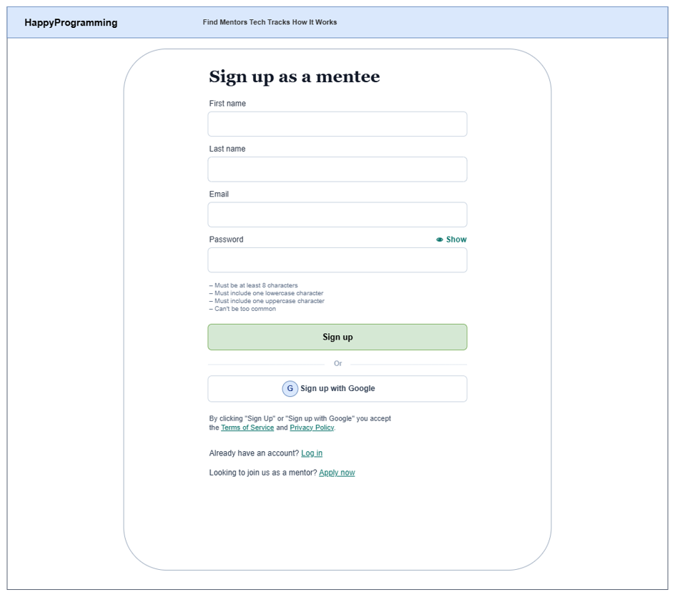
This screen allows Guest to:
- Create a new HappyProgramming mentee account by entering first name, last name, email address, and password.
- Review password security requirements before submission.
- Accept the platform Terms of Service and Privacy Policy.
- Register quickly using third-party Google OAuth2 authentication.
- Navigate to the Login screen if an account already exists, or redirect to the mentor application flow.
Field Name | Description
First name | Text input field for entering the user's first name.
Last name | Text input field for entering the user's last name.
Email | Text input field for entering a valid email address used for account registration and notifications.
Password | Secured password input field for creating account password. Includes a toggle action to show or hide entered characters.
Password Requirements | Instructional guidelines listing password complexity constraints (minimum 8 characters, lowercase, uppercase, and not too common).
Sign up | Primary action button that submits the form data and registers the new mentee account.
Sign up with Google | Third-party authentication button to register or sign in via Google OAuth2.
Terms of Service & Privacy Policy | Hyperlinks that open the platform terms and privacy statements.
Log in | Navigation link redirecting existing users to the Login screen.
Apply now | Navigation link redirecting applicants to the mentor onboarding process.

1.2 Apply as a mentor

1.2.1 Step 1: About you
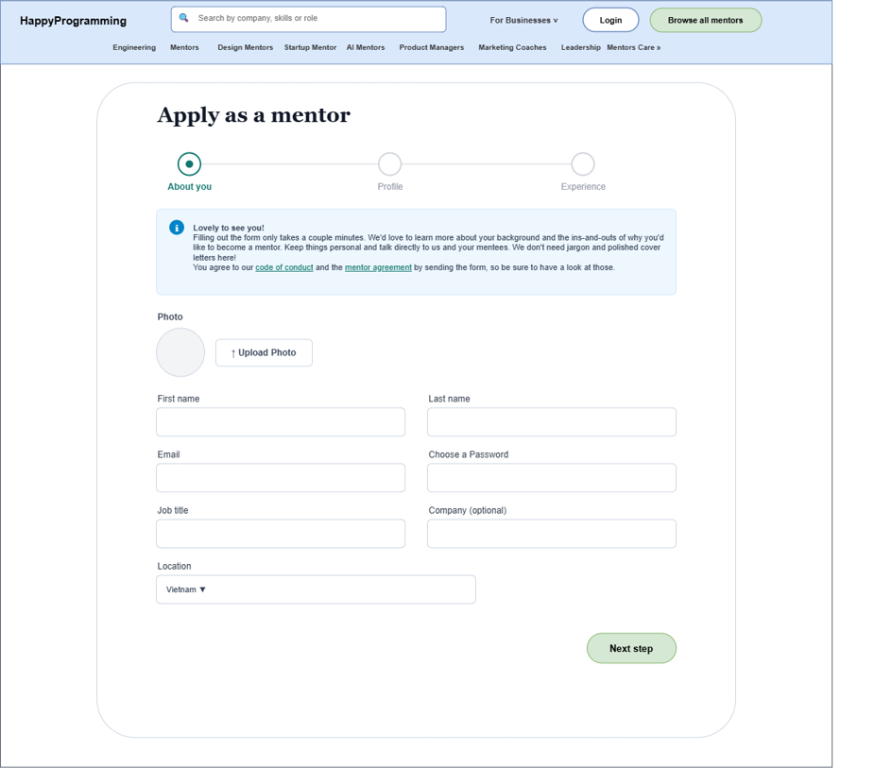
This screen allows Guest to:
- Review onboarding instructions, Code of Conduct, and Mentor Agreement terms.
- Upload a professional profile photograph.
- Provide core personal details, job title, company name, and geographical location.
- Validate step inputs and proceed to the profile configuration step.
Field Name | Description
Progress Stepper | Visual sequence tracker highlighting the active stage as About you.
Callout Banner | Informational alert displaying onboarding advice and links to the Code of Conduct and Mentor Agreement.
Upload Photo | Action button opening the file picker to upload a profile avatar (JPG/PNG).
First name | Text input field for entering the applicant's first name.
Last name | Text input field for entering the applicant's last name.
Email | Text input field for entering the official contact and account email.
Choose a Password | Password input field for configuring account credentials.
Job title | Text input field specifying current professional title (e.g., Senior Backend Engineer).
Company (optional) | Optional text input field indicating current employer or organization.
Location | Dropdown selection control to specify country or region of residence.
Next step | Action button validating Step 1 inputs and navigating to Step 2.

1.2.2 Step 2: Profile
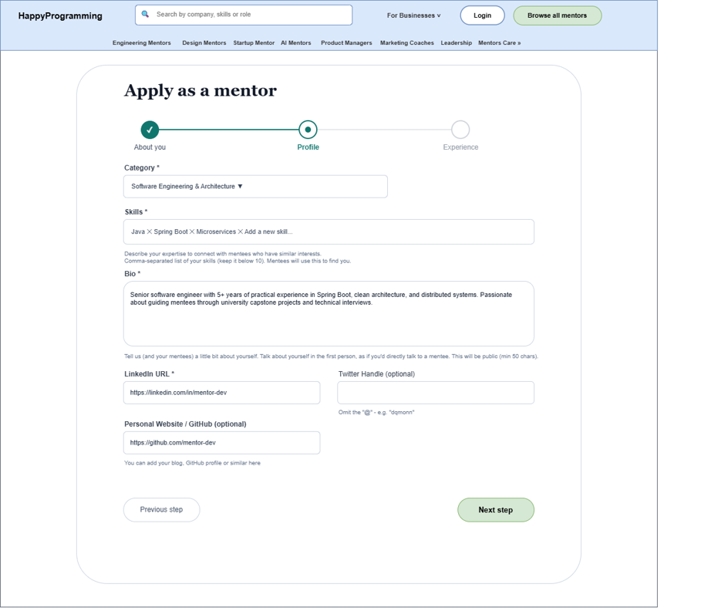
This screen allows Guest to:
- Select a primary technical specialization category.
- Define core programming skills and technical stack keywords.
- Compose a personal professional biography for public mentee discovery.
- Provide professional social links including LinkedIn, Twitter, and personal portfolio or GitHub repository.
- Navigate between sequential application steps.
Field Name | Description
Progress Stepper | Visual sequence tracker indicating Step 1 completed and Step 2 (Profile) active.
Category | Dropdown control to select the primary mentoring track (e.g., Software Engineering & Architecture).
Skills | Tag-based input component allowing entry of up to 10 teaching technologies.
Bio | Multi-line text area for the applicant's introduction and mentoring philosophy (minimum 50 characters).
LinkedIn URL | Text input field for the applicant's verified LinkedIn profile link.
Twitter Handle (optional) | Optional text input field for the applicant's Twitter/X username.
Personal Website / GitHub (optional) | Optional text input field for portfolio, personal blog, or GitHub link.
Previous step | Navigation button returning to Step 1 to revise personal details.
Next step | Action button validating Step 2 inputs and navigating to Step 3.

1.2.3 Step 3: Experience
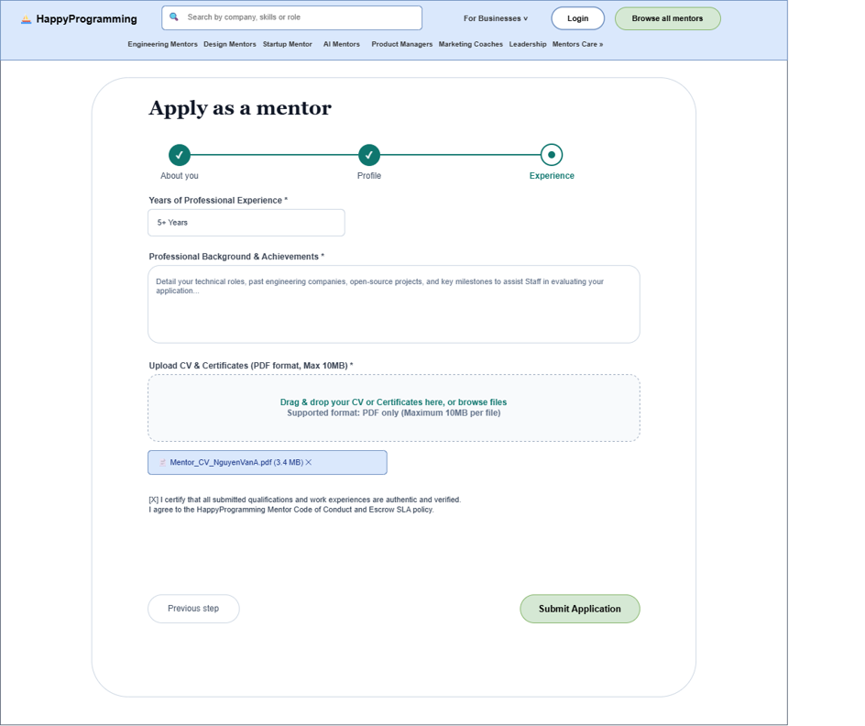
This screen allows Guest to:
- Declare total years of practical professional software development experience.
- Provide a comprehensive summary of career milestones, technical achievements, and background.
- Upload resume/CV documents and qualification certificates in PDF format.
- Certify submission authenticity and agree to platform conduct and Escrow SLA policies.
- Finalize and dispatch the application to the Staff review queue.
Field Name | Description
Progress Stepper | Visual sequence tracker indicating Steps 1 and 2 completed and Step 3 (Experience) active.
Years of Professional Experience | Numeric or text input specifying total verified years of industry practice.
Professional Background & Achievements | Multi-line text area detailing past engineering roles and project highlights.
Upload CV & Certificates Dropzone | Drag-and-drop file upload target accepting PDF credentials up to 10MB.
Uploaded File Item | Read-only visual badge displaying the uploaded PDF file name, file size, and remove action (✕).
Terms Certification Checkbox | Mandatory checkbox confirming credential authenticity and acceptance of mentor policies.
Previous step | Navigation button returning to Step 2 to edit profile information.
Submit Application | Primary action button saving the application with PENDING status and routing to Staff Review.

1.3 Login
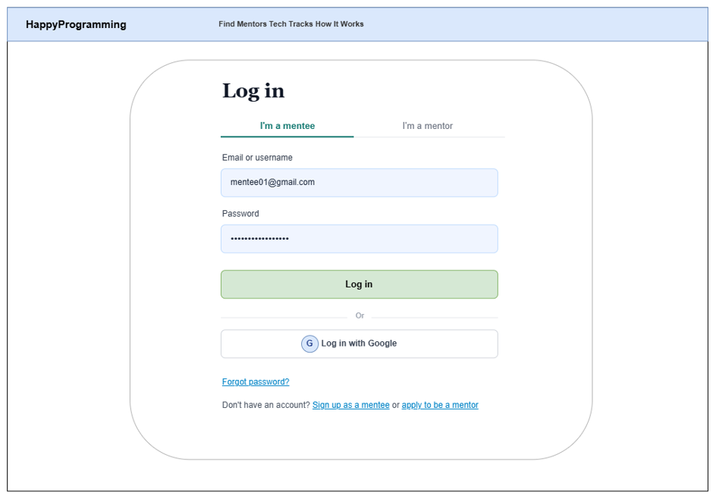

This screen allows Guest to:
- Switch between platform authentication roles using the I'm a mentee and I'm a mentor tabs.
- Authenticate into HappyProgramming using registered credentials (email address or username along with password).
- Sign in directly using Google account authentication via Google OAuth2.
- Navigate to the password recovery flow when credentials are forgotten.
- Navigate to account registration links for both mentees and prospective mentors.

Field Name | Description
I'm a mentee | Tab control to select the Mentee role before submitting login credentials.
I'm a mentor | Tab control to switch to the Mentor authentication interface.
Email or username | Text input field for entering the registered email address or account username.
Password | Secured password input field for entering the user's account password.
Log in | Primary action button that validates credentials and logs the user into the platform.
Log in with Google | Third-party authentication button that logs the user in via Google OAuth2.
Forgot password? | Hyperlink that redirects the user to the password reset request screen.
Sign up as a mentee | Navigation link redirecting the user to the Mentee account registration screen.
apply to be a mentor | Navigation link redirecting the user to the multi-step mentor application form.

1.4 View Mentor Ratings and Comments
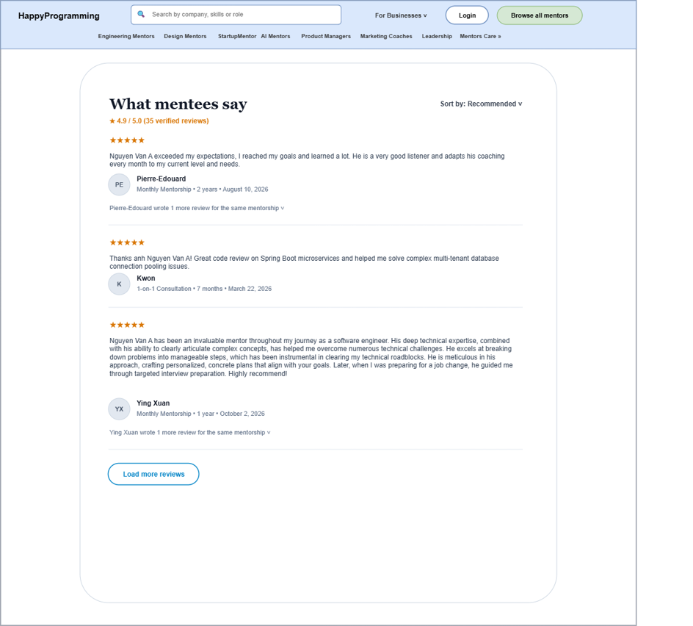

This screen allows Guest to:
- Review aggregated mentor reputation metrics including overall rating score and total review count.
- Sort mentee feedback entries using preference filters (e.g., Recommended, Most Recent).
- Read detailed mentee review comments, star ratings, package types, and submission dates.
- Expand secondary reviews from returning mentees or load additional feedback records.
- Return to the mentor's public profile overview.
Field Name | Description
Back to Mentor Profile | Navigation action returning the user to the selected mentor's public profile.
What mentees say | Section header introducing the verified mentee feedback catalog.
Sort by | Dropdown selection control to reorder feedback items (e.g., Recommended, Highest Rated, Newest).
Average Rating & Total Reviews | Summary metrics displaying the mentor's score (e.g., 4.9 / 5.0) and total verified review count.
Star Rating | Visual indicator displaying 1 to 5 stars earned for the specific session.
Reviewer Avatar & Name | Display badge showing the mentee's avatar initials and full name.
Review Meta Information | Metadata line stating mentorship package type, total engagement duration, and review post date.
Comment Text | Text block presenting detailed mentee feedback regarding mentoring quality and outcomes.
Nested Review Link | Expandable control allowing users to inspect additional reviews left by the same mentee.
Load more reviews | Action button retrieving and appending earlier review entries to the active feed.

2. Mentee

2.1 Mentor discovery
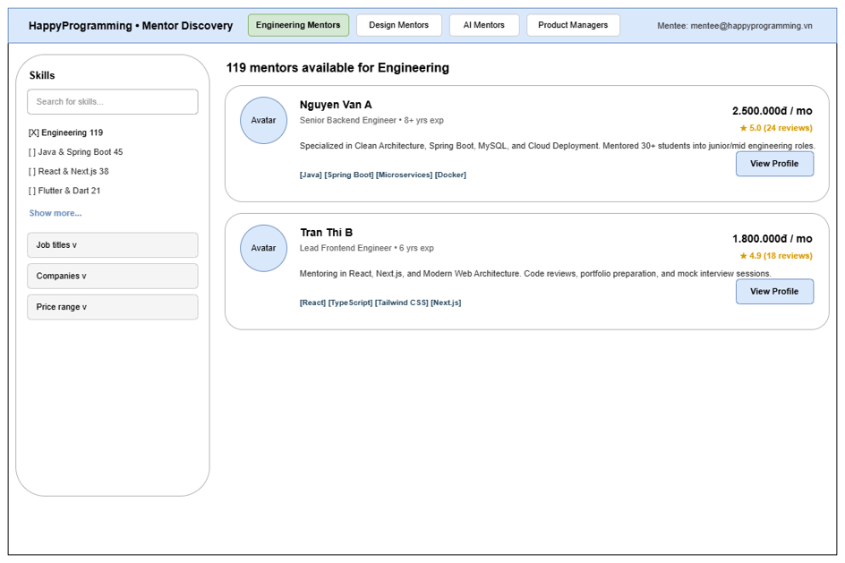
This screen allows Mentee to:
- Search and filter mentors by skills, job title, and price range.
- View high-level information of mentors on the platform.
- Save mentors to wishlist or navigate to view detailed profile.

Field Name | Description
Category Tabs | Allows switching mentor domains (Engineering, Design, AI, Product).
Search for skills | Input field for entering skill keywords to search mentors.
Skill Checkboxes | Allows selecting one or multiple skills to filter mentors.
Job titles | Dropdown list to filter mentors by job title.
Companies | Dropdown list to filter mentors by company.
Price range | Dropdown list to filter mentors by price range.
View Profile | Button to navigate the user to the mentor detail profile screen.
Save to Wishlist | Button with heart icon to save or remove the mentor from wishlist.

2.2 View mentor profile

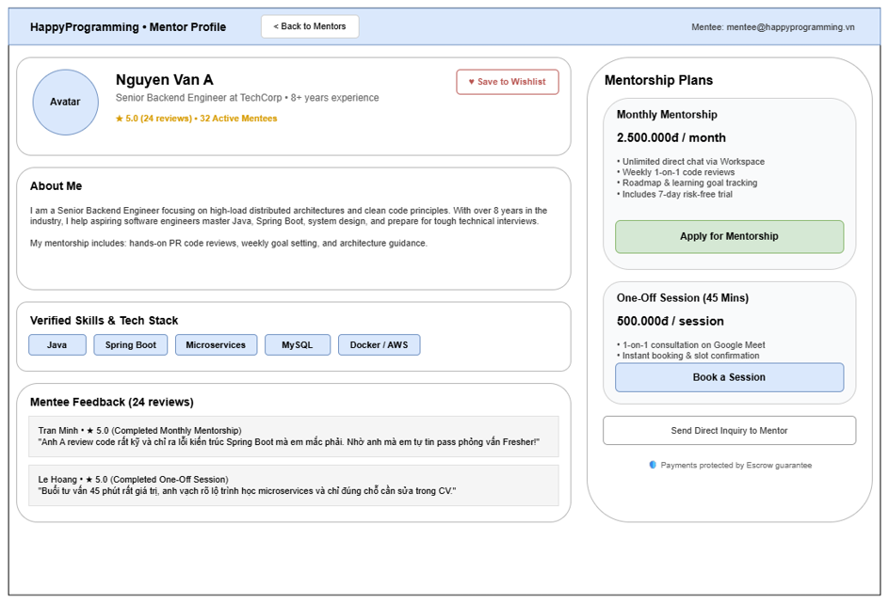

This screen allows Mentee to:
- View detailed credentials, bio, verified skills, and past reviews of the mentor.
- Select a mentorship package (Monthly or One-Off) to proceed with booking.
- Send a direct inquiry to the mentor.

Field Name | Description
Back to Mentors | Button to return to the Mentor Discovery screen.
Save to Wishlist | Button to save the mentor to personal wishlist.
Verified Skills | Badges displaying technical skills verified by the platform.
Apply for Mentorship | Button to navigate to the application and learning goals screen.
Book a Session | Button to navigate to the 1-on-1 session booking screen.
Send Direct Inquiry to Mentor | Button to open a modal for sending a direct message to the mentor.

2.3 Application & Learning Goals
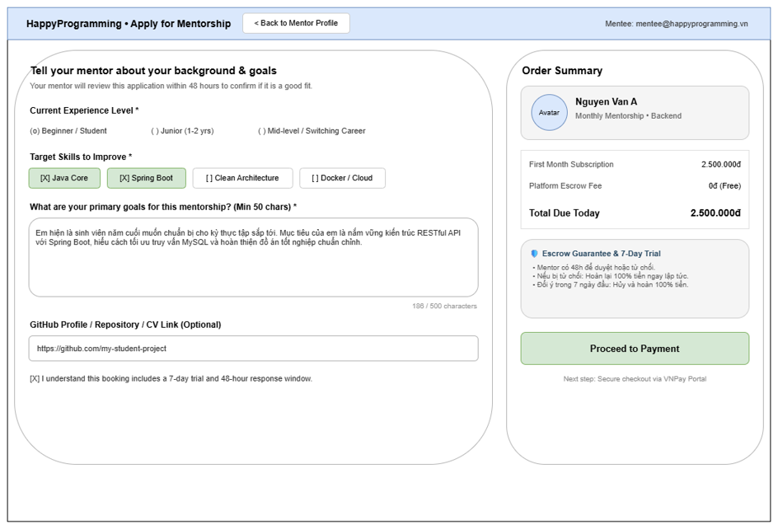
This screen allows Mentee to:
- Enter learning goals, current background, and project links for monthly mentorship.
- Review order fee and trial terms before checkout.

Field Name | Description
Back to Mentor Profile | Button to return to the Mentor Profile screen.
Current Experience Level | Radio buttons to select current level (Beginner, Junior, Mid-level).
Target Skills to Improve | Checkboxes to select skills to focus on during mentorship.
Learning Goals Description | Text area for entering detailed learning goals, minimum 50 characters.
GitHub / CV Link | Optional input field for providing repository or portfolio links.
Terms Checkbox | Mandatory checkbox to accept the 48-hour mentor response policy, payment terms, escrow hold, and cancellation/refund policy.
Submit Application | Submits the monthly mentorship application for mentor review. Payment becomes available only after acceptance.

2.4 Payment Process
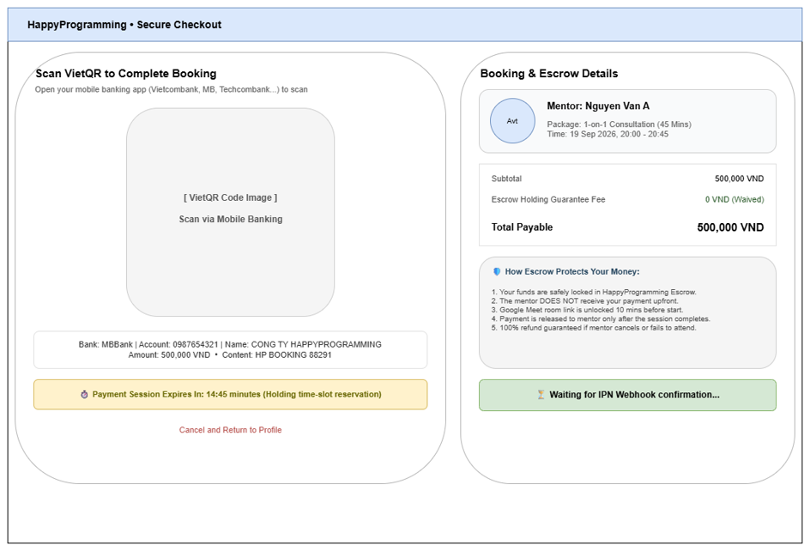

This screen allows Mentee to:
- Scan the SePay-generated bank-transfer QR code with a supported banking application or copy the displayed transfer details.
- View transfer details, countdown timer, and order summary.

Field Name | Description
SePay Bank Transfer QR | Displays the dynamic bank-transfer QR generated from the configured receiving account, exact amount, and unique transfer reference.
Bank Transfer Info | Displays bank name, masked or authorized account number, account holder, exact amount, and unique transfer reference with copy actions.
Payment Timer | Shows the remaining validity period of the current payment attempt (15 minutes).
Cancel or Return to Applications | Allows the mentee to leave checkout. Leaving the page does not confirm or cancel a bank transaction already sent.
Payment Status | Displays PENDING, SUCCEEDED, EXPIRED, CANCELLED, or RECONCILIATION based on backend status polling. Only a verified server webhook can produce SUCCEEDED.

2.5 Mentee Workspace & Chat
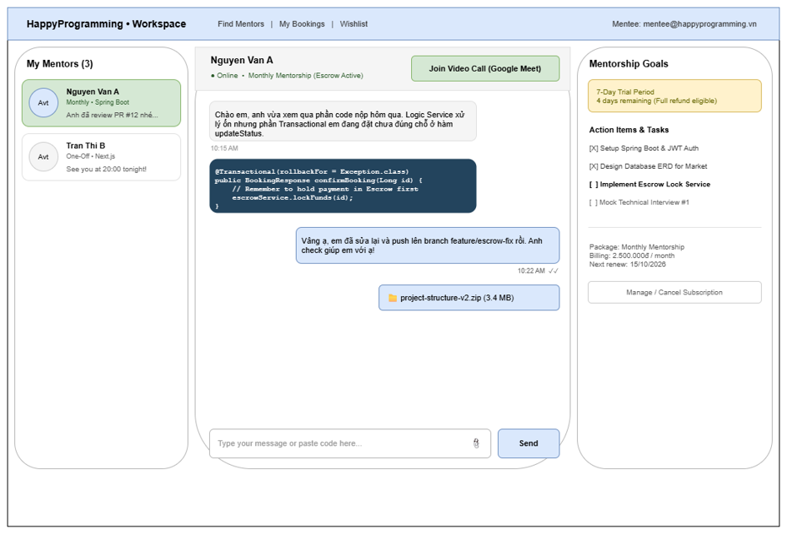

This screen allows Mentee to:
- Chat in real-time, send code snippets, and share files with mentors.
- The mentor shares call information or an external meeting link through the private workspace.
- View learning goals checklist and manage active subscriptions.

Field Name | Description
My Mentors List | Displays active mentors and recent conversation snippets.
Join Video Call | Button to open the Google Meet room in a new browser tab.
Message Input Field | Text field where the user types a message to send.
Attachment Icon | Button to upload attachment files such as PDF or ZIP up to 20MB.
Send | Button to dispatch typed message and attachments to the mentor.
Action Items | Checklist to track progress of learning tasks assigned by the mentor.
Manage / Cancel Subscription | Button to open modal for managing or canceling recurring subscription renewal.

2.6 Mentee My Bookings & Sessions
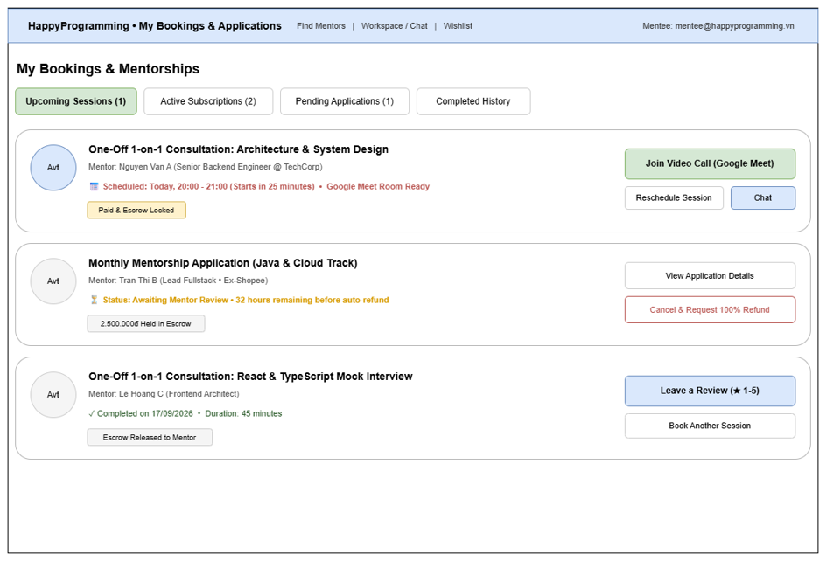

This screen allows Mentee to:
- View and track upcoming sessions, active subscriptions, and pending applications.
- Reschedule sessions, or cancel pending applications.
- Submit reviews for completed sessions.

Field Name | Description
Status Tabs | Tabs to filter bookings by status (Upcoming, Subscriptions, Pending, Completed).
Join Video Call | Button to directly join the Google Meet room for the session.
Reschedule Session | Button to pick another time slot for the scheduled session.
Chat | Button to open chat workspace with the selected mentor.
Cancel & Request 100% Refund | Button to cancel pending application and request escrow refund.
Leave a Review | Button to open modal for submitting rating and review for completed sessions.
Book Another Session | Button to return to the mentor profile to book a new session.

2.7 Book 1-on-1 Session
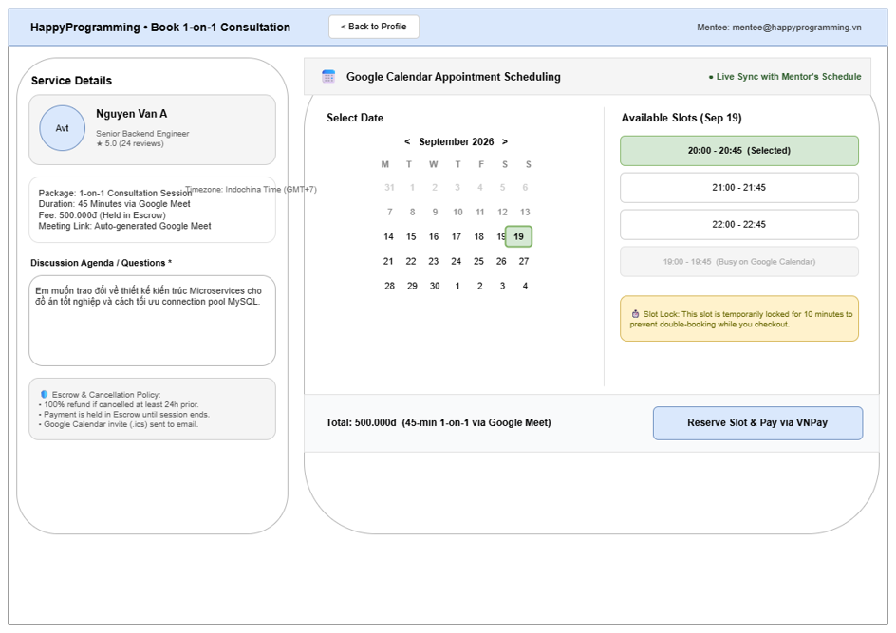

This screen allows Mentee to:
- Available time slots are generated from the availability configured by the mentor in HappyProgramming.
- Input session agenda and proceed to checkout.

Field Name | Description
Back to Profile | Button to return to the mentor profile screen.
Discussion Agenda / Questions | Text area for entering discussion topics or questions for the meeting.
Month Switcher | Controls to switch between previous and next calendar months.
Date Picker Grid | Grid allowing the user to select an available date on the calendar.
Time Slots | Buttons allowing the user to select an available time block for the chosen date.
Reserve Slot and Pay by SePay QR | Places a temporary hold on the slot and opens the on-page bank-transfer QR checkout.

2.8 Rating and Submit Review

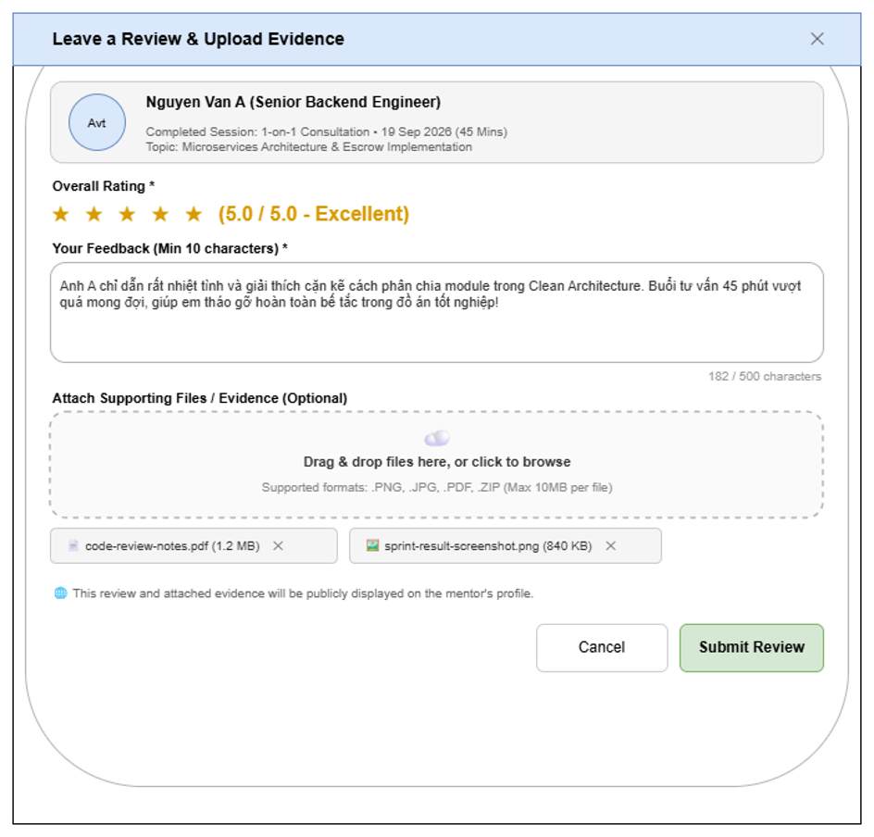
This modal allows Mentee to:
- Rate the mentor from 1 to 5 stars for a completed session.
- Submit written feedback and optional evidence files.

Field Name | Description
Close Icon | Button in the top-right corner to close the modal without saving.
Overall Star Rating | Allows the user to select a rating score from 1 to 5 stars.
Feedback | Mandatory text area for entering written review comments, minimum 10 characters.
Upload Evidence | Dropzone allowing the user to drag and drop or browse files up to 10MB.
Cancel | Button to discard entered data and close the modal.
Submit Review | Primary button to submit ratings, comments, and uploaded files.

3.Mentor

3.1 Mentor Workspace Overview & Requests
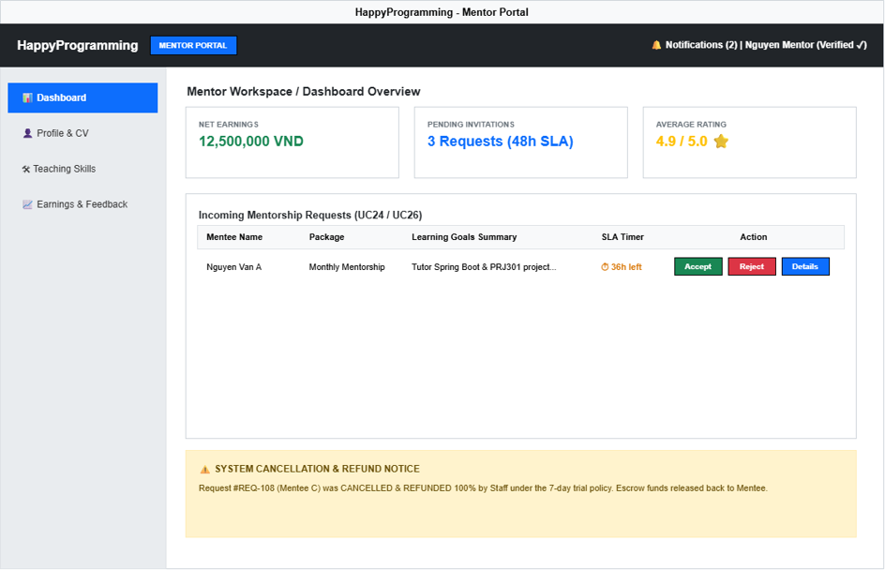

This screen allows Mentor to:
- View real-time net earnings, pending Escrow funds, and average mentee rating scores.
- Review incoming mentorship requests, inspect mentee learning goals, and accept or reject requests within the 48-hour SLA.
- Track system cancellation logs and 100% Escrow refund updates processed by Staff under the platform policy.

Field Name | Description
Net Earnings Card | Displays verified net balance calculated after platform commission deduction, along with locked pending Escrow funds.
Pending Invitations Card | Shows the total count of active requests requiring Mentor response within the 48-hour SLA.
Average Rating Card | Displays overall star rating score calculated from verified completed mentee reviews.
Incoming Requests Table | Lists pending invitations with Mentee Name, Package Type, Learning Goals summary, and SLA countdown timer.
Accept Button | Confirms acceptance of a mentorship request, changing status to ACCEPTED and enabling Mentee payment workflow.
Reject Button | Opens a confirmation modal to decline an unpaid request with an optional reason. The system records REJECTED and notifies the mentee without creating a refund.
Details Button | Opens full Mentee Profile, selected service package details, and submitted project repository links.
Cancellation Notice Box | Displays recent cancellations and verified refund or reconciliation updates processed according to platform policy.

3.2. Mentor Profile & CV Management
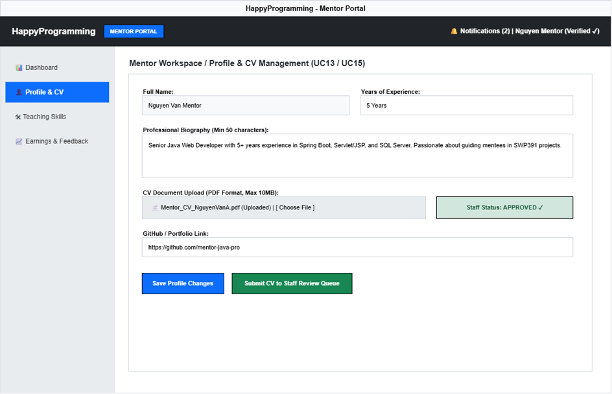

This screen allows Mentor to:
- View and edit personal biography, work experience, and portfolio/GitHub links.
- Upload CV and qualification certificates in PDF format for Staff review.
- Monitor Staff application verification status (PENDING or APPROVED).

Field Name | Description
Full Name | Read-only / Editable text field displaying the Mentor's registered full name.
Years of Experience | Input field to specify total verified professional development years.
Biography (Bio) | Textarea for professional summary and introduction (Minimum 50 characters).
CV Document Upload | File upload picker supporting PDF documents up to 10MB.
Staff Status Badge | Visual status indicator displaying current review state (APPROVED or PENDING).
GitHub / Portfolio Link | Input field for adding external repository or personal website links.
Save Profile Button | Saves updated personal information and biography to the database.
Submit CV Button | Dispatches uploaded CV document to Staff Review Queue for verification.

3.3 Teaching Skills Management
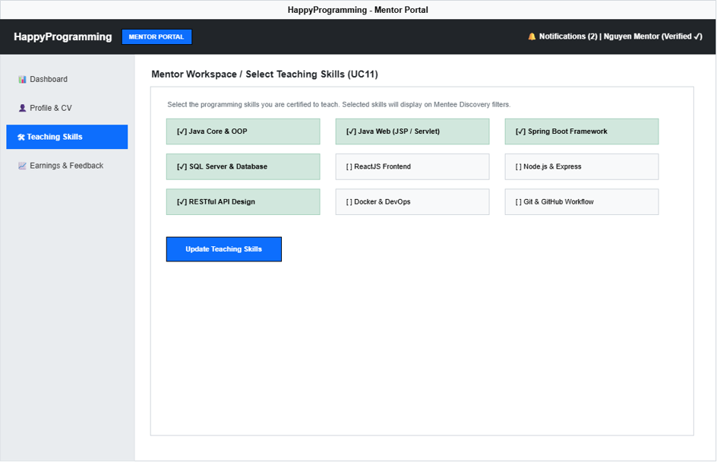

This screen allows Mentor to:
- Browse active programming skills approved in the platform directory.
- Select or unselect target skills matching their verified teaching capabilities to update public discovery filters.

Field Name | Description
Skill Selection Checkboxes | Interactive checkboxes for active topics (Java, Spring Boot, SQL Server, REST API, etc.).
Update Teaching Skills Button | Saves skill selection changes to database, updating Mentor Discovery filter mappings.

3.4 Statistics, Net Earnings & Mentee Feedback

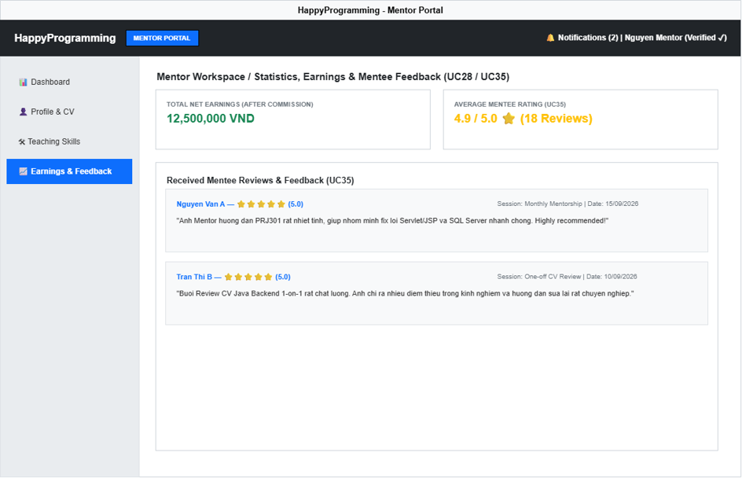

This screen allows Mentor to:
- Track calculated net revenue after platform commission deductions.
- Review star ratings (1–5 stars) and detailed comments submitted by mentees after completed sessions.

Field Name | Description
Total Net Earnings Card | Display card showing total payout balance calculated via formula: Net Earnings = Gross Revenue - Commission.
Average Mentee Rating Card | Card displaying overall star rating average and total review count.
Received Feedback List | Container displaying individual feedback cards with Mentee Name, Star Rating, Session Type, Submission Date, and Comment text.

3.5 Wallet and Withdrawals
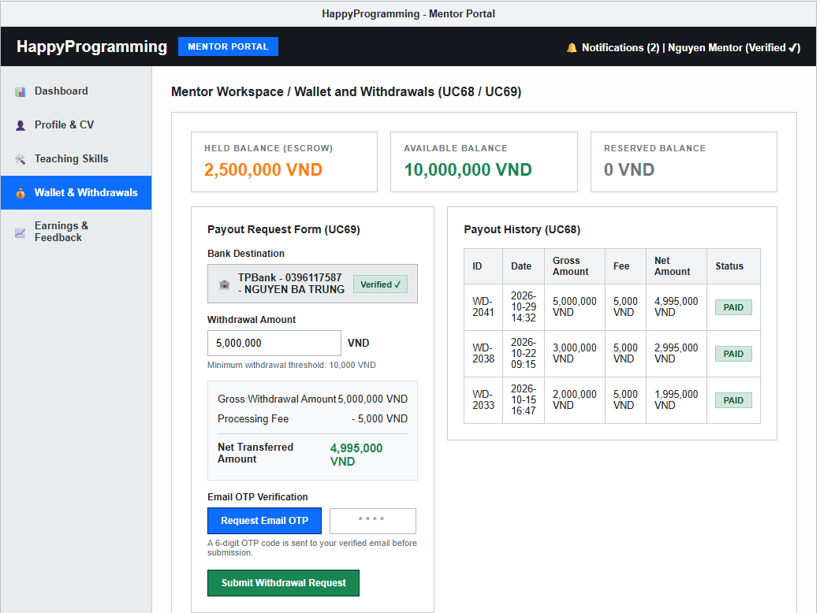
This screen allows Mentor to:
- View held balances (in escrow), available balances (ready for withdrawal), and reserved balances.
- Track the withdrawal form details showing minimum thresholds, gross withdrawal amounts, processing fees, and net transferred amounts.
- Request and verify Email OTP before securely submitting a withdrawal request.
- Inspect complete payout request history including processing statuses (Requested, Approved, Paid, Rejected).

Field Name | Description
Balance Summary Cards | Display blocks showing current Held (Escrow), Available, and Reserved balances in VND.
Bank Destination Info | Displays the linked receiving bank name, account number, and verified beneficiary account holder name.
Withdrawal Form | Input interface allowing mentors to enter whole-VND withdrawal amounts while checking platform thresholds and calculated net fees.
Email OTP Verification | Security control requiring mentors to request and input a valid 6-digit email OTP code before dispatching a withdrawal request.
Payout History Table | Data table recording historical withdrawal records with transaction IDs, dates, gross amounts, fees, net amounts, and processing status badges.

4. Admin

4.1 Admin Dashboard
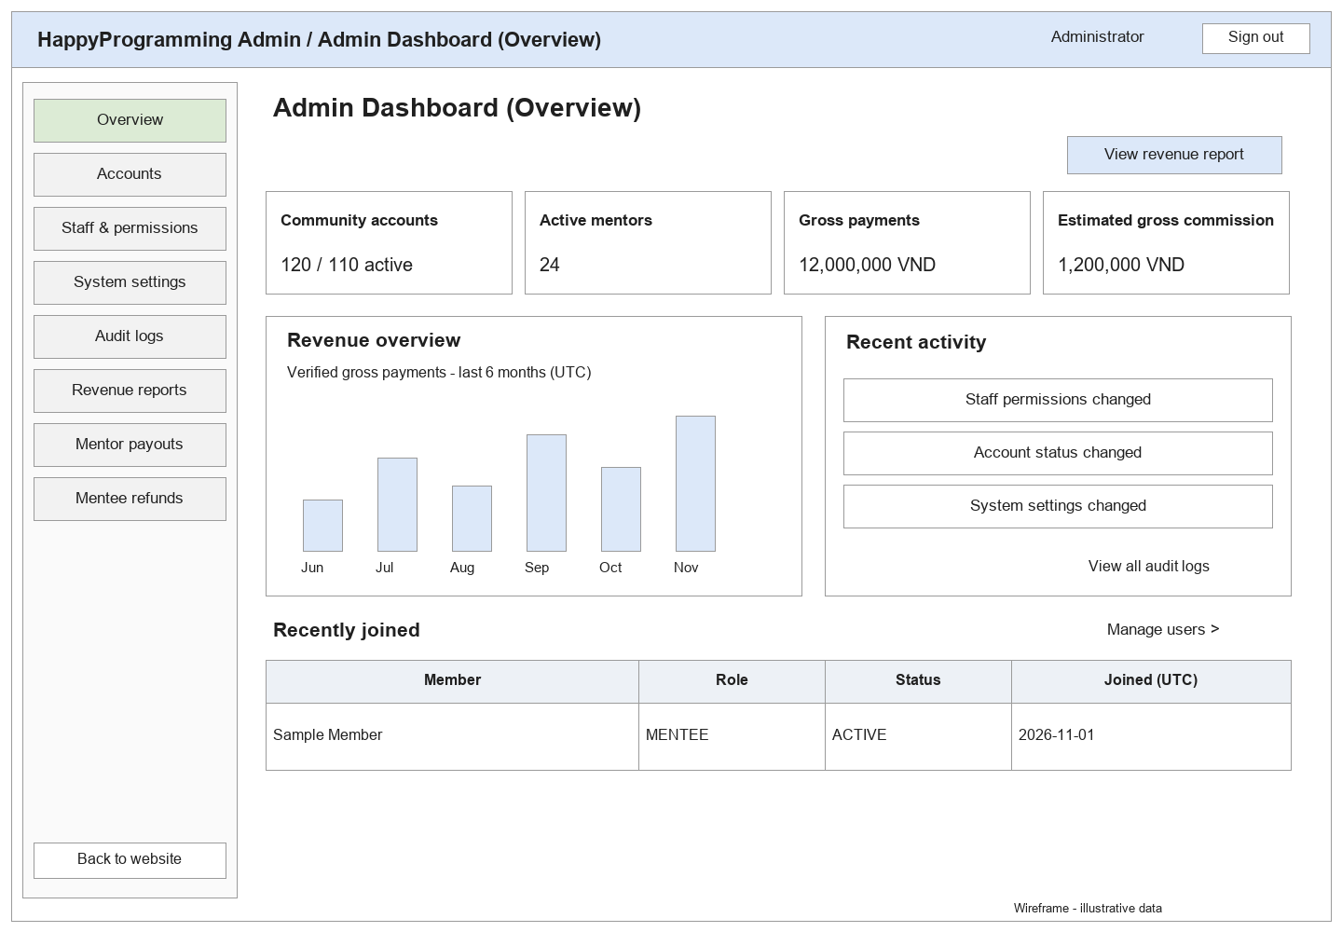

This screen allows the Admin to:
• View Platform Summary: review Total Users, Active Mentors, Active Staff, and Monthly Revenue on the dashboard.
• View Platform Activity: review the platform activity chart presented on the dashboard.
• View Recent Administrative Activity: review the latest recorded administrative activities shown in the activity panel.
On the screen, s/he can also:
• Open Audit Logs: use the “View Audit Logs” action to navigate to the Audit Logs screen.
• Navigate Administration Modules: use the left navigation menu to access Accounts, Staff Authorization, System Configuration, Audit Logs, and Revenue Reports.
• Logout: end the current Admin session using the Logout option.

Field Name | Description
Total Users | Read-only summary metric showing the total number of user accounts in HappyProgramming
Active Mentors | Read-only summary metric showing the number of currently active Mentor accounts.
Active Staff | Read-only summary metric showing the number of currently active Staff accounts.
Monthly Revenue | Read-only summary metric showing the current monthly revenue value
Platform Activity | Read-only chart presenting overall platform activity.
Recent Administrative Activity | Read-only list presenting recent administrative actions.
View Audit Logs | Navigation action that opens the Audit Logs screen.

4.2 Account Management
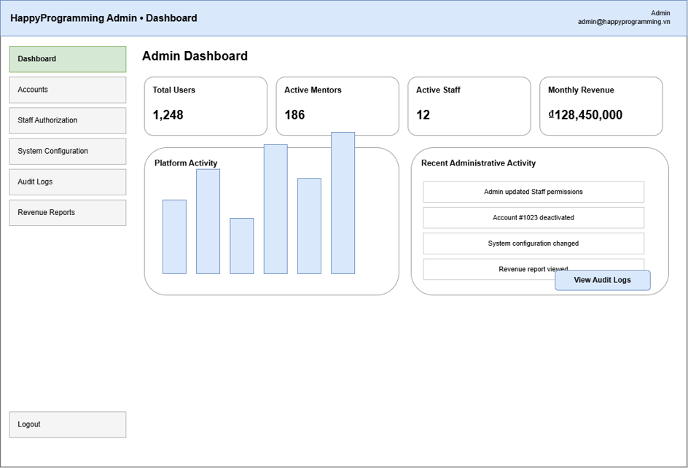

This screen allows the Admin to:
• View Accounts: review the account list with ID, Name, Email, Role, Status, and Action information.
• Search Accounts: enter a name or email and use Search to locate matching accounts.
• Filter Accounts: filter the account list by Role and Status.
• View Account Detail: select “View Detail” for an account to open its detailed information.
On the screen, s/he can also:
• Reset Search and Filters: use Reset to clear the current search and filter selections.
• Navigate Account Pages: use the pagination control to move through the account list.
Field Description

Field Name | Description
Search by Name / Email | Text input used to search account records by user name or email address.
Role Filter | Selection control used to display accounts belonging to a selected role or all roles.
Status Filter | Selection control used to display accounts by account status or all statuses.
Search | Action button that applies the entered search criteria and selected filters
Account List | Table showing account ID, name, email, role, status, and available row action.
View Detail | Row-level action that opens the Account Detail screen for the selected user account.
Pagination | Navigation control used to move between pages of account records.

4.3 Account Detail

This screen allows the Admin to:
• View User Information: review Account ID, Full Name, Email, Role, Created Date, and Last Login of the selected account.
• View Account Status: review the current status of the selected account.
• Change Account Status: activate or deactivate the selected account using the available status action.
On the screen, s/he can also:
• Return to Account List: use “Back to Account List” to return to Account Management.
• Confirm Status Change: complete the required confirmation before the system changes the account status.
Field Description

Field Name | Description
Back to Account List | Navigation control that returns the Admin to the Account Management screen.
User Information | Read-only information section showing the selected account’s ID, full name, email, role, created date, and last login.
Account Status | Read-only value showing the current Active or Inactive status of the selected account.
Activate Account | Action used to activate an inactive account.
Deactivate Account | Action used to deactivate an active account.
Status Change Confirmation | Confirmation step required before an account-status change is applied.

4.4 Staff Authorization

This screen allows the Admin to:
• View Staff Accounts: review Staff accounts with email, status, and permissions summary.
• Search Staff: enter a staff name or keyword and use Search to locate a Staff account.
• Review Staff Permissions: select a Staff account and review the permissions currently assigned to that account.
• Update Staff Permissions: select or clear operational permissions for the chosen Staff account and save the changes.
On the screen, s/he can also:
• Review Permission Summary: view the current permission summary shown for each Staff account before editing.
Filed Description

Field Name | Description
Search Staff | Text input and Search action used to locate Staff accounts.
Staff List | Table showing Staff name, email, status, and permissions summary.
Edit Permissions | Permission-editing area for the selected Staff account.
Manage Mentor Applications | Permission option controlling access to mentor-application management.
Manage Mentees | Permission option controlling access to mentee-management functions.
Manage Requests | Permission option controlling access to mentorship-request management.
Manage Skills | Permission option controlling access to skill-management functions.
Save Permissions | Primary action that stores the selected permissions for the Staff account.

4.5 System Configuration

This screen allows the Admin to:
• Manage General Platform Settings: review and update Platform Name, Support Email, Default Currency, Session Timeout, and Maintenance Mode.
Manage Payment and Notification Settings: review and update the SePay-linked receiving account, webhook authentication, QR template, public webhook URL, and email notification settings.
• Save Configuration: save valid changes made to the system configuration.
Field Description

Field Name | Description
Platform Name | Editable value defining the display name of the HappyProgramming platform.
Support Email | Editable email address used as the platform support contact.
Default Currency | Configuration value defining the default currency used by the platform.
Session Timeout | Numeric configuration value defining the session timeout duration in minutes.
Maintenance Mode | Toggle configuration controlling whether platform maintenance mode is enabled or disabled.
SePay Payment Configuration | Configuration for the linked receiving bank, account holder, API key or HMAC secret, QR template, public HTTPS webhook URL, payment-attempt expiry, and enabled status. Secrets must be masked and stored outside source control.
Email Notifications | Configuration value controlling whether system email notifications are enabled.
Save Configuration | Primary action that saves the current system-configuration values.

4.6 Audit Log
This screen allows the Admin to:
• View Audit Logs: review audit records showing Time, Actor, Role, Action, and Target information.
• Filter Audit Logs: use Actor/keyword, Action, Date From, and Date To criteria to narrow the displayed log records.
• Apply Audit Log Filter: use Filter to apply the current audit-log criteria.
On the screen, s/he can also:
• Export Logs: export the displayed audit-log information using the Export Logs action.
Field Description

Field Name | Description
Actor / Keyword | Text input used to search audit records by actor or keyword.
Action Filter | Selection control used to filter audit records by action type.
Date From | Date input defining the beginning of the audit-log period
Date To | Date input defining the end of the audit-log period.
Filter | Action button that applies the selected audit-log criteria.
Audit Log List | Read-only table showing time, actor, role, action, and target for recorded activities.
Export Logs | Action used to export the audit-log information.

4.7 Revenue Report

This screen allows the Admin to:
• View Revenue Summary: review Gross Revenue, Successful Payments, Refunded amount, and Net Revenue.
• Filter Report Period: select a report period or specify From and To dates, then use Apply to refresh the report.
• View Revenue Trend: review the revenue trend visualization for the selected reporting period.
• View Recent Transactions: review the recent payment transactions shown on the report.
On the screen, s/he can also:
• Export Report: export the current revenue report using the Export Report action.
• View All Transactions: open the complete transaction list using “View All Transactions”.
Field Description

Field Name | Description
Period | Selection control used to choose the revenue-report period.
From | Date input defining the start date of a custom reporting period.
To | Date input defining the end date of a custom reporting period.
Apply | Date input defining the end of the audit-log period.
Export Report | Action button that applies the selected audit-log criteria.
Audit Log List | Read-only table showing time, actor, role, action, and target for recorded activities.
Export Logs | Action used to export the currently displayed revenue report.
Gross Revenue | Read-only summary metric showing gross revenue for the selected period. .
Net Revenue | Read-only summary metric showing net revenue after refunds.
Revenue Trend | Read-only visualization showing revenue movement for the selected reporting period.
Recent Transactions | Read-only list of recent payment transactions included in the report.
View All Transactions | Navigation action that opens the complete transaction list.

4.8 Mentor Payout
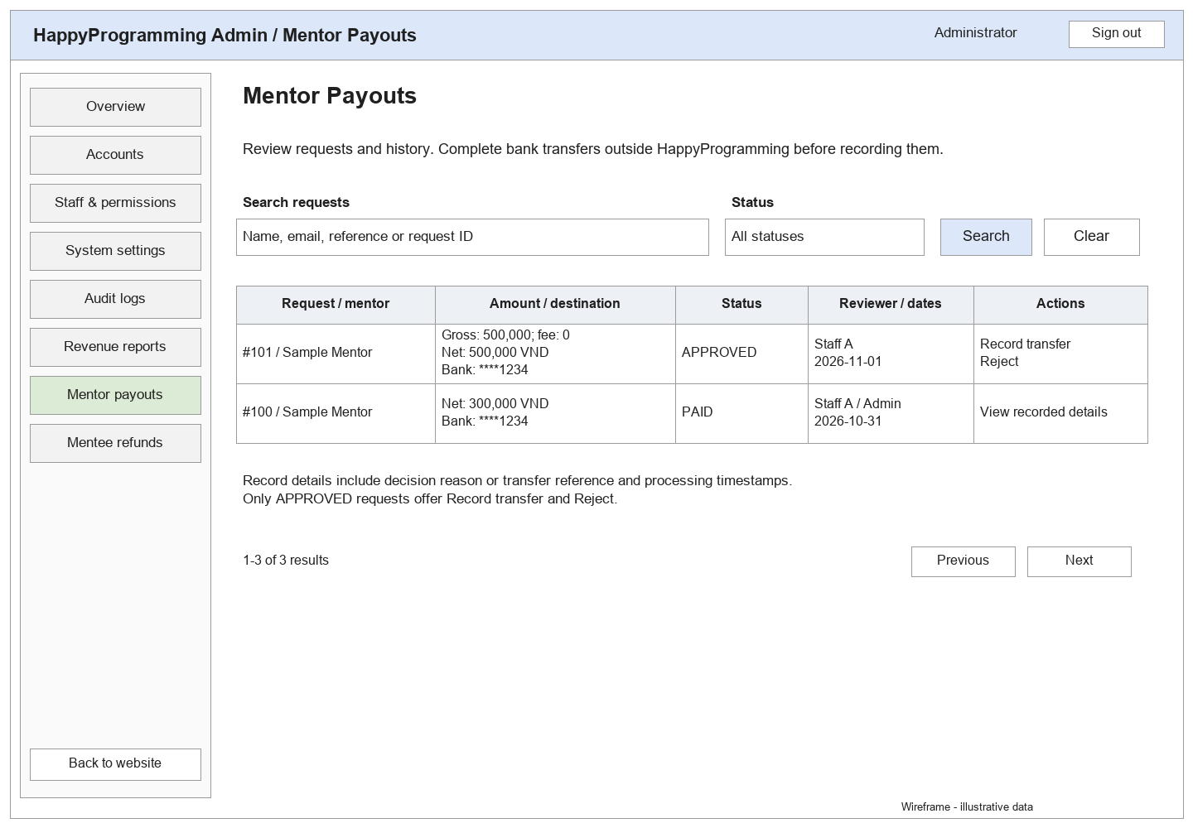
This screen allows the Admin to:
- View Payout Requests and History: review mentor withdrawal requests with REQUESTED, APPROVED, PAID, or REJECTED status.
- Search Payouts: search by mentor name, email, payout ID, or bank transfer reference.
- Filter by Status: select a payout status and use Search to apply the filter.
- Review Transfer Information: inspect the requested amount, withdrawal fee, net transfer amount, and receiving bank details.
- View Processing Details: review request dates, reviewer information, transfer references, and rejection reasons.
On the screen, s/he can also:
- Record Transfer: open an APPROVED request, verify that the external bank transfer has been completed, enter its reference, and confirm payment. This action records the payout; it does not automatically transfer money.
- Reject Payout Request: reject an APPROVED request with a reason. The reserved amount is released back to the mentor’s available balance.
- Clear Filters: reset the search and status filters.
- Navigate Results: use pagination to view additional payout records.
Field Description

Field Name | Description
Search Payouts | Text input used to search by mentor name, email, payout ID, or transfer reference.
Status | Selection control used to filter requests by REQUESTED, APPROVED, PAID, or REJECTED.
Search | Action button that applies the entered search text and selected status.
Clear | Action button that resets the search and status filters.
Request / Mentor | Read-only information identifying the payout request and the mentor.
Requested Amount | Gross amount requested for withdrawal from the mentor’s available balance.
Withdrawal Fee | Fee recorded for the payout request and deducted from the requested amount.
Net Transfer Amount | Amount to transfer to the mentor’s bank account, calculated as the requested amount minus the withdrawal fee.
Bank Destination | Receiving bank, account number, and beneficiary name associated with the payout request.
Payout Status | Current processing state of the request: REQUESTED, APPROVED, PAID, or REJECTED
Dates / Reviewer | Read-only timestamps and reviewer information associated with processing the request. Dates are displayed in UTC.
Decision Details | Recorded processing information, including the transfer reference or rejection reason, where applicable.
Record Transfer | Action available for APPROVED requests that opens the payout recording dialog.
Reject | Action available for APPROVED requests that opens the rejection dialog.
Previous / Next | Pagination controls used to navigate the payout list.

5. Staff

5.1 Staff Dashboard

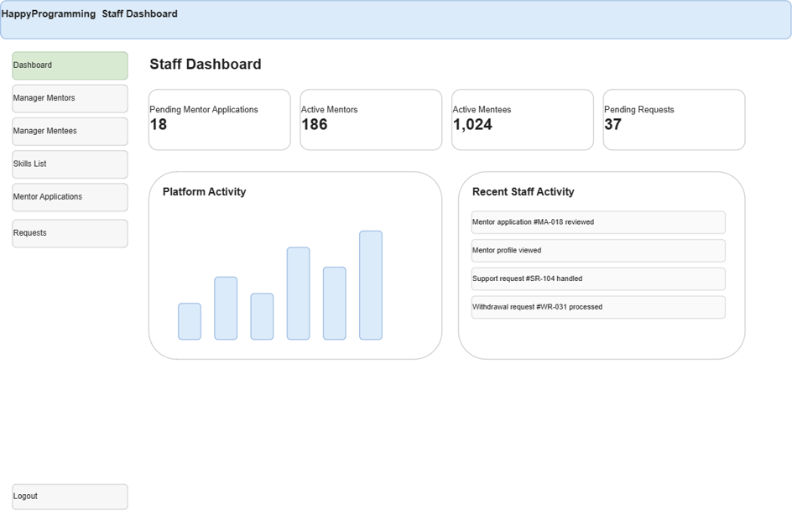

This screen allows staff to:
- Search and Filter Requests: filter the mentorship request list by entering a Request ID or name, choosing a specific Status, and using the Search button to update the table.
- Reset Filters: clear all active query criteria and return the table to its default state using the Reset action.
- View Request Details: open the detailed verification workspace for an individual mentorship request using the View action.
- On the screen, s/he can also:
- Navigate Pages: browse through sequential pages of the request records using the Pagination controls.

Field Name | Description
Search by Request ID or Name... | Text input field allowing users to enter a specific Request ID, Mentee Name, or Mentor Name to filter the list.
Status | Dropdown selection to filter rows by request state. Options include: All, Pending, Accepted, Paid, Completed, Rejected, Cancelled.
Sort | Dropdown selection to arrange list data in chronological order. Default option is Newest.
Search | Action button that executes and applies the filtering mechanism based on the entered criteria.
Reset | Action button that flushes all query inputs and drops dropdown selections back to default settings.
No | Read-only index sequence number displaying the incremental line position on the current page.
Request ID | Read-only identifier generated uniquely by the system for each mentorship request (Format: RQ-XXXX).
Mentee | Read-only text field displaying the full name of the student who initiated the request.
Mentor | Read-only text field displaying the full name of the targeted system mentor.
Skill | Read-only text field showing the specific tech stack or programming skill requested for guidance (e.g., Java, React, Python).
Status (Table) | Read-only visual badge indicator color-coded by state: Yellow (Pending), Blue (Accepted), Green (Paid/Completed), Red (Rejected/Cancelled).
Created | Read-only date field indicating when the request was successfully submitted to the system (Format: DD/MM/YYYY).
Action | Action button labeled View that redirects the user to the full request evaluation and timeline workspace.
Pagination Bar | Navigation block displaying data volume metrics (e.g., Showing 1-8 of 37 requests) with clickable targets (Prev, page numbers, Next).

5.2 Manager Mentor
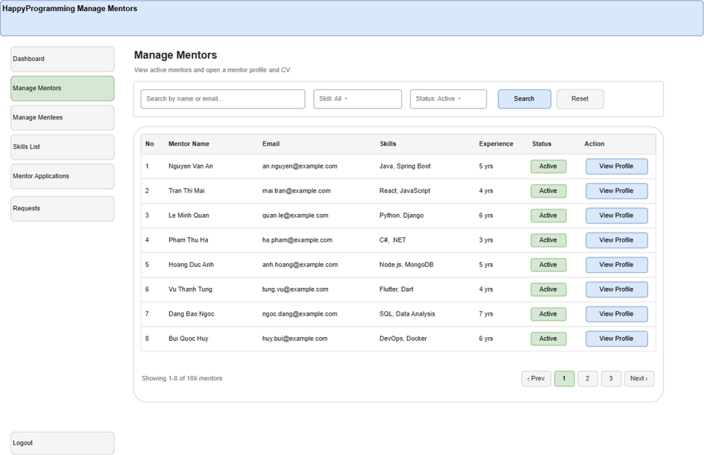
This screen allows staff to:
• Search and Filter Mentors: query approved teaching specialists by name or email, isolate profiles by specific Skill categories, and check their operational Status.
• View Mentor Profile: open the full public workspace profile, availability configuration, and uploaded CV files using the View Profile action.
On the screen, s/he can also:
• Review Professional Experience: track and compare the specific technical stacks and years of work background listed on the table layout.
• Navigate Expert Directory: browse through the complete mentor database using the interactive Pagination controls.

Field Name | Description
Search by name or email... | Text input field to query specific teaching staff by searching Mentor Name or Email strings.
Skill | Dropdown selection used to isolate mentors specialized in teaching a specific programming language (e.g., Java, React, Python, .NET).
Status | Dropdown selection to filter by professional system standing. Default pre-filtered option is set to Active.
No | Read-only index sequence number displaying the individual line position inside the layout template.
Mentor Name | Read-only text field displaying the full official display name of the approved platform mentor.
Email | Read-only text field displaying the corporate or personal email address registered for mentor operations.
Skills | Read-only text field displaying a concatenated list of programming keywords tagged to this expert profile (separated by commas).
Experience | Read-only text field stating individual professional work background duration metrics (e.g., 5 yrs, 4 yrs).
Status (Table) | Read-only visual badge indicator displaying the professional visibility state (e.g., Green filled Active).
Action | Action button labeled View Profile that initiates a deep dive review of the mentor's workspace, CV assets, and performance records.
Pagination Bar | Navigation block displaying data volume metrics (e.g., Showing 1-8 of 166 mentors) with interactive step buttons.

5.3 Manager Mentees
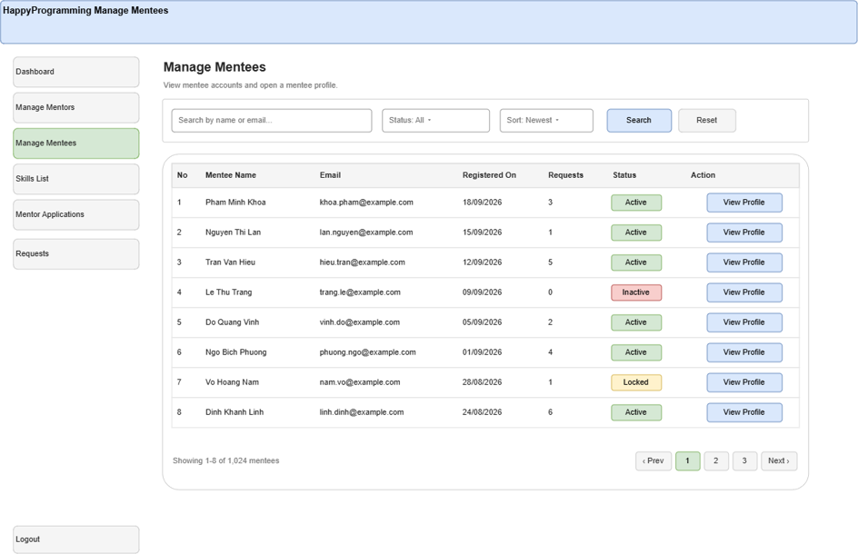
This screen allows staff to:
• Search and Filter Mentees: search for specific students using their name or email, filter by account Status, and sort the directory list.
• View Mentee Profile: open the detailed account information and comprehensive activity history page of a selected student using the View Profile action.
On the screen, s/he can also:
• Navigate Directory: browse through the complete list of registered students using the Pagination bar

Field Name | Description
Search by name or email... | Text input field to query accounts by matching characters against Mentee Name or Email fields.
Status | Dropdown selection to filter the student directory by account life cycle state: All, Active, Inactive, Locked.
Sort | Dropdown selection that controls the row sequence stacking order. Default option is Newest.
No | Read-only index sequence number displaying the individual line position inside the table.
Mentee Name | Read-only text field displaying the verified full name belonging to the student user account.
Email | Read-only text field displaying the primary email address registered and tied to the user profile.
Registered On | Read-only date field showing the calendar date the account was successfully created and verified (Format: DD/MM/YYYY).
Requests | Read-only numeric counter tracking the cumulative total number of connection requests submitted by this student.
Status (Table) | Read-only visual badge tracker indicating if the account status is currently Active, Inactive, or Locked.
Action | Action button labeled View Profile that triggers redirection to inspect the specific student's log and full profile page.
Pagination Bar | Navigation block displaying data volume metrics (e.g., Showing 1-8 of 1,024 mentees) with page switches.

5.4 Manager Requests
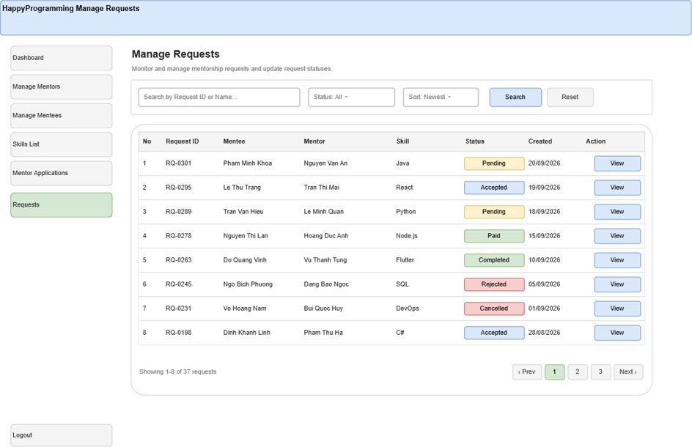
This screen allows staff to:
• Monitor Live Metrics: review core platform metrics including Pending Mentor Applications, Active Mentors, Active Mentees, and Pending Requests.
• Track Platform Activity: review the real-time engagement and interaction trends rendered on the Platform Activity bar chart.
• Review Recent Activity: monitor the live back-office information ledger to inspect the most recent task executions and logging records

Field Name | Description
Pending Mentor Applications | Read-only metric card counter showing new Mentor registration forms currently awaiting verification review steps.
Active Mentors | Read-only metric card live counter tracking the total number of mentors configured as active within the platform database.
Active Mentees | Read-only metric card live counter tracking the total number of students logged as active on the platform.
Pending Requests | Read-only metric card counter displaying the total number of connection requests currently suspended on a Pending state.
Platform Activity | Read-only bar chart visualization layout rendering platform interaction volumes over sequential timeline increments.
Recent Staff Activity | Read-only information ledger list showing the most recent task executions, approved application items, and logging records.

6. Background Job Inventory

6.1 Clean Up Old Audit Log Entries (JOB-01)
Trigger: Scheduled — daily at 2:00 AM
Purpose: Remove old audit log records to prevent the database from growing too large.
Processing steps:
- The system checks audit log records older than the configured retention period.
- System deletes or archives expired audit logs.
- The system records the number of processed log entries.
Failure behavior:
Scenario | System behavior
Database unavailable | Job stops and retries on the next scheduled run.
No expired audit logs found | Job completes normally with no changes.
Error occurs during cleanup | The system logs the error and keeps the remaining records unchanged.

6.2 Expire Pending Payments and Bookings (JOB-02)
Trigger: Scheduled — every 15 minutes
Purpose: Automatically cancel unpaid payments or bookings after the allowed payment period expires.
Processing steps:
- System finds payment or booking records with status Pending that have passed the payment deadline.
- System updates the status to Expired or Cancelled.
- System releases any temporary booking reservation related to the expired payment.
- System records the number of expired transactions.

Failure behavior:
Scenario | System behavior
Database unavailable | Job stops and retries on the next scheduled run.
No expired payments or bookings found | Job completes normally with no changes.
Status update fails | System logs the error and retries during the next scheduled run.

7. External API Inventory

7.1 SePay Bank Transaction Webhook (API-01)
URL | POST /api/payments/sepay/webhook
Purpose | Receives incoming bank transaction notifications from SePay, reconciles a pending payment attempt, records the escrow hold, and activates the eligible mentorship or booking atomically.
Caller | SePay Webhook Service
Auth | Configured API key or HMAC-SHA256 verification over the raw request payload; HTTPS is required. The backend also verifies event idempotency, receiving account, incoming direction, transfer reference, and exact amount.

7.2 Google OAuth2 Callback (API-02)
URL | GET /api/v1/auth/google/callback
Purpose | Receives the authentication result from Google OAuth2 so users can sign in or register with their Google account.
Caller | Google OAuth2
Auth | OAuth2 authorization code and token validation

7.3 Email Notification Service (API-03)
URL | Configured Gmail API or SMTP service endpoint
Purpose | Sends account verification, password reset, application decision, payment confirmation, and session notification emails.
Caller | HappyProgramming System
Auth | OAuth2 or configured email-service credentials.

IV. Non functional requirement

1. External Interfaces
The system must ensure proper communication with:
- The system shall provide a responsive web interface for Guest, Mentee, Mentor, Staff and Admin.
- The system shall support Google OAuth 2.0 sign-in and validate authentication responses before creating a user session.
- The system shall integrate with SePay to generate bank-transfer QR payment instructions and receive incoming-transaction webhook notifications. Before updating payment status, the backend shall authenticate the webhook and verify the event identifier, receiving account, incoming-transfer direction, unique transfer reference, expected amount, and transaction status. Only the server-side verified webhook may settle a payment.
- The system shall use Gmail or the configured email service to send verification, password-reset, application-decision, payment-confirmation and session-notification emails.
- The messaging interface shall support real-time delivery and reconnection. Saved messages shall remain accessible after reconnection.

2. Quality Attributes

2.1 Usability
- Navigation, terminology, buttons and status labels shall remain consistent across screens.
- Forms shall provide clear inline validation messages and preserve valid entries when validation fails.
- The interface shall display application, payment, booking and subscription statuses separately.
- Monthly mentorship payment shall become available only after the Mentor accepts the application. Payment actions shall be unavailable before acceptance.
- Cancellation, account suspension, permission changes and other consequential actions shall require confirmation that explains their effects.
- The interface shall adapt to desktop and mobile screens without hiding essential actions.
- Forms and primary actions shall be keyboard-accessible. Errors and status indicators shall not rely on color alone.
- Prices shall display their currency, and session times shall display their applicable time zone.

2.2 Performance
Response Time and Concurrent Users:
- Under the agreed test environment with 100 concurrent users, at least 95% of mentor listing, search, profile and booking-detail page loads shall complete within 3 seconds.
- Under the same load, at least 95% of ordinary application API requests shall complete within 2 seconds, excluding file transfers and external-service response times.
- Under the same load and a stable network, at least 95% of text messages shall reach online recipients within 2 seconds.
Scalability and Processing:
- Mentor lists, message histories, application lists and audit logs shall use pagination or incremental loading.
- Email delivery and retryable integration tasks shall run asynchronously to avoid blocking user actions.
- Frequently accessed database queries shall be supported by appropriate indexes.
- Performance tests shall record server configuration, dataset size, workload and network conditions so results can be reproduced.

2.3 Availability
Service Availability:
- The system shall target 99% monthly availability, excluding announced maintenance. External-service outages shall be tracked separately.
Reliability:
- SePay, receiving-bank, or email-service failures shall not cause the loss of saved applications, bookings, payment attempts, or messages.
- Unverified payments shall remain pending. QR display, frontend polling, browser refresh, or any client-side request alone shall not activate mentorship.
- Repeated webhook deliveries and retries shall be processed idempotently and shall not create duplicate payments, subscriptions, refunds, wallet credits, or escrow movements.
- Concurrent booking operations shall not confirm overlapping sessions for the same Mentor.
- Related database changes shall use transactions to prevent partially completed business operations.
- Expired slot holds shall not be confirmed, even if the cleanup job has not yet executed.
- Failed background jobs shall be logged and retried without duplicating completed work.
Backup and Recovery:
- Database backups shall run daily, with backup access restricted to authorized operators.
- The proposed recovery point objective (RPO) shall be 24 hours, and the recovery time objective (RTO) shall be 4 hours.
- A backup restoration test shall be completed before deployment.

2.4 Security
Authentication and Authorization:
- Protected functions shall require an authenticated, active account. Authorization shall be enforced server-side for every protected operation.
- Mentees and Mentors shall access only requests, bookings, private messages, files and meeting links they are authorized to access.
- Staff shall access only assigned permissions. Admin shall be able to grant and revoke individual Staff permissions.
Data Protection:
- Passwords shall be stored using a salted adaptive password hash, such as BCrypt, and shall never be stored as plaintext or with reversible encryption.
- Verification and password-reset tokens shall expire and be usable only once. Login attempts and token requests shall be rate-limited.
- Production traffic shall use HTTPS and secure WebSockets where applicable. Secrets and tokens shall not be exposed in source code, client-side content or logs.
Payment and Escrow Security:
- Payment amounts and payment eligibility shall be validated server-side without trusting client-submitted values.
- Changes to the configured commission rate shall not modify commission snapshots on existing payment records.
- Escrow corrections shall use compensating or reversal entries that preserve the original transaction history.
Input and File Security:
- Inputs shall be validated server-side, and database operations shall use parameterized SQL.
- Uploads shall be validated for file type and size; executable files shall be rejected. Private-file downloads shall require authorization.
- The upload size limit shall be 20 MB for chat files and 10 MB for application documents and review evidence.
- User-generated content shall be rendered safely to prevent script injection.
Audit Logging:
- Account-status changes, Staff-permission changes, configuration changes and financial changes shall be traceable in audit logs.
- Audit logs shall record the action, timestamp, actor where applicable and target. Logs shall be read-only through the Admin interface and shall exclude passwords and authentication secrets.

2.5 Maintainability
- The system shall separate authentication, mentor discovery, applications, scheduling, payments, messaging, reviews and administration into maintainable modules.
- Code and APIs shall use consistent naming, validation and error-handling conventions.
- Commission rates and timeouts shall be configurable rather than scattered as hardcoded values.
- Database schema changes shall be managed using versioned migrations.
- Automated tests shall cover critical flows: Mentor acceptance before monthly payment, payment verification, scheduling conflicts, authorization, cancellations and refunds.
- Application and integration failures shall produce diagnostic logs without exposing sensitive information.
- Retention policies shall distinguish technical logs from business and financial records. General cleanup processes shall not delete financial records.

2.6 Portability
- Core user flows shall work on the latest two stable versions of Chrome, Edge, Firefox and Safari available at acceptance testing.
- The application shall be deployable on a compatible runtime with Microsoft SQL Server.
- Database connections, storage locations, credentials and public URLs shall be supplied through external configuration.
- Development, testing and production shall use separate configurations and credentials.
- SePay account details, webhook authentication credentials, QR template, and public webhook URL shall be configurable through environment variables without changes to business logic.

2.7 SEO
- Public mentor and discovery pages shall provide descriptive page titles, descriptions and readable URLs.
- Public pages shall provide canonical URLs and be included in a sitemap where appropriate.
- Private workspaces, payment pages, account pages and administrative pages shall not be indexed by search engines.
- Search-engine indexing rules shall not replace authentication or authorization controls.

V. Requirement Appendix

1. Business Rules

GBR-ID | Rule Statement | Applies To | Rationale | Enforced By
GB-01 | Each email address may be associated with only one HappyProgramming account. | Registration / Account Management | Prevent duplicate accounts. | System automatically during registration and account update.
GB-02 | Passwords must be at least 8 characters and include an uppercase letter, a number, and a special character. | Authentication | Protect user accounts. | System validation during registration and password update.
GB-03 | Account verification links or OTP codes are valid for 15 minutes. | Registration / Verification | Prevent use of expired verification credentials. | System automatically checks verification expiry time.
GB-04 | Only active and approved Mentor profiles may be publicly displayed. | Mentor Discovery | Prevent unapproved Mentors from receiving requests or bookings. | System automatically filters Mentor profiles by status.
GB-05 | Only active and approved programming skills may be displayed or selected. | Skill Management / Mentor Profile | Keep skill information valid and consistent. | System automatically filters active skills.
GB-06 | A Mentee cannot have multiple pending monthly mentorship applications with the same Mentor at the same time. | Monthly Mentorship | Prevent duplicate applications. | Prevent duplicate applications.
GB-07 | Payment for monthly mentorship is enabled only after the Mentor accepts the application. | Mentorship Request / Payment | Prevent payment for unaccepted requests. | System checks request status before enabling payment.
GB-08 | A payment must be successfully verified from an authenticated SePay incoming-transaction webhook before the mentorship workspace is activated. | Payment / Booking | Ensure only server-verified paid bookings receive mentorship access. | Backend verifies webhook authentication, event idempotency, receiving account, direction, transfer reference, and exact amount.
GB-09 | Only Mentees with completed mentorship bookings may submit ratings and comments. | Rating & Comment | Ensure feedback comes from actual mentorship experiences. | System checks booking status before allowing review submission.
GB-10 | Only Admin may modify Staff authorization and permissions. | Staff Authorization | Prevent unauthorized permission changes. | Role-based access control.
GB-11 | Changes to account status, Staff permissions, and system configuration must be recorded in the audit log. | Admin Management | Maintain traceability of administrative actions. | System automatically creates audit log records.
GB-12 | Audit log records are read-only through the Admin interface. | Audit Logs | Preserve audit history and integrity. | System disables modification of audit records.
GB-13 | Revenue reports include only server-verified successful payments and corresponding internal ledger entries. | Revenue Reports | Prevent failed or pending payments from being counted as revenue. | System filters payment records by successful status.
GB-14 | Staff may only perform actions allowed by their assigned permissions. | Staff Functions | Prevent unauthorized operational access. | Role-based access control.
GB-15 | Staff may only update mentorship request statuses according to valid request lifecycle transitions. | Request Management | Preserve request status consistency. | System validates status transitions.
GB-16 | Mentor must respond to a monthly mentorship application within 48 hours. | Monthly Mentorship Request | Prevent requests from remaining pending indefinitely. | System automatically tracks the response deadline.
GB-17 | Successfully verified mentorship funds are recorded in the internal escrow ledger and remain held until the configured release conditions are satisfied. | Payment / Mentorship Booking | Protect both Mentee and Mentor and prevent premature mentor withdrawal. | Payment settlement and immutable ledger workflow.
GB-18 | Pending payments or bookings that exceed the allowed payment period must be automatically expired or cancelled. | Booking / Payment | Prevent inactive transactions from remaining pending indefinitely. | Background Job / System.
GB-19 | A withdrawal amount must be a whole-VND value strictly greater than the configured threshold (default 10,000 VND) and no greater than available unreserved funds. | Mentor Withdrawal | Preserve role separation and accurate financial records | Backend authorization, validation and transaction processing.
GB-20 | OTP resend cooldown and expiry are configurable. Withdrawal submission requires a valid unused OTP and confirmation of the current fee. | | OTP / Withdrawal | Preserve role separation and accurate financial records. | Backend authorization, validation and transaction processing.
GB-21 | REQUESTED and APPROVED payouts reserve the gross amount. Staff reviews REQUESTED; Admin processes APPROVED. The payout approver and payer must be different users. | Payout Authorization | Preserve role separation and accurate financial records. | Backend authorization, validation and transaction processing.
GB-22 | An external transfer sends the net payout amount; PAID requires a reference and records one gross wallet debit. Rejection releases the reservation. | Payout Accounting | Preserve role separation and accurate financial records | Backend authorization, validation and transaction processing.
GB-23 | A dispute requires ownership and a paid eligible target. One-off disputes are accepted from session start through 48 hours after its end; monthly disputes require the active trial window. | Dispute Eligibility | Preserve role separation and accurate financial records. | Backend authorization, validation and transaction processing
GB-24 | Open and approved disputes block earnings release. Staff refund approval sets APPROVED and does not transfer money. Partial refunds must be positive and no greater than the disputed amount | Dispute Resolution | Preserve role separation and accurate financial records | Backend authorization, validation and transaction processing.
GB-25 | Admin records only an approved dispute refund. A paid full or partial refund records REFUND_OUT, resolves the case and cancels the disputed target. Repeated processing cannot duplicate the refund. | Refund Settlement | Preserve role separation and accurate financial records. | Backend authorization, validation and transaction processing
GB-26 | A transfer-reference recording error does not authorize another bank transfer. Reconcile the bank outcome before retrying. Evidence and receipt access is restricted to authorized users | Financial Integrity | Preserve role separation and accurate financial records. | Backend authorization, validation and transaction processing.

2. System Messages

# | Message code | Message Type | Context | Content
1 | MSG01 | Toast message | Mentor profile unavailable | Mentor profile is unavailable.
2 | MSG02 | Inline message | No mentor search result | No mentors found matching your criteria
3 | MSG03 | In red, under the text box | Required field is empty | This field is required.
4 | MSG04 | Toast message | Mentor application submitted | Application submitted. Awaiting Staff review.
5 | MSG05 | Toast message | Inquiry sent successfully | Your inquiry has been sent to the mentor.
6 | MSG06 | Toast message | Payment successful | Payment completed successfully.
7 | MSG07 | Toast message | Payment failed | Payment failed. Please try again.
8 | MSG08 | Toast message | Review submitted successfully | Review submitted successfully.
9 | MSG09 | Toast message | Registration successful | Account registered successfully.
10 | MSG10 | In red, under the text box | Invalid email format | Invalid email. Please try again.
11 | MSG11 | In red, under the text box | Password security requirements not met | Password must contain at least 8 characters, an uppercase letter, a number, and a special character.
12 | MSG12 | In red, under the text box | Email already registered | This email is already registered. Please log in or reset your password.
13 | MSG13 | In red, under the text box | Verification link or OTP invalid/expired | Invalid or expired verification link or OTP. Please request a new one.
14 | MSG14 | Toast message | Google authentication unavailable | Google sign-in is currently unavailable. Please try again later.
15 | MSG15 | Toast message | Account suspended | Your account is suspended. Please contact support.
16 | MSG16 | Inline message | No mentors available | No mentors are currently available.
17 | MSG17 | Inline message | No mentor ratings or comments | No ratings or comments yet for this mentor
18 | MSG18 | Toast message | Mentor added to wishlist | Mentor added to your wishlist.
19 | MSG19 | Toast message | Mentor removed from wishlist | Mentor removed from your wishlist.
20 | MSG20 | Toast message | Wishlist update failed | Unable to update your wishlist. Please try again.
21 | MSG21 | Toast message | Selected slot taken after payment and hold expiry | The selected time slot is no longer available. Please choose another slot or request a refund.
22 | MSG22 | In red, under the text box | Learning goals missing or fewer than 50 characters | Please describe your learning goals (minimum 50 characters).
23 | MSG23 | Inline message | No available slots on selected date | No open slots found for this date. Please pick another date.
24 | MSG24 | Toast message | Slot reserved by another user | This time slot has just been reserved. Please select another available slot.
25 | MSG25 | Confirmation dialog | Cancel subscription at end of billing period | Cancel your subscription? Your mentorship access will remain active until the current billing period ends, and you will not be charged for the next period.
26 | MSG26 | Toast message | Subscription cancellation successful | Subscription cancelled. Mentorship access remains active until the end of the current billing cycle.
27 | MSG27 | Toast message | Payment cancelled | Payment cancelled. You were not charged.
28 | MSG28 | Toast message | Chat attachment is an executable or exceeds 20MB | Unable to upload this file. Executable files (.exe) are not allowed, and files must not exceed 20MB.
29 | MSG29 | Inline message | Real-time connection lost | Connection lost. Reconnecting...
30 | MSG30 | Tooltip | Join Call attempted too early | You can join the call 10 minutes before the scheduled start time.
31 | MSG31 | Toast message | Meeting link unavailable | The meeting link is unavailable. Support has been notified.
32 | MSG32 | Toast message | Booking incomplete or already reviewed | You can only review a completed booking that you have not already reviewed.
33 | MSG33 | In red, under the text box | Prohibited language in review | Your review contains inappropriate language. Please revise it.
34 | MSG34 | Toast message | Data retrieval failed | Unable to load {data_name}. Please try again.
35 | MSG35 | Inline message | No accounts, Staff accounts, audit logs, revenue or dashboard data | No {data_name} available.
36 | MSG36 | Toast message | Account not found | The selected account could not be found.
37 | MSG37 | Toast message | Staff permissions updated | Staff permissions updated successfully.
38 | MSG38 | Toast message | Staff permission update failed | Unable to update permissions. Previous permissions have been retained.
39 | MSG39 | Toast message | System configuration saved | Configuration saved successfully.
40 | MSG40 | Toast message | System configuration save failed | Unable to save configuration. Previous settings have been retained.
41 | MSG41 | In red, under the text box | Inquiry shorter than 10 characters | Your inquiry must contain at least 10 characters.
42 | MSG42 | Toast message | Inquiry contains phone numbers or external bank details | Please remove phone numbers and external bank details before sending your inquiry.
43 | MSG43 | In red, under the text box | CV is not PDF or exceeds 10MB | Please upload a PDF file no larger than 10MB.
44 | MSG44 | Toast message | Mentor application already pending | Your application is currently under review by Staff.
45 | MSG45 | Toast message | Profile updated successfully | Profile updated successfully.
46 | MSG46 | In red, under the text box | Biography length outside allowed range | Bio must be between 50 and 1,000 characters.
47 | MSG47 | Toast message | Teaching skills updated | Teaching skills updated successfully.
48 | MSG48 | In red, under the text box | No teaching skill selected | You must select at least one teaching skill.
49 | MSG49 | Toast message | Financial query timed out | Unable to load your earnings. Please refresh the page.
50 | MSG50 | Inline message | No matching mentee | No matching mentee was found.
51 | MSG51 | Toast message | Mentorship request not found | The selected mentorship request no longer exists.
52 | MSG52 | Toast message | Request changed by another user | This request was updated by another user. Please refresh the page before making changes.

3. Other Requirements

